Crimpers

608-384N
foto | p\n | mfg | comment
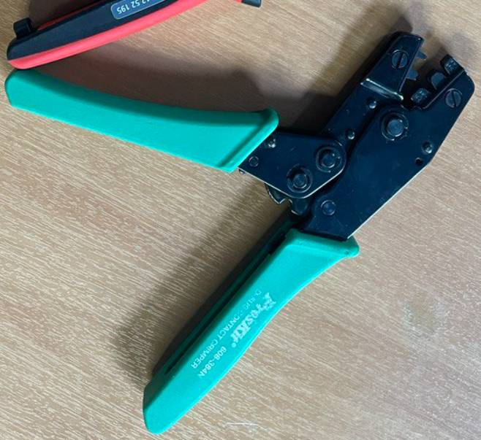 | 608-384N | Pros Kit | Кримпер для разъемов D-SUB, BLS,HU,PHU

YE-013B
foto | p\n | mfg | comment
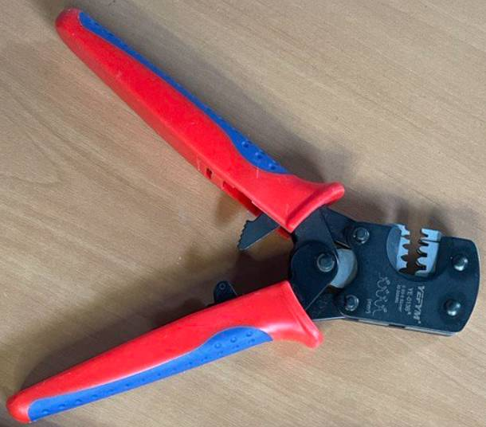 | YE-013B | YEFIM | Crimping tool for XH2.54 PH2.0 SM2.5 2510 SMH200 Narrow-pitch Connector Pins 0.03-0.52mm2

