POE
IEEE802.3af
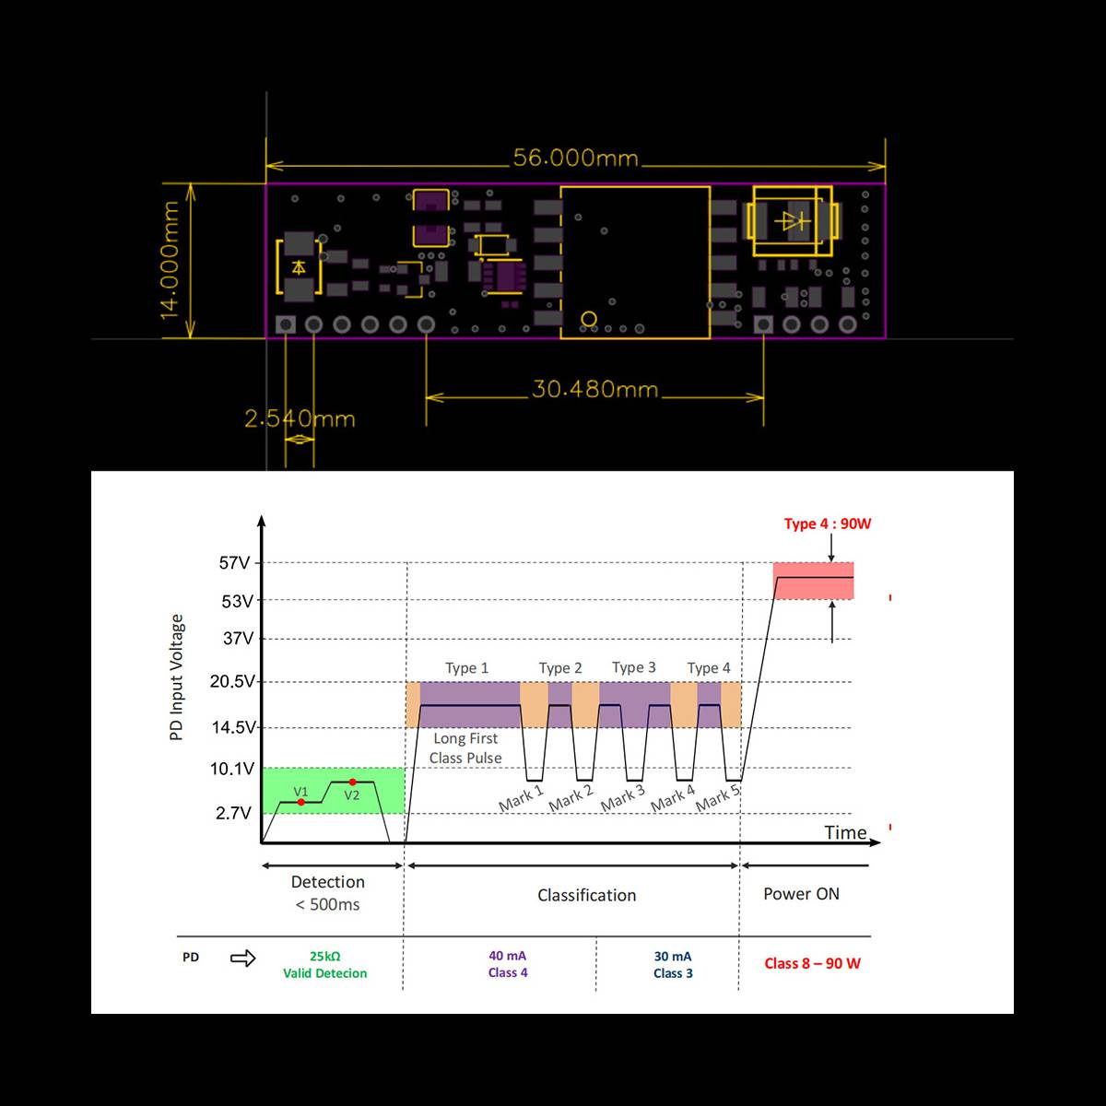
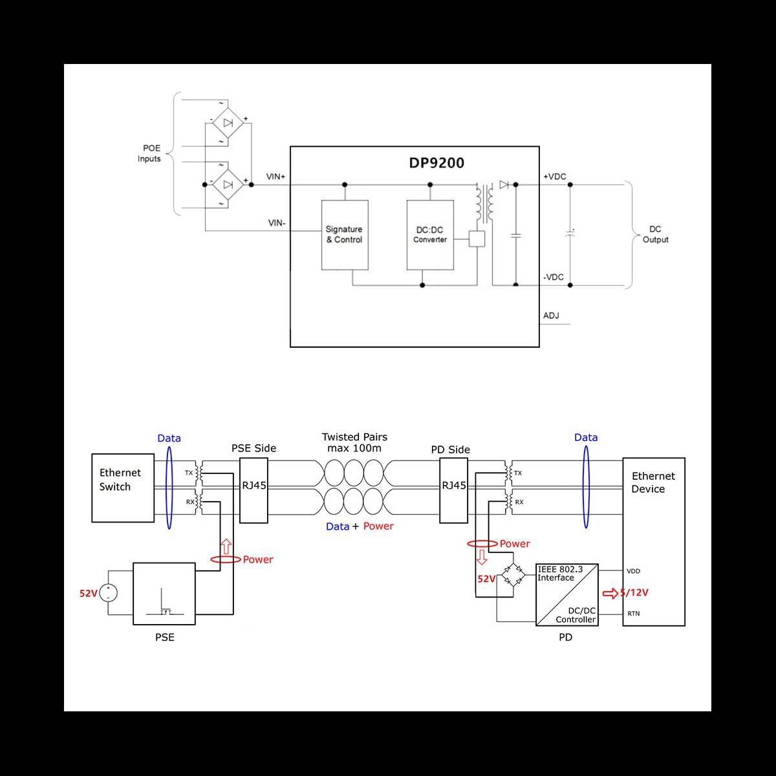
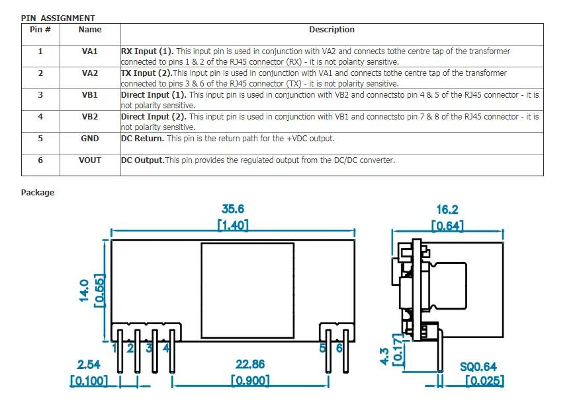
RT9400 | 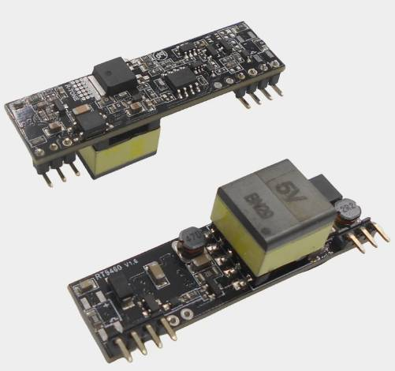 | link | 237р. | 15W (5V, 12V, 24V)
RT9460 |  | link | 237р. | 15W (3.3V)
DP9200 | 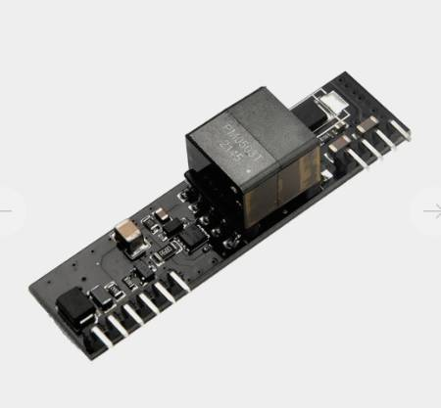 | link | 330р. | 13W (5V) | 56x14mm
DP1435 | 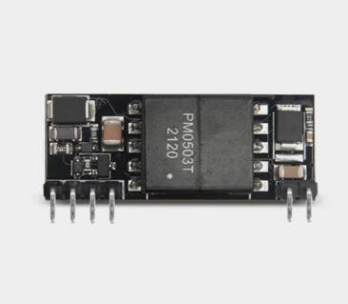 | link | 346р. | 13W (5V) | 35.6x14mm
DP9900M | 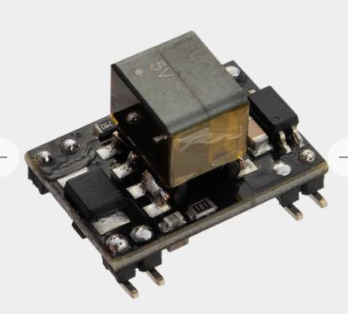 | link | 396р. | 13W (5V) | 21.2x14x13.35mm
RT7640 | 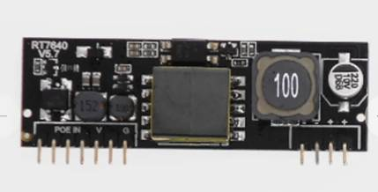 | link | 678р. | 30W (5V)
PD13C012A | 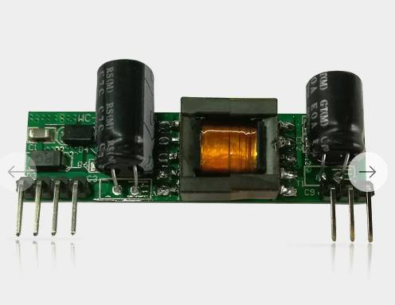 | link | 687р. | 10W (5V, 12V) | 51x14x12mm
38×38 1 | 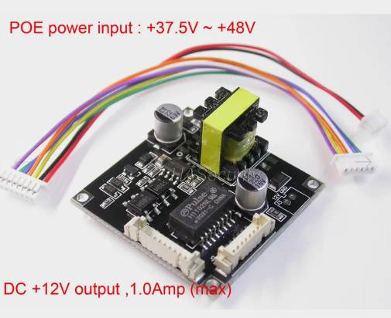 | link | 159р. | 12W (12V) | 38x38x?mm
38×38 2 | 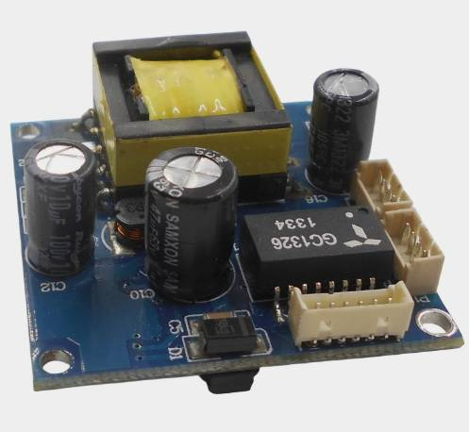 | link | 167р. | 13W (12V) | 38x38x?mm
38×38 3 | 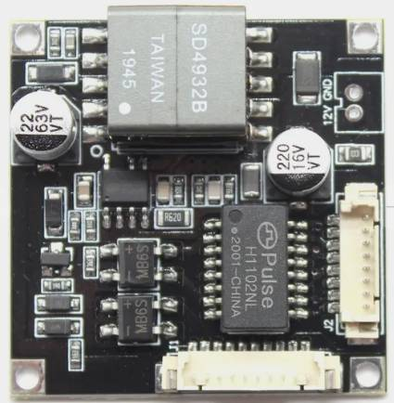 | link | 212р. | 15W/24W? (12V) | 38x38x?mm
38×38 SD4932B | 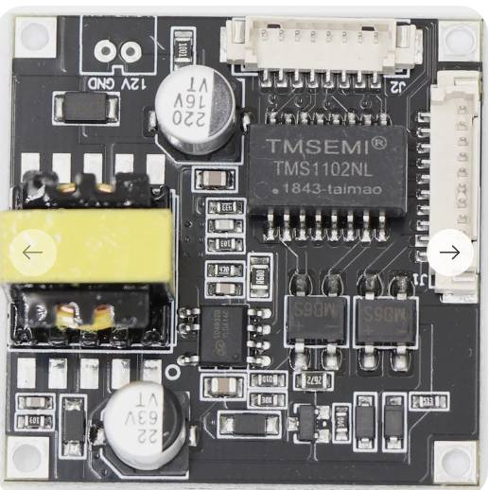 | link | 188р. | 12W (12V) | 38x38x?mm
PM3812RCL | 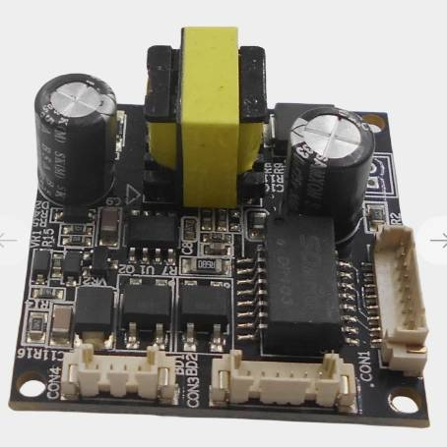 | link | 216р. | 12W (12V) | 38x38x?mm

