DCDC

Load Line
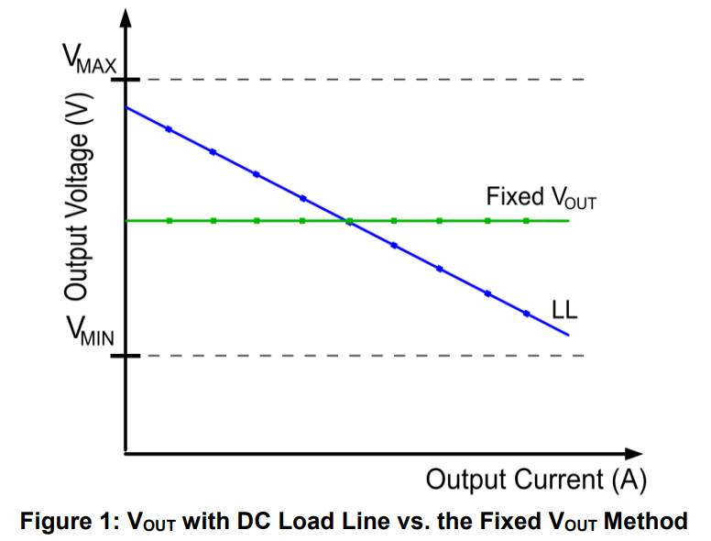
https://doc.inmys.ru/hash/cab9b5440d4a49a3630d42354300008e/load-line_design_for_a_multi-phase_buck_converter_r1.0.pdf
https://doc.inmys.ru/hash/a290a7033d13d866a335dc45bea88c7c/Infineon-DCDC_FPGA_load-line-AN-v01_00-EN.pdf

Snubber
Snubber - цепочка, компенсирующая паразитные L и C в DCDC.
- Резистор может прилично греться
- Надо подбирать экспериментально
Про snubber:
- ROHM AN
- Toshiba AN
- Nexperia AN
- TI AN
- Infineon AN
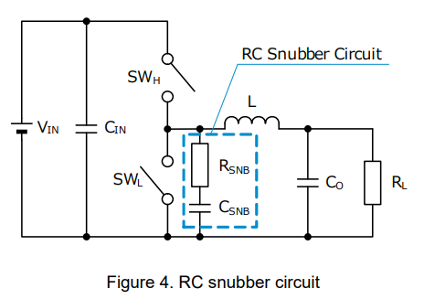
Snubber:
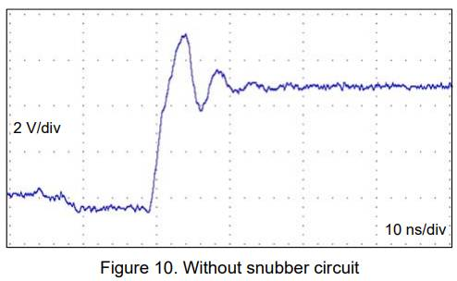
Пример без snubber:
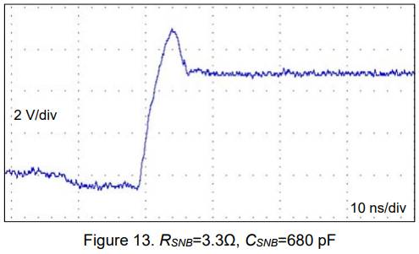
Пример после настройки Snubber:

MOSFET Self-Turn-On Phenomenon
Эффект произвольного включения верхнего транзистора.
Про эффект:
- Toshiba AN
Из app note toshiba:
Selecting MOSFETs with a high Vth and a low Cgd is of primary importance.
Из даташита ISL6625A:
Should the driver have insufficient bias voltage applied, its outputs are floating. If the input bus is energized at a high dV/dt rate while the driver outputs are floating, due to self-coupling via the internal CGD of the MOSFET, the gate of the upper MOSFET could momentarily rise up to a level greater than the threshold voltage of the device, potentially turning on the upper switch. Therefore, if such a situation could conceivably be encountered, it is a common practice to place a resistor (RUGPH) across the gate and source of the upper MOSFET to suppress the Miller coupling effect. The value of the resistor depends mainly on the input voltage’s rate of rise, the CGD/CGS ratio, as well as the gate-source threshold of the upper MOSFET. A higher dV/dt, a lower CDS/CGS ratio, and a lower gate-source threshold upper FET will require a smaller resistor to diminish the effect of the internal capacitive coupling. For most applications, the integrated 20kΩ resistor is sufficient, not affecting normal performance and efficiency.
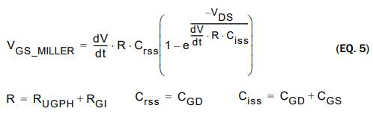
The coupling effect can be roughly estimated with Equation 5, which assumes a fixed linear input ramp and neglects the clamping effect of the body diode of the upper drive and the bootstrap capacitor. Other parasitic components such as lead inductances and PCB capacitances are also not taken into account. Figure 6 provides a visual reference for this phenomenon and its potential solution.
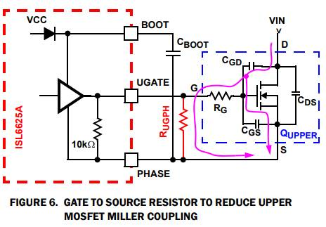

NTC temp measurement and treshold
На примере ISL95866.
Кусок схемы:
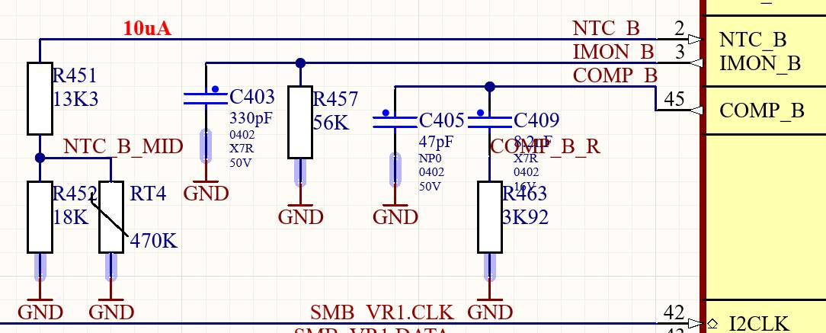
Характеристика термистора NCP18WM474E03RB (2-я кривая):
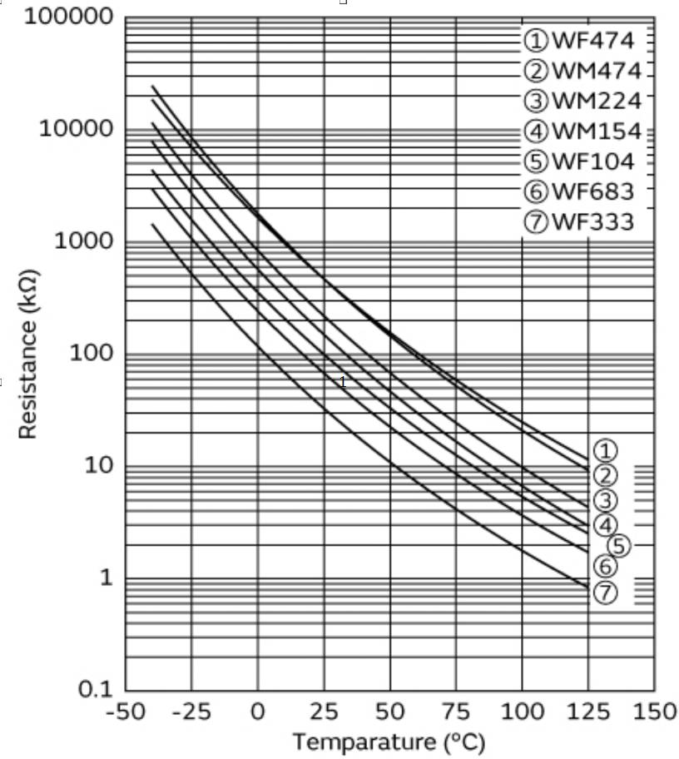
Внутри контроллера:
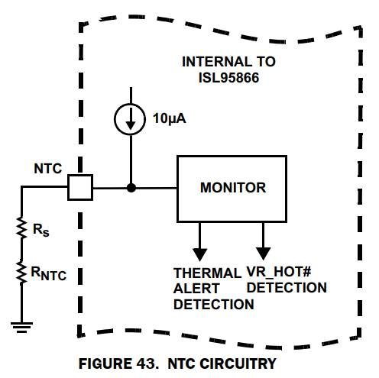
Пороги контроллера:
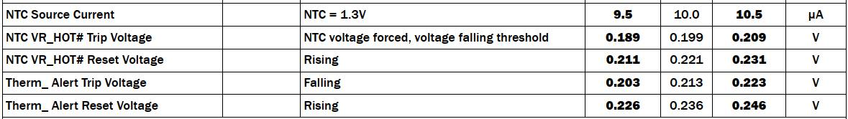
R|| = 1/(1/18k + 1/Rntc)
U = 10uA * (13k3 + R||)
Температура | Сопротивление термистора | Напряжение на входе при токе 10uA
25 град | 475k | 306mV
75 град | 54k | 268mV
90 град | 25k | 237mV
Видно, что при 90 град. защита ещё не сработает.
Если необходимо, чтобы при 90 град. срабатывла защита, то R451 можно заменить на 10K. Тогда получается:
Температура | Сопротивление термистора | Напряжение на входе при токе 10uA
25 град | 475k | 273mV
75 град | 54k | 235mV
90 град | 25k | 204mV
Т.е. при достижении 90 град. будет вырабатываться сигнал VR_HOT. При остывании до 75 град. VR_HOT будет сбрасываться.
Надо всё это проверить.

