Упаковка ЭК
Onsemi | https://www.onsemi.com/pub/collateral/brd8011-d.pdf
Analog | https://www.analog.com/media/en/package-pcb-resources/tape-and-reel-packaging.pdf
MiniCircuits | https://www.minicircuits.com/pdfs/tape_reel.pdf
TI | https://www.ti.com/lit/ug/snoa403i/snoa403i.pdf
Vishay | https://www.vishay.com/docs/88869/packaging.pdf
Diodes | https://www.diodes.com/assets/Tape%20Reel%20Files/tapereel_2.pdf
Renesas | https://www.renesas.com/us/en/document/oth/tb347-tape-and-reel-specification-integrated-circuits
KOAspeer | https://www.koaspeer.com/pdfs/Appendix_A.pdf
ST | https://www.st.com/resource/en/technical_note/tn1173-packing-information-for-ipad-protection-rectifiers-thyristors-and-ac-switches-stmicroelectronics.pdf

REEL - Катушки
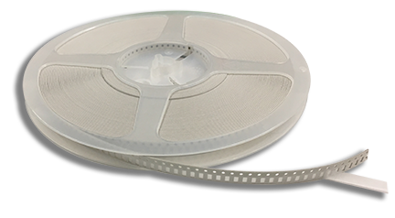
SMD компоненты
- reel size
  - 7 inch (178mm, 180mm, 185mm)
    - 2.4 inch hub
  - 12 inch (255mm, 260mm)
  - 13 inch (330mm)
    - 4 inch hub
    - 6 inch hub
  - 14 inch (380mm)
- tape width
  - REEL8 - 8mm tape
    - 2 - pitch
    - 4 - pitch
    - 8 - pitch
  - REEL12 - 12mm tape
  - REEL16 - 16mm tape
  - REEL24 - 24mm tape
  - REEL32 - 32mm tape
  - REEL44 - 44mm tape
  - REEL56 - 56mm tape
  - REEL72 - 72mm tape
  - REEL88 - 88mm tape
- tape pitch
  - 1
  - 2
  - 4
  - 8
  - 12
  - 16
  - 20
  - 24
  - 32
  - 36
  - 40

Onsemi
годится ли вместо NCP1589AMNTWG вариант NCP1589AMNTXG ?
NOTE: Pin 1 orientation for TWG Suffix is Quadrant 1, upper left; Pin 1 orientation for TXG Suffix is Quadrant 2, upper right

TAPE - Лента?
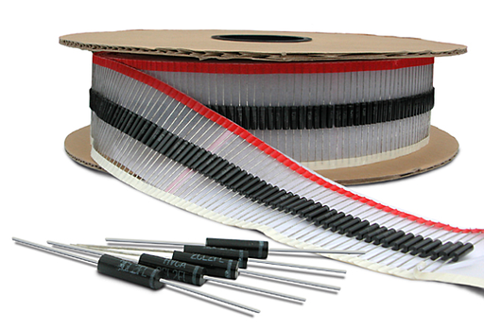

TRAY - Поддон?
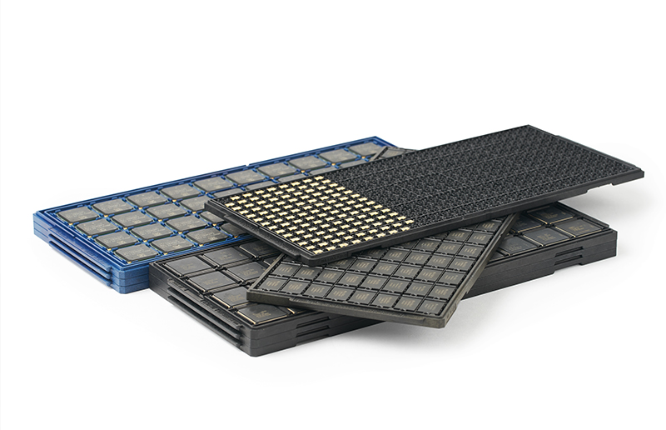

TUBE - Туба?
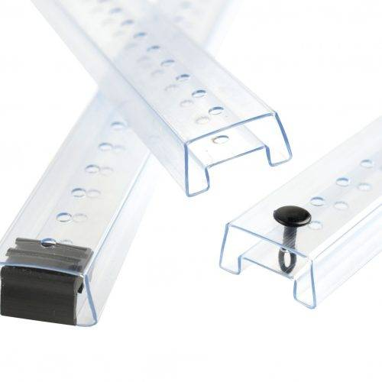
Внешняя ширина:
- 8 mm
- 10 mm
- 16 mm

