SIM card
https://en.wikipedia.org/wiki/SIM_card

Form factors
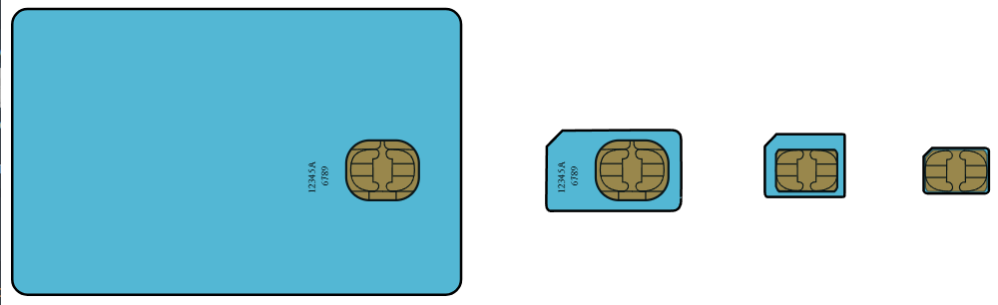
From left, full-size SIM (1FF), mini-SIM (2FF), micro-SIM (3FF), and nano-SIM (4FF)
SIM card format | Introduced | Standard reference | Length | Width | Thickness
Full-size (1FF) | 1991 | ISO/IEC 7810:2003, ID-1 | 85.6 mm  (3.37 in) | 53.98 mm  (2.125 in) | 0.76 mm  (0.030 in)
Mini-SIM (2FF) | 1996 | ISO/IEC 7810:2003, ID-000 | 25 mm  (0.98 in) | 15 mm  (0.59 in) | 0.76 mm  (0.030 in) | 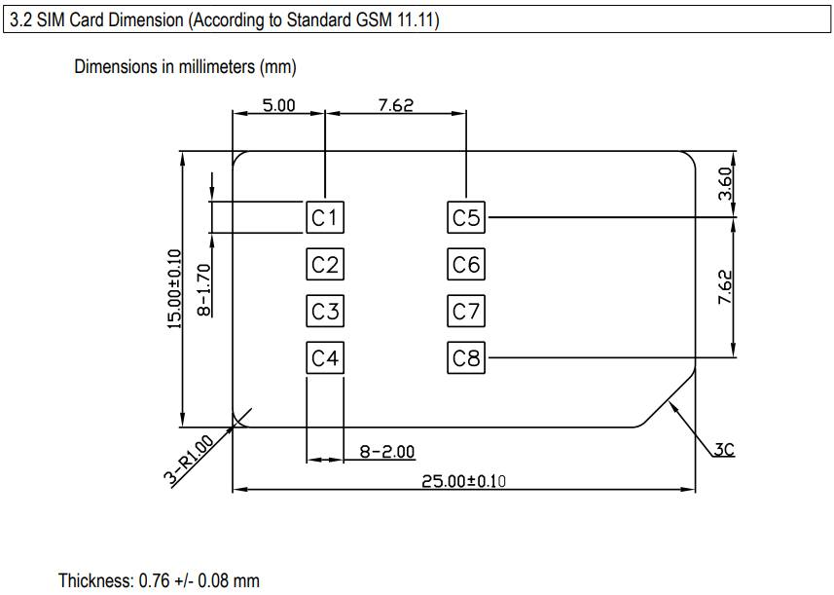
Micro-SIM (3FF) | 2003 | ETSI TS 102 221 V9.0.0, Mini-UICC | 15 mm  (0.59 in) | 12 mm  (0.47 in) | 0.76 mm  (0.030 in) | 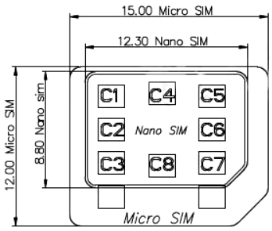
Nano-SIM (4FF) | early 2012 | ETSI TS 102 221 V11.0.0 | 12.3 mm  (0.48 in) | 8.8 mm  (0.35 in) | 0.67 mm  (0.026 in) | 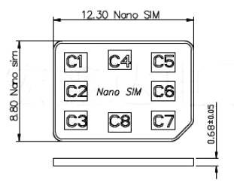
Embedded-SIM (eSIM) | 2016 | ETSI TS 102.671 V9.0.0  JEDEC Design Guide 4.8, SON-8  GSMA SGP.22 V1.0 | — | — | —

Connectors
PUSH-PUSH | with ejection mechanizm
PUSH-PULL | no ejection mechanizm
HINGE | no ejection mechanizm | 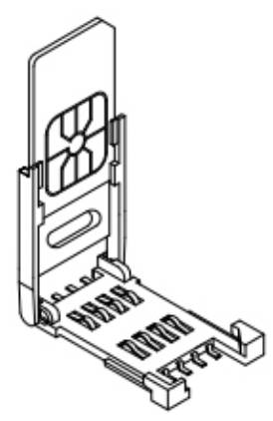
GUIDE AND HOLDER
KLS | https://www.klsele.com/products/connectors/Card-connectors/SIM-card-connectors.html
KLS | https://www.klsele.com/products/connectors/Card-connectors/Micro-SIM-card-connectors.html
KLS | https://www.klsele.com/products/connectors/Card-connectors/Nano-SIM-card-connectors.html
HSM
Connfly
Attend

Pinout
At first we need to understand SIM Pinouts:
- 6-pin includes VCC, GND, I/O, VPP, RST, CLK
- 8-pin includes VCC, GND, I/O, VPP, RST, CLK, SIM_PRESENCE, GND
Contact No | Assignment | Description
C1 | VCC | Power Voltage.
C2 | RST | Reset Signal.
C3 | CLK | Clocking Signal.
C4 | RFU | Reserved for Feature Use.
C5 | GND | Power and Signal Ground.
C6 | VPP | Programming Voltage.
C7 | I/O | Serial Data input/output.
C8 | RFU | Reserved for Feature Use

