M.2
M.2 Specification | link
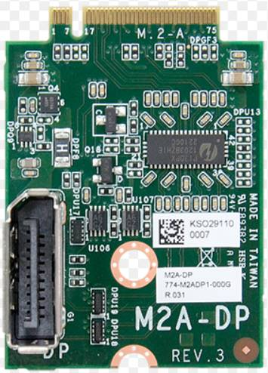 | 3042 | Key A | DP | 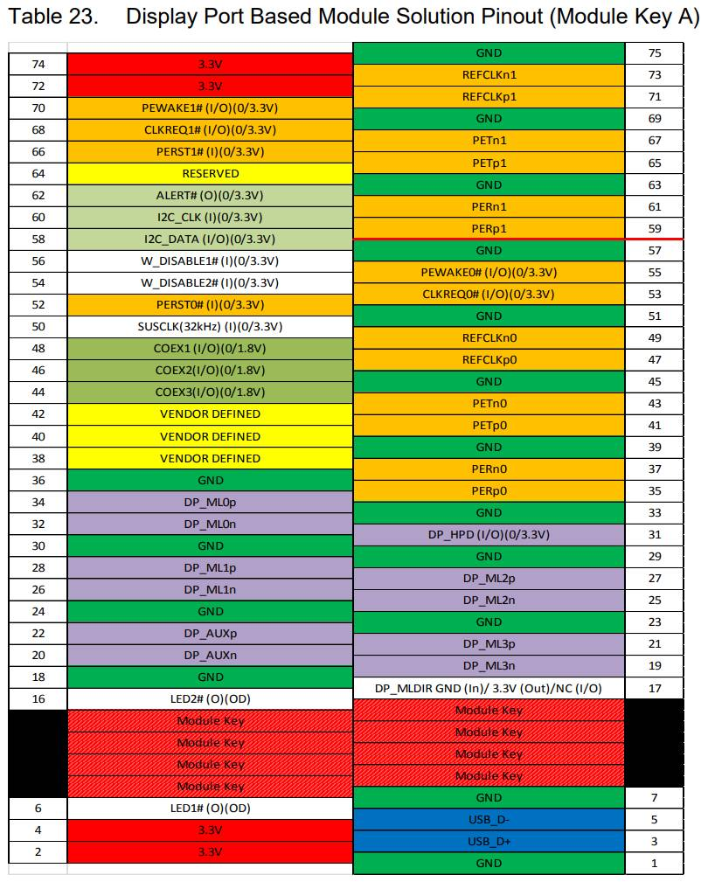 | M2A-VGA  M2A-DP  M2A-eDP/LVDS
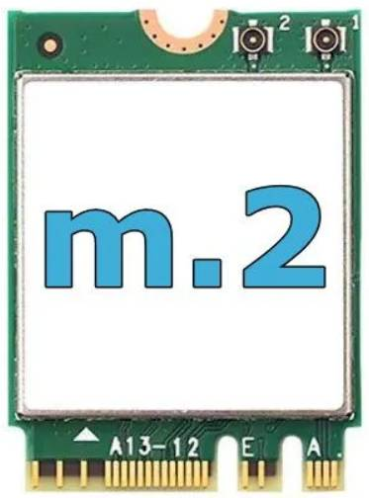 | 2230 | Key E+A | Wifi+Bluetooth | 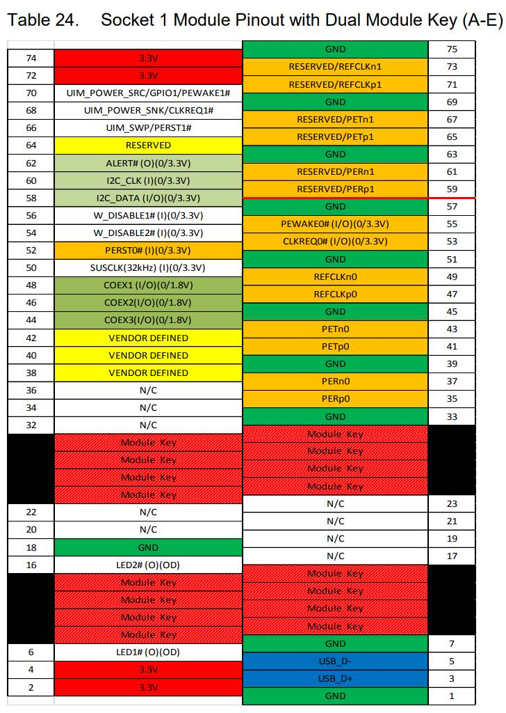
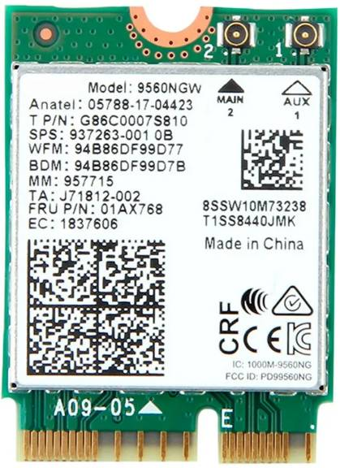 | 2230 | Key E | Wifi+Bluetooth | 

