eSPI
Enhanced SPI Master Bus Functional Model | https://github.com/akaeba/eSpiMasterBfm
Intel/Altera eSPI to LPC Bridge Core | https://www.intel.com/content/dam/www/programmable/us/en/pdfs/literature/ug/ug_embedded_ip.pdf
Intel eSPI Specification | https://www.intel.com/content/dam/support/us/en/documents/software/chipset-software/327432-004_espi_base_specification_rev1.0_cb.pdf
SmartDV eSPI Slave IIP | https://www.smart-dv.com/iip/espi_slave.html
eSPI protocol | https://www.prodigytechno.com/espi-protocol
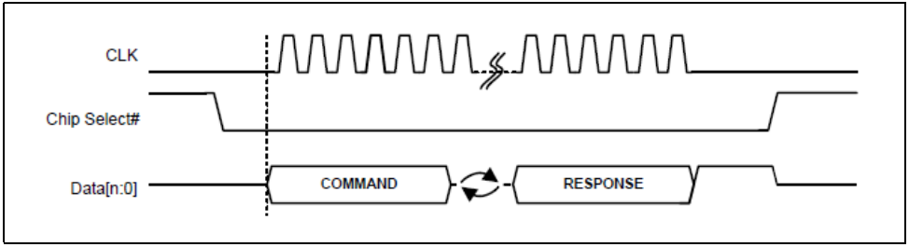
IT8883E-I | ITE | eSPI to LPC Bridge | link
ECE1200 | Microchip | eSPI to LPC Bridge | link
F85227 | fintek | eSPI to LPC Bridge | link

EHL
The eSPI Target has an Alert Mode bit in its General Capabilities and Configuration register, which selects between the discrete and in-band Alert# indications. For a single Initiator – single Target configuration, the default value of this bit (in-band Alert#) works as-is. When two or more targets are present, this bit must be set to 1 by the eSPI Initiator to ensure that Alert# is signaled by discrete pins (one per target).

