OCP NIC 3.0

Разработчик:
https://www.opencompute.org/
Страничка стандарта:
https://www.opencompute.org/projects/mezz-nic
https://www.opencompute.org/wiki/Server/NIC
Два типоразмера: 115mm x 76mm и 115mm x 139mm
Разъём -
Версии стандарта: 2.0, 3.0

Статьи
https://www.servethehome.com/ocp-nic-3-0-form-factors-quick-guide-intel-broadcom-nvidia-meta-inspur-dell-emc-hpe-lenovo-gigabyte-supermicro/

Продукты
https://www.servethehome.com/intel-x710-da2-ocp-nic-3-0-review-10gbe-for-the-form-factor/
https://www.lr-link.com/ru/product/mezzanine-card/10gsfp_mezzanineadapters.html
AIOM == OCP3.0 ??? https://www.supermicro.com/en/products/networking/adapters
https://servers.asus.com/products/Servers/Server-Accessories/OEI-10G-X710-2T

Примеры
Intel
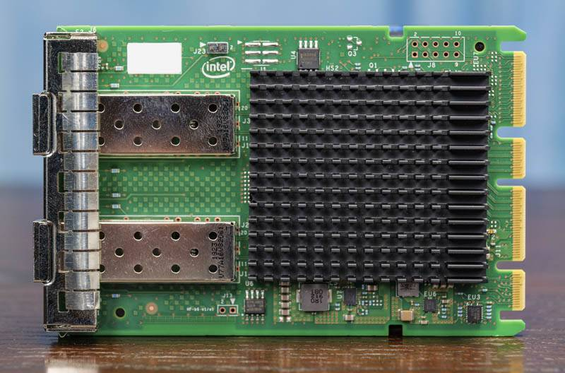
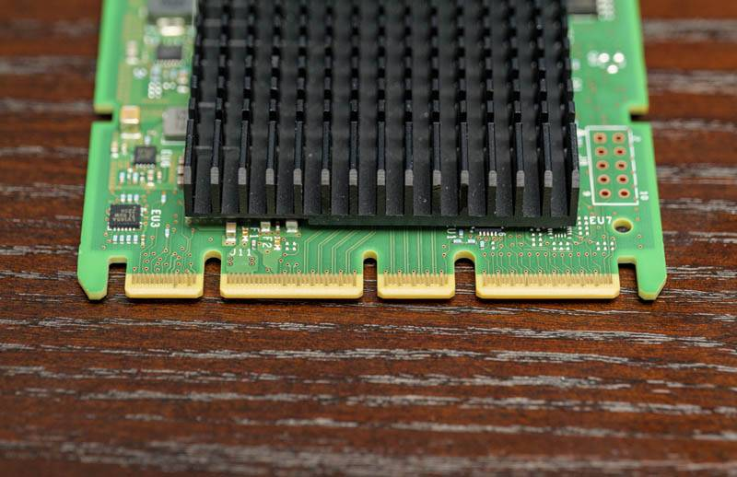
Supermicro AIOM ???
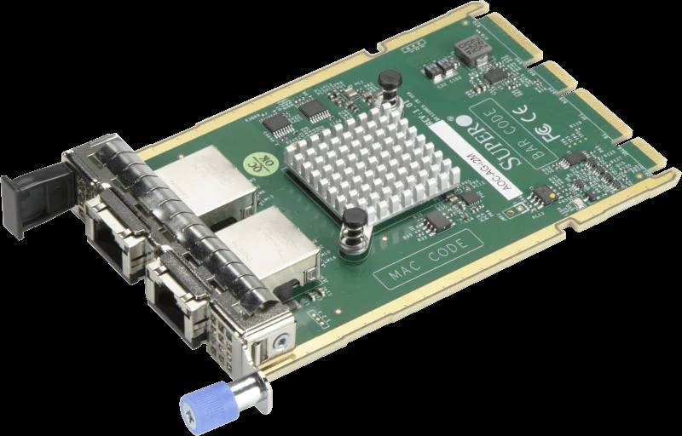
Asus
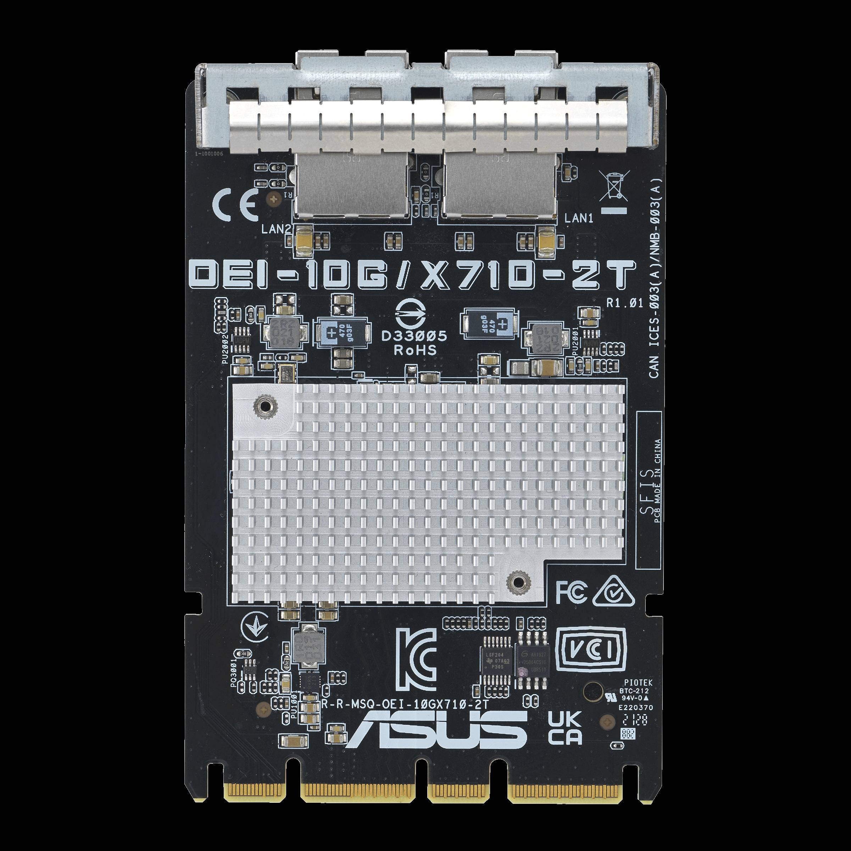

Размеры

Power

MODULE AND CARRIER SERIAL EEPROMS

pcb routing

Разъём

