Wireless

http://nvs-gnss.ru/ | NVS - навигационные технологии

Antenna

GNSS
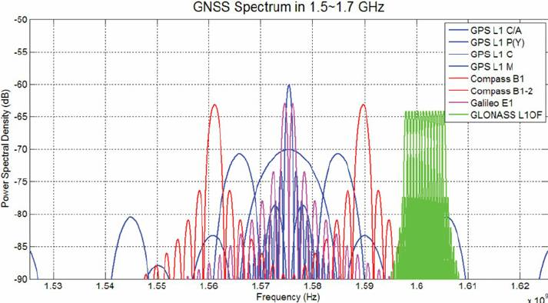
http://nvs-gnss.ru/products/antennas/item/12-glonass-antenna-gpsl1gl-tmg-40n.html

WIFI

Manufacturers
https://www.nxp.com/products/wireless/wi-fi-plus-bluetooth:WIFI-BLUETOOTH | NXP |  | chipsets, PMIC. NXP купила WIFI бизнес Marvell
https://www.infineon.com/cms/en/product/wireless-connectivity/ | Infineon |  | chipsets, Infineon купила WIFI бизнес Cypress
https://www.silabs.com/wireless/wi-fi?tab=hardware#hardware | Silabs |  | SIP
https://ark.intel.com/content/www/ru/ru/ark.html#@Wireless | Intel |  | chipsets, modules
https://www.ti.com/wireless-connectivity/wi-fi/overview.html | TI |  | chipsets
https://www.qualcomm.com/products/technology/wi-fi#overview | Qualcom |  | chipsets
https://www.nxp.com/products/wireless/wi-fi-plus-bluetooth/wi-fi-plus-bluetooth-modules:WIFI-BLUETOOTH-MODULES | NXP |  | Modules from Nxp partners
https://www.infineon.com/dgdl/Infineon-Wireless_Module_Partners_Selector_Guide-ProductSelectionGuide-v01_00-EN.pdf?fileId=8ac78c8c82ce56640183184a05d72e5a | Infineon |  | Modules from Infineon partners
https://www.broadcom.com/solutions/broadband-wired-networking/broadband-wi-fi-ap-solutions | Broadcom |  | SOC
https://www.murata.com/products/connectivitymodule/wi-fi-bluetooth | Murata |  | Modules, SIP
https://www.azurewave.com/wireless-modules.html | AzureWave |  | Modules, SIP
https://www.inventeksys.com/ | Inventek |  | Modules
https://www.lairdconnect.com/wireless-modules/wifi-modules-bluetooth | Laird Connectivity |  | Modules
https://www.lantronix.com/products-class/embedded-wireless-modules/ | Lantronix |  | Modules
https://www.quectel.com/wifi-iot-modules | Quectel |  | Modules
https://www.usiglobal.com/en/products?p_id=WiFi-Module | USI |  | Modules, SIP
https://www.u-blox.com/en/short-range-radio-modules | u-blox |  | Modules
https://www.cel.com/product/ | CEL |  | Modules
https://kagafeieurope.com/products/modules/modules-2/ | KAGA FEI |  | Modules, SIP
https://www.hd-wireless.com/products/connectivity-modules/products/ | H&D Wireless |  | Modules, SIP
https://pideu.panasonic.de/products/wireless-modules.html | Panasonic Industrial Devices Europe GmbH |  | Modules

Modules
link | ext | description | manufacturer | version | date | lang
lbee5kl1dx-1274263.pdf | pdf |  | Murata
type1ym.pdf | pdf |  | Murata
wf200-datasheet.pdf | pdf |  | Silabs

