TQ-Embedded TQMxE41S
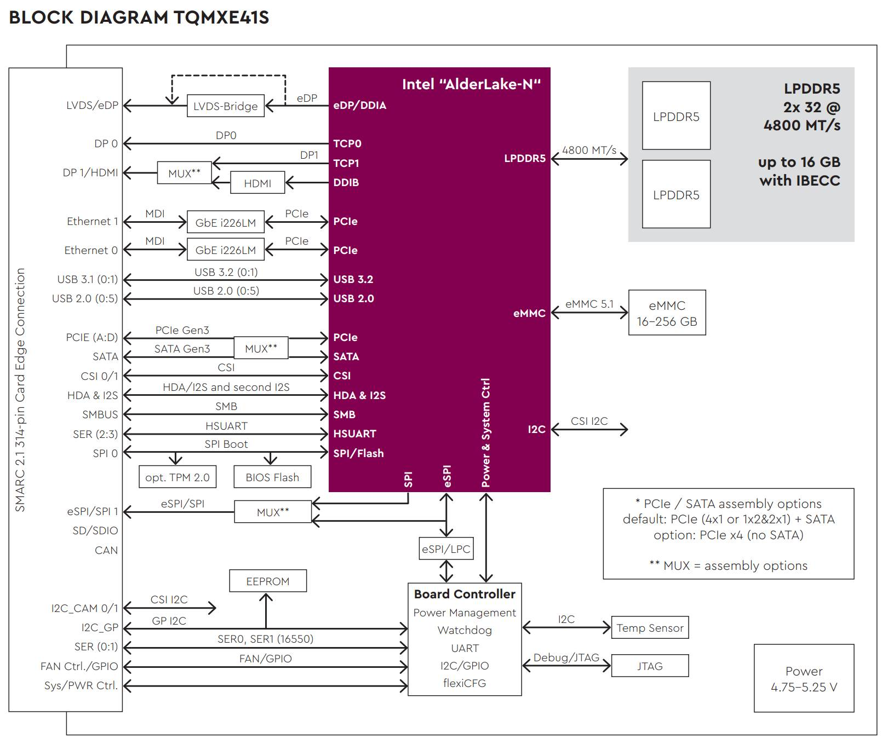
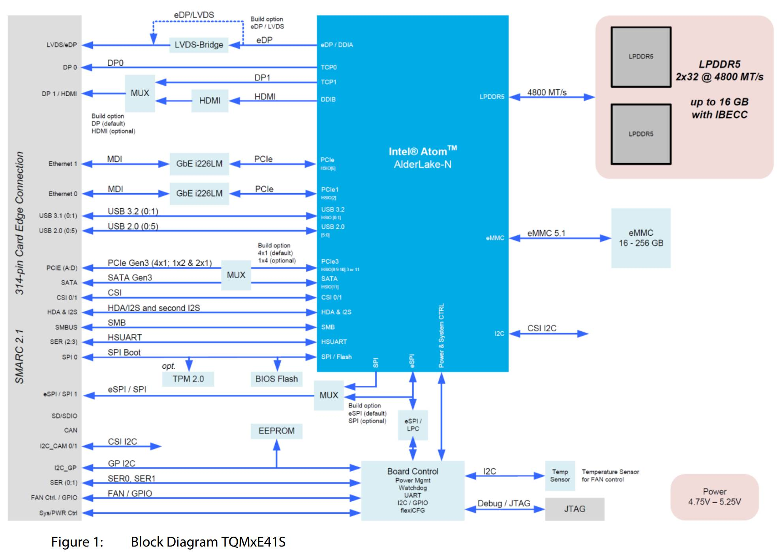
Intel® Core™ i3-N305 | (8-Core, 1.8/3.8 GHz, 32 EU, 15 W TDP)
Intel® Core™ i3-N305* | (8-Core, 1.0/3.8 GHz, 32 EU, 9 W cTDP)
Intel Atom® x7425E | (4-Core, 1.5/3.4 GHz, 24 EU, RT, 12 W TDP)
Intel Atom® x7413E | (2-Core, 1.7/3.2 GHz, 16 EU, RT, 10 W TDP)
Intel Atom® x7411E | (2-Core, 1.0/3.2 GHz, 16 EU, RT, 6 W TDP)
Intel® Processor N200 | (4-Core, 1.0/3.7 GHz, 32 EU, 6 W TDP)
Intel® Processor N97 | (4-Core, 2.0/3.6 GHz, 24 EU, 12 W TDP)
Intel® Processor N50 | (2-Core, 1.0/3.4 GHz, 16 EU, 6 W TDP)

