TQ-Embedded TQMxE40S
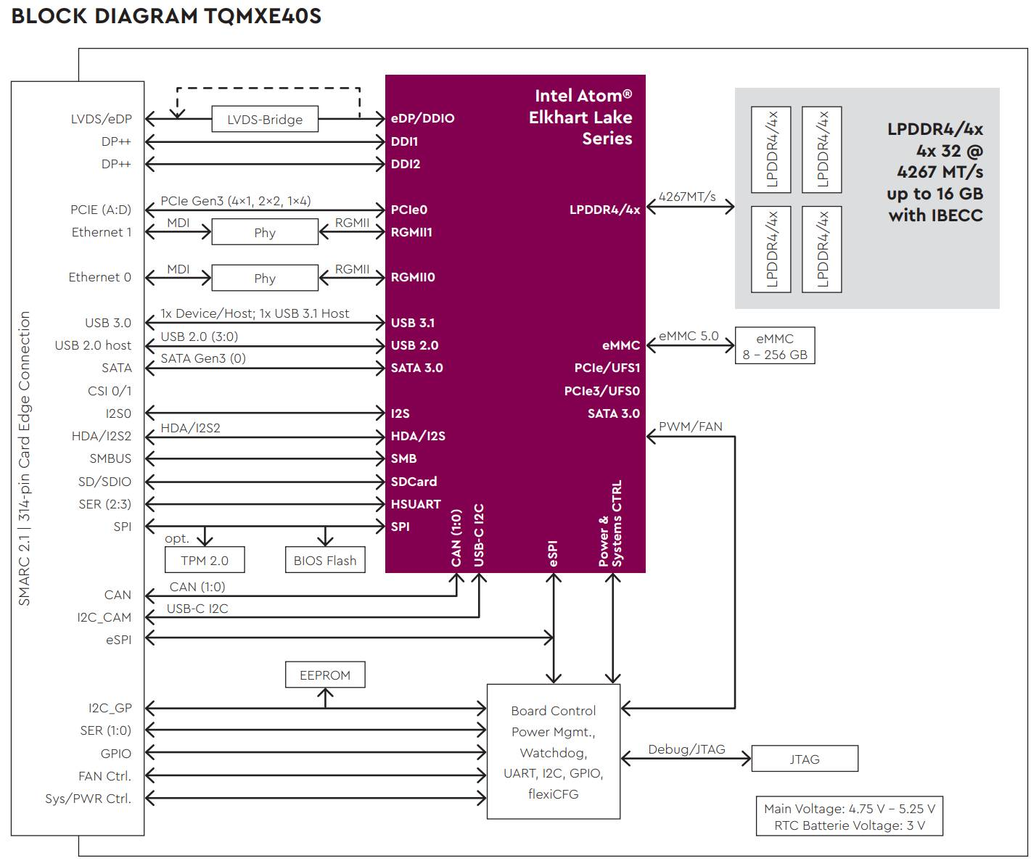
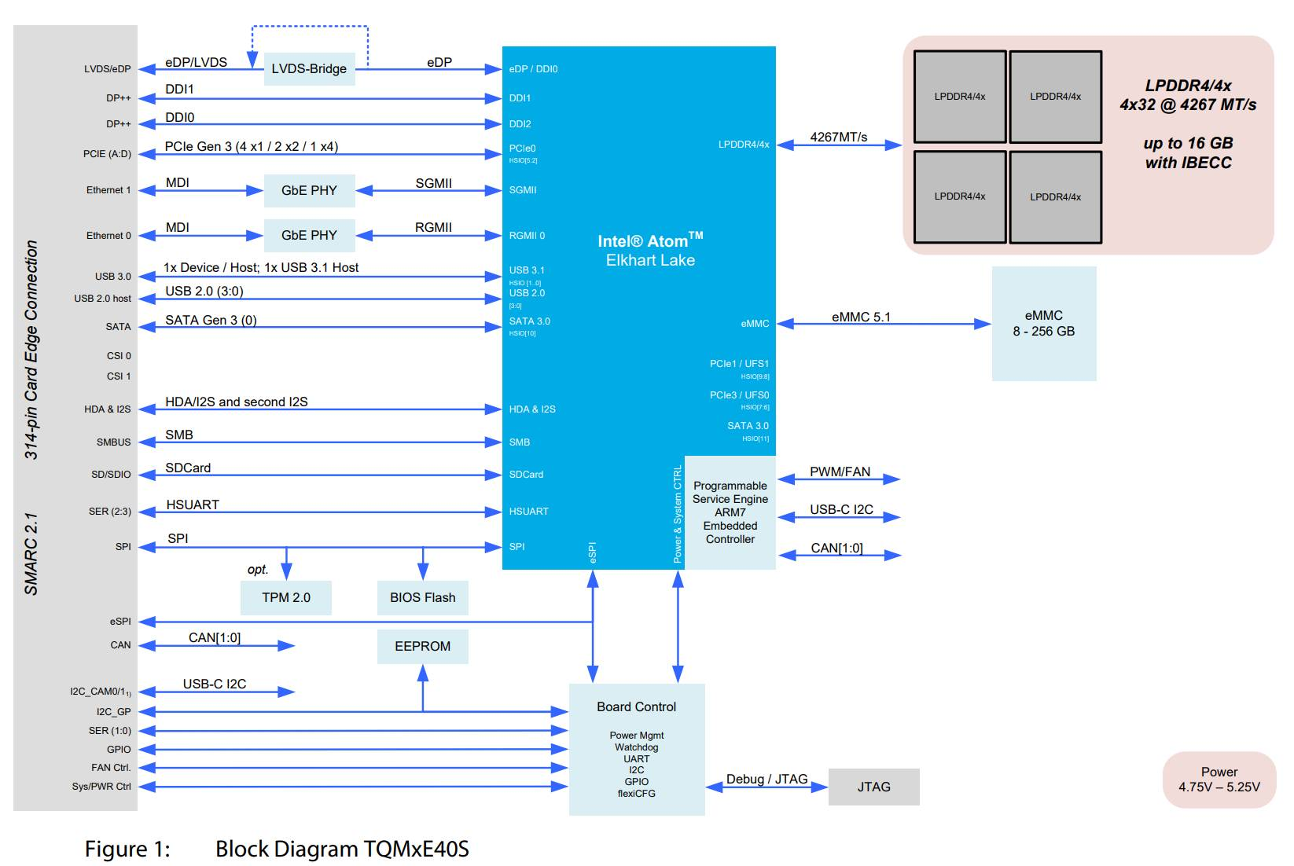
TQMxE40S-AA | Intel Atom® x6425RE | 16 GB | LPDDR4x | 8 GB eMMC | eDP |  | -40°C…+85°C
TQMXE40S-AB | Intel Atom® x6414RE | 8 GB | LPDDR4x | 32 GB eMMC | LVDS | TPM 2.0 | -40°C…+85°C
TQMXE40S-AC | Intel Atom® x6212RE | 4 GB | LPDDR4x | 16 GB eMMC | LVDS | TPM 2.0 | -40°C…+85°C
TQMXE40S-AD | Intel Atom® x6425E | 16 GB | LPDDR4x |  | LVDS | TPM 2.0 | -40°C…+85°C
TQMXE40S-AE | Intel Atom® x6413E | 8 GB | LPDDR4x |  | LVDS | TPM 2.0 | -40°C…+85°C
TQMXE40S-AF | Intel Atom® x6211E | 4 GB | LPDDR4x | 32 GB eMMC | LVDS | TPM 2.0 | -40°C…+85°C
TQMXE40S-AG | Intel Atom® x6425RE | 8 GB | LPDDR4x | 32 GB eMMC | LVDS | TPM 2.0 | -40°C…+85°C

