TQ-Embedded TQMxE40M
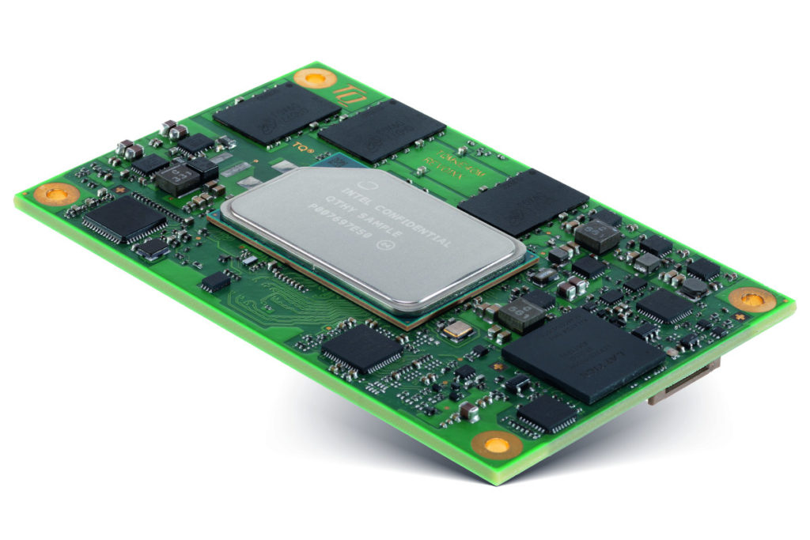
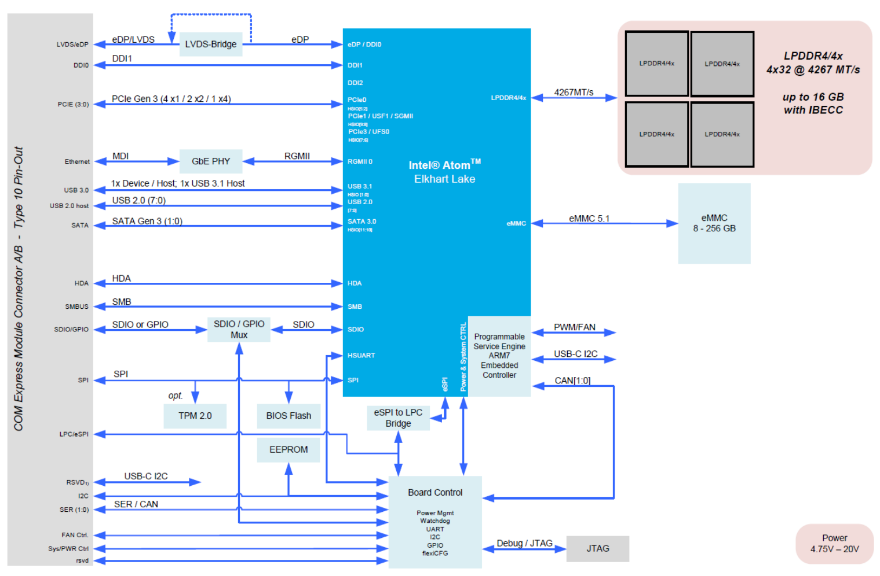
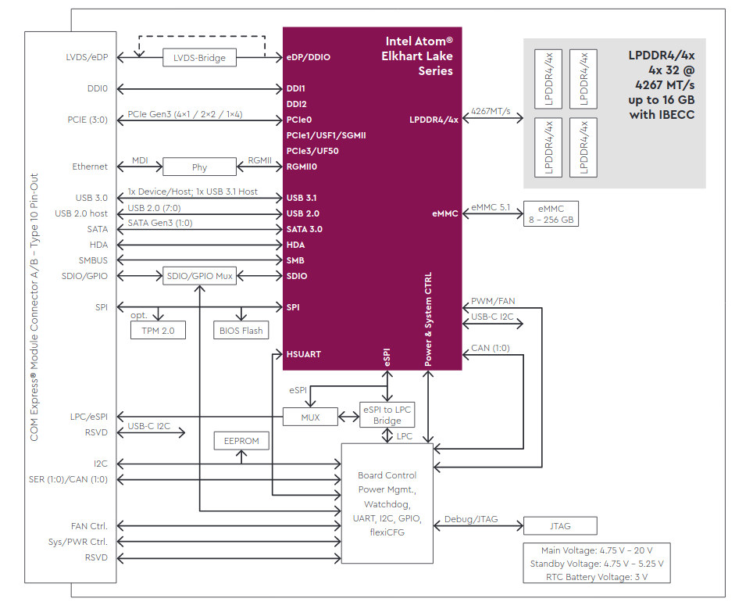

Docs
Datasheet www | TQ-Embedded |  | link
Datasheet Short | TQ-Embedded |  | link
Datasheet | TQ-Embedded |  | link
MX25L25645GM2I-08G | Macronix | 3.3V 256Mbit | link
SLB9670 | Infineon | TPM2.0 | link
88E1512 | Marvell | 1G Eth | link
24AA32AT | Microchip | 32k I2C EEPROM | link

SPI Boot Flash
Flash for carrier:
MX25L25645GM2I-08G | Macronix | 3.3V 256Mbit | link

USB
The USB 2.0 port 0 must be paired with USB 3.2 SuperSpeedPlus port 0.
The USB 2.0 port 1 must be paired with USB 3.2 SuperSpeedPlus port 1.

HDA
On the COM Express™ connector there is no HDA_SDIN2 signal available.

SPI
The SPI interface can only be used for SPI boot Flash devices.

UART
COM Express™ Signal | COM Express™ Pin | TQMxE40M | Remark
SER0_TX | A98 | SER0_TX | 3.3 V output
SER0_RX | A99 | SER0_RX | 3.3 V input
SER1_TX | A101 | SER1_TX | 3.3 V output
SER1_RX | A102 | SER1_RX | 3.3 V input
SER0_RTS# | B77 | SER0_RTS# | 3.3 V output
SER0_CTS# | B78 | SER0_CTS# | 3.3 V input
SER1_RTS# | B91 | SER1_RTS# | 3.3 V output
SER1_CTS# | B92 | SER1_CTS# | 3.3 V input
In Revision 2.1 of the COM Express™ specification, the signals A98, A99, A101 and A102 have been reclaimed from the VCC_12V pool. Therefore protection on the carrier board is necessary to avoid damage to those when accidentally connected to 12 V. The implementation of this circuitry causes lower transfer rates at both serial ports.
On the TQMxE40M the protection circuit is removed by default and the serial ports provide transfer rates of up to 115 kbaud. Therefore the TQMxE40M can only be used in COM.0 Revision 2.1 and 3.0 Type10 pinout carrier boards.

CAN
The TQMxE40M provides a CAN interface. The signals for the CAN interface are shared with the serial port (SER1) signals and can be configured via a register setting.

DEBUG
The TQMxE40M includes a 14-pin flat cable connector, to connect an external debug module (TQ specific), to provide BIOS post code information, debug LEDs and a JTAG interface for on-board FPGA. This header is intended for TQ internal use only!


