SOM
https://www.criticallink.com/ | FPGA, MCU boards | Intel, TI
https://www.compulab.com/ | CPU boards, SBC | NXP, TI
https://www.mixtile.com/ | SOMs | Rockchip
https://www.atronik.ru/ | SOMs, SBC, CPU modules | Атроник
https://www.data-modul.com/ |  | Data Modul
https://www.congatec.com/ |  | Congatec
https://www.tq-group.com/ |  | TQ-Embedded
https://www.kontron.com/ |  | Kontron
https://edge.seco.com/ |  | Seco
https://www.adlinktech.com/ |  | Adlink
https://www.avnet.com |  | Avnet
https://www.advantech.com/ |  | Advantech

Форм-факторы процессроных модулей
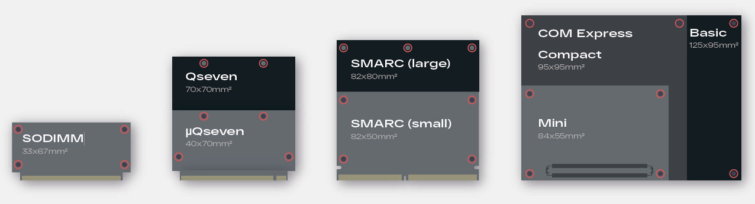

QSeven
QSeven

SMARC
SMARC

Com Express
COM Express
https://www.portwell.com/pdf/embedded/PCOM-B634VG.pdf | Portwell

SOM модули
- https://www.kontron.com/en/products/smarc-sxal-e2-smarc-sxal4-e2-/p145462 E3900
- https://www.avnet.com/wps/portal/integrated/products/embedded-boards/smarc-modules/MSC+SM2S-EL?family=/Integrated%20Content/MSC%20Board%20Families/SMARC/MSC%20SM2S-EL&nodeClicked=84b8469d-f5eb-4aae-af12-196a61152620

