Portwell PCOM-BA02GL
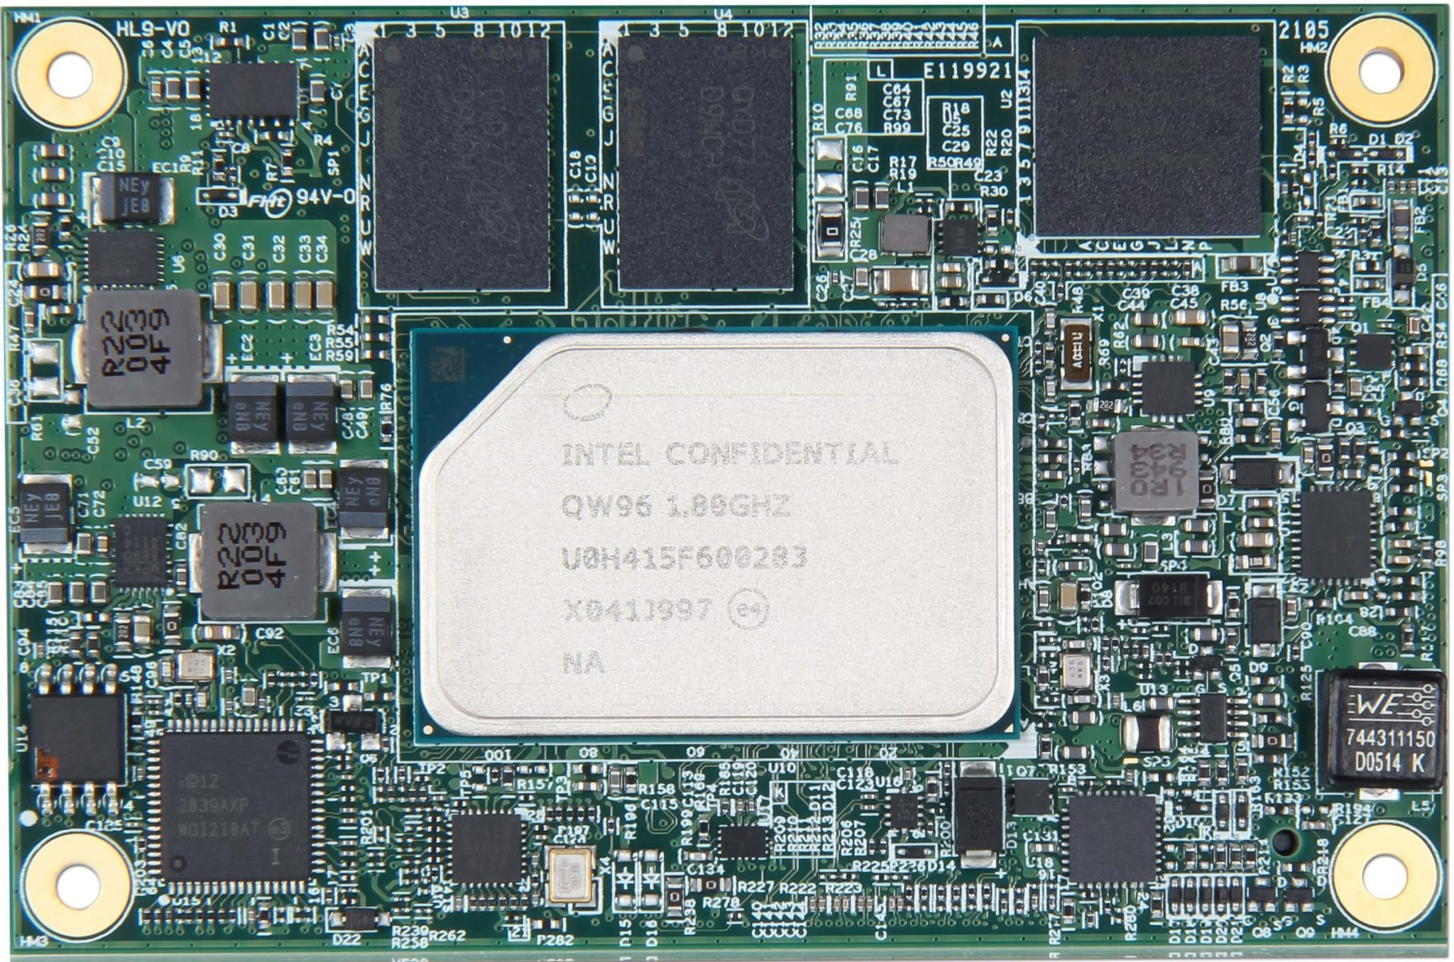 | 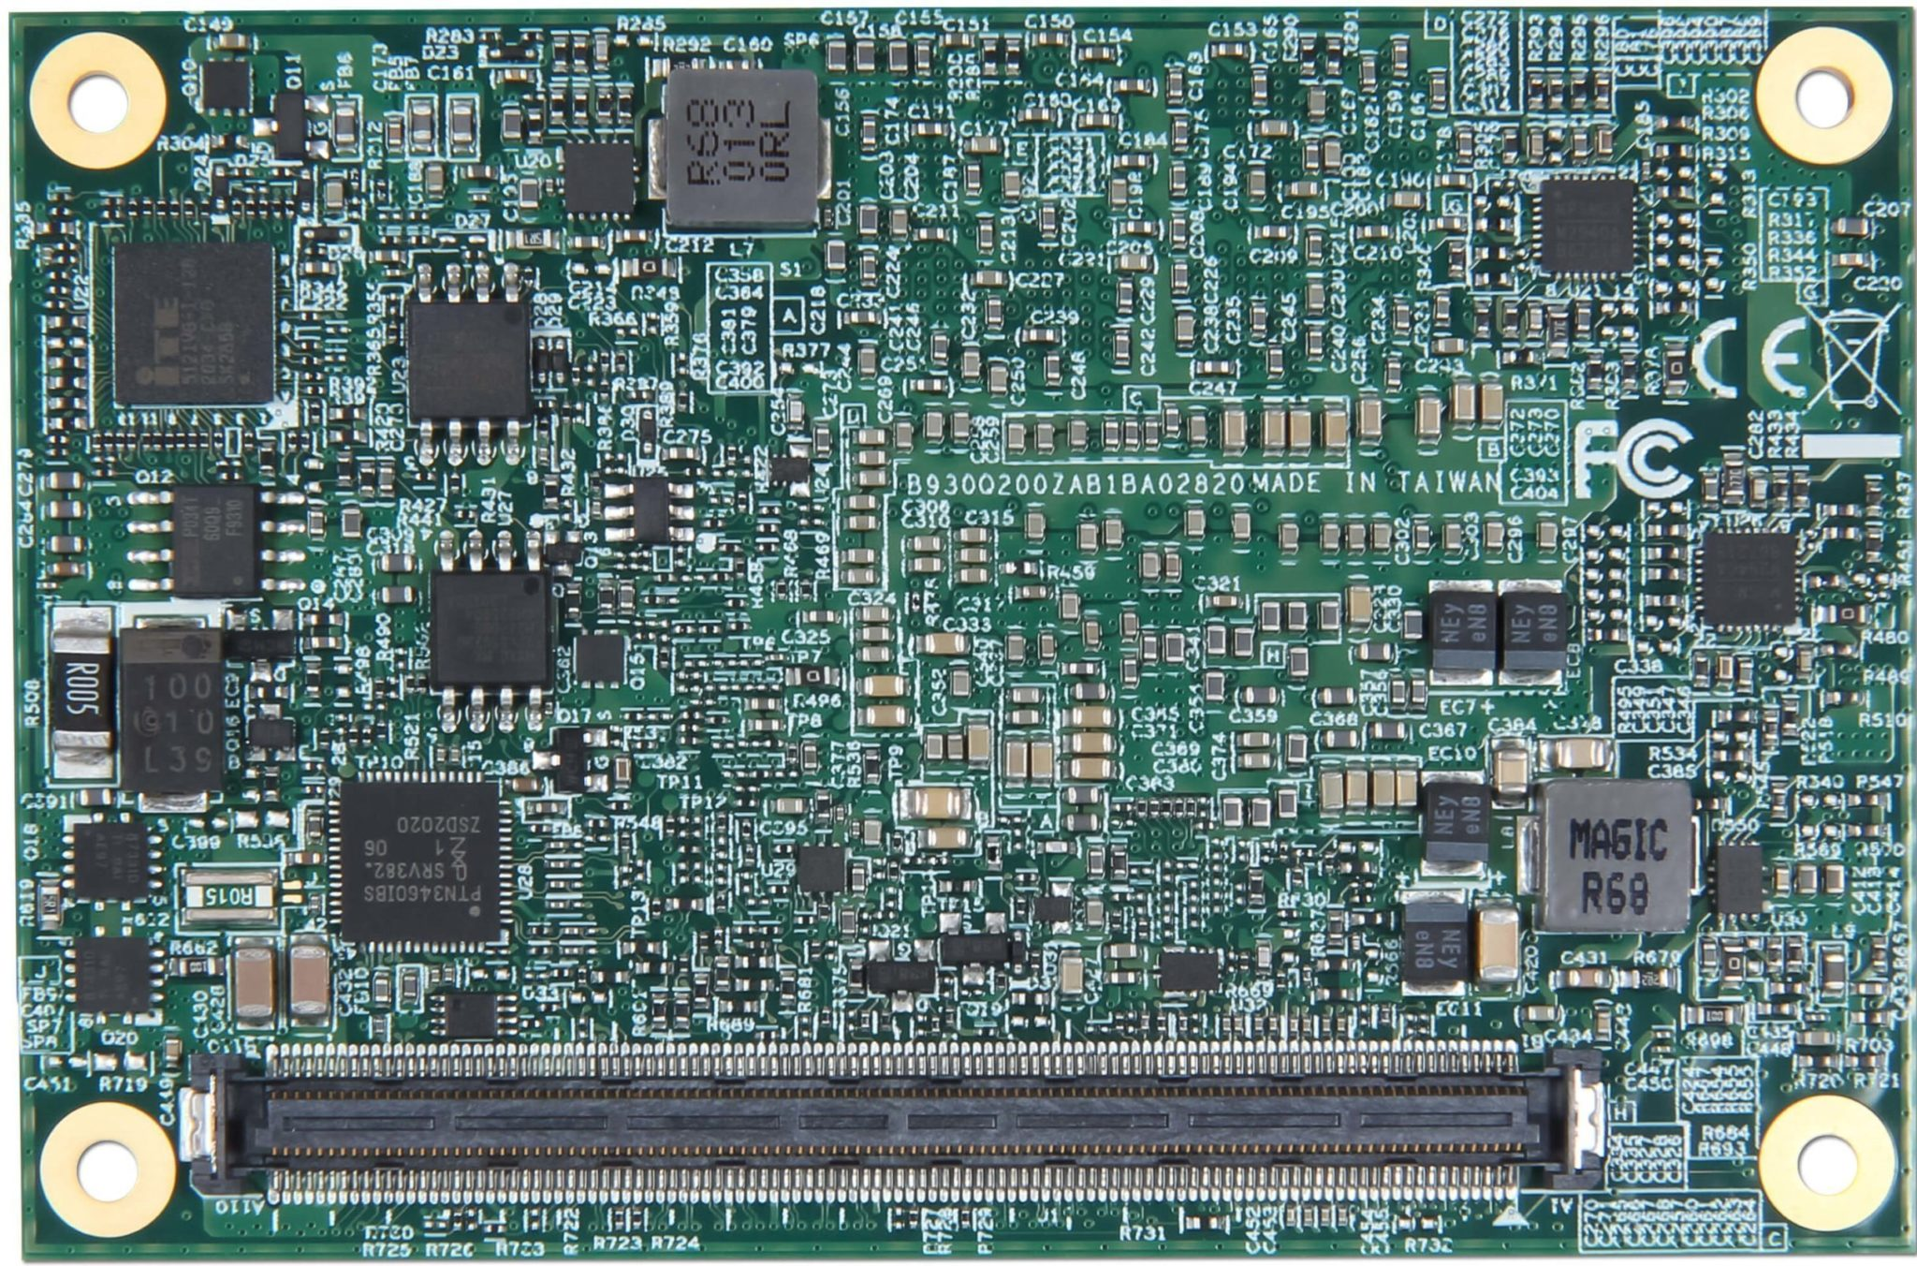
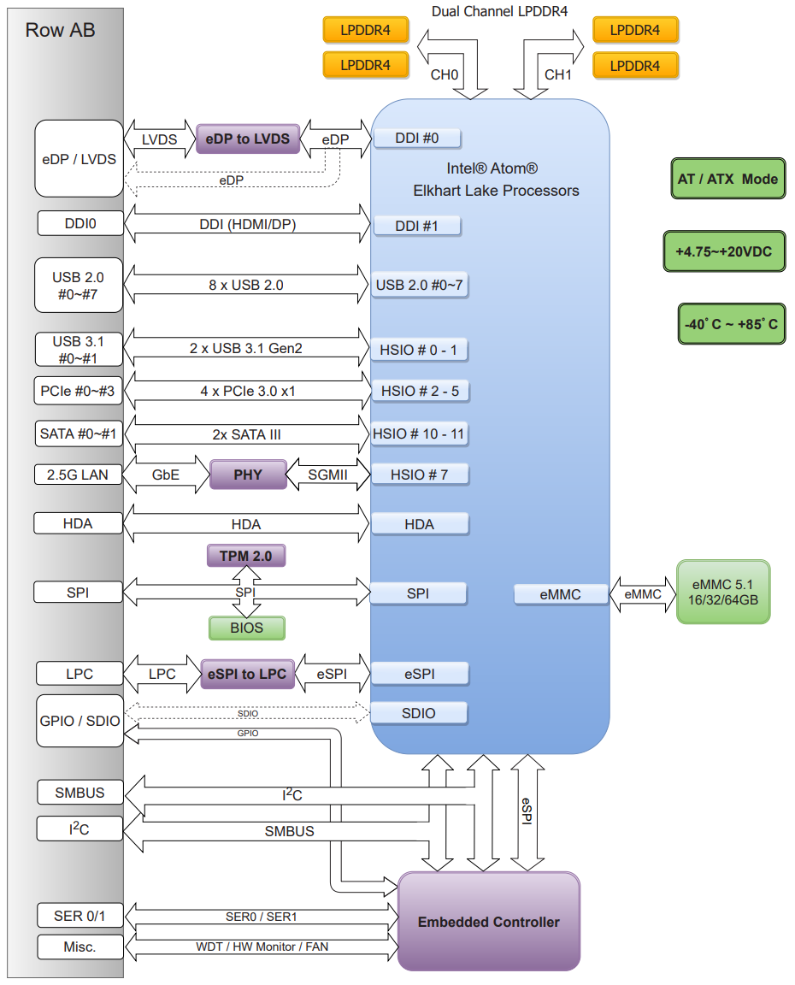
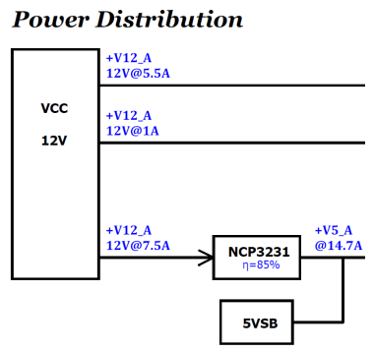

docs
PCOM-BA02GL | Portwell | SOM flyer | link
PCOM-BA02GL | Portwell | User's guide | link
PTN3460 | NXP | eDP<>LVDS bridge | link
IT5121VG-I-128 | ITE | EC
ECE1200 | Microchip | eSPI<>LPC | link

USB
USB 0 | HSIO 0 | from XHCI controller
USB 1 | HSIO 1 | from XHCI controller

PCIe
PCIE0 | HSIO 2
PCIE1 | HSIO 3
PCIE2 | HSIO 4
PCIE3 | HSIO 5

SATA
SATA0 | HSIO 10
SATA1 | HSIO 11

LPC
LPC Bus is supported by a eSPI-to-LPC bridge IC

