Kontron COMe-mEL10
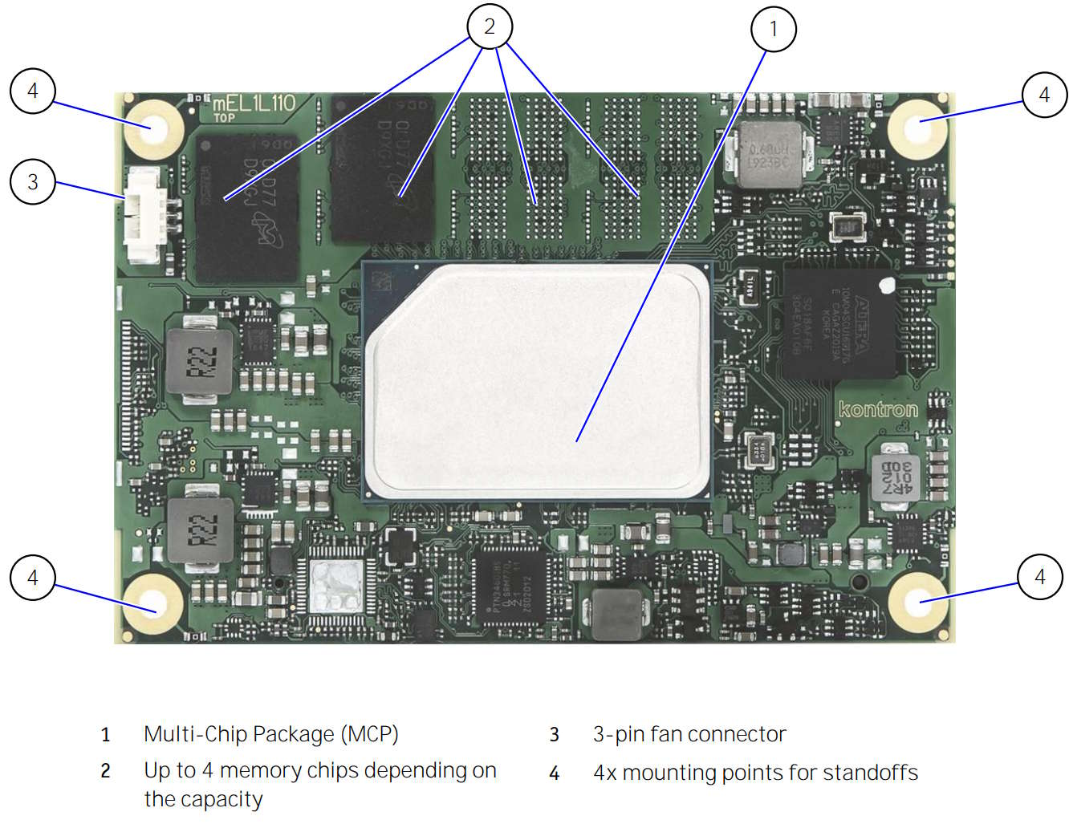 | 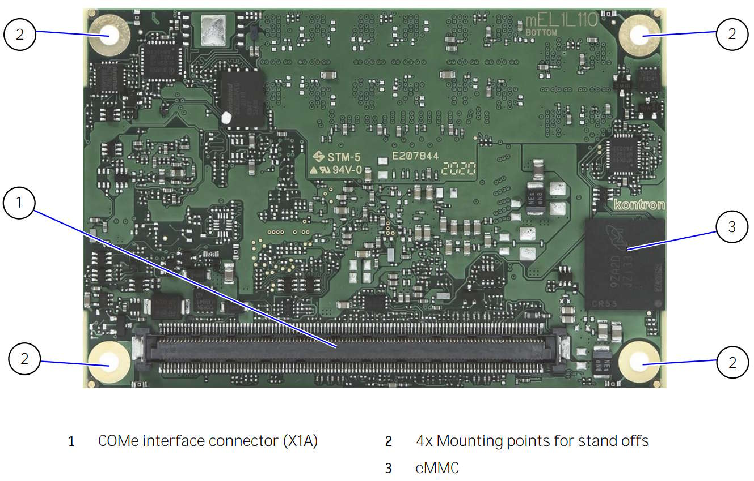
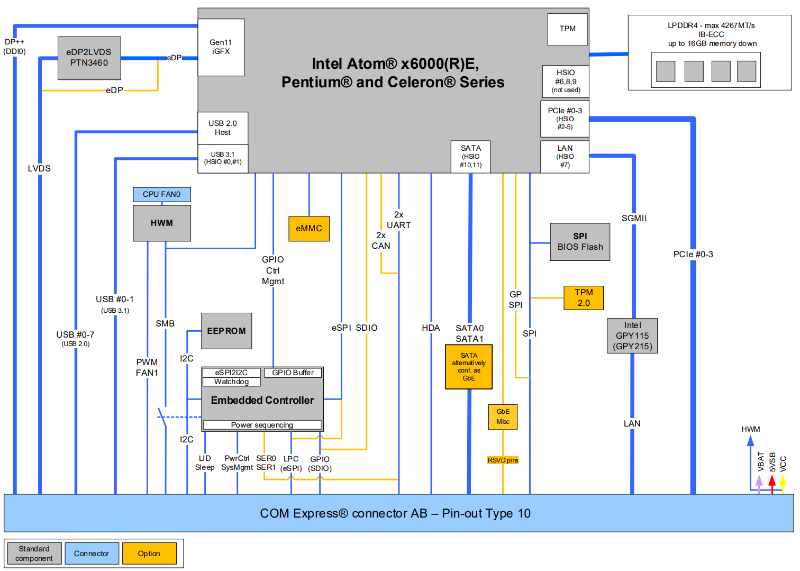

docs
COMe-mEL10 | Kontron | SOM flyer | link
COMe-mEL10 | Kontron | User's guide | link
PTN3460 | NXP | eDP<>LVDS bridge | link
MAX10 10M04SCU169I7G | Altera | EC

Boot flash
Size | Manufacturer | Part Number | Device ID
32MB | Winbond | W25Q256JV | EFh / 40h / 19h
32MB | Macronix | MX25L25645GZ2I | C2h / 20h / 19h
32MB | Micron | MT25QL256ABA1EW9-0SIT | 20h / BAh / 19h
32MB | Cypress | S25FL256LAGNFI010 | 01h / 60h / 19h

Hardware monitor
NCT7802Y (SMBus)

USB
USB 0 | HSIO 0 | from XHCI controller
USB 1 | HSIO 1 | from XHCI controller

PCIe
PCIE0 | HSIO 2
PCIE1 | HSIO 3
PCIE2 | HSIO 4
PCIE3 | HSIO 5

SATA
SATA0 | HSIO 10
SATA1 | HSIO 11

LPC
LPC_CLK = 25 MHz, eSPI_CK = 20 MHz

