Data Modul eDM-SMX-EL
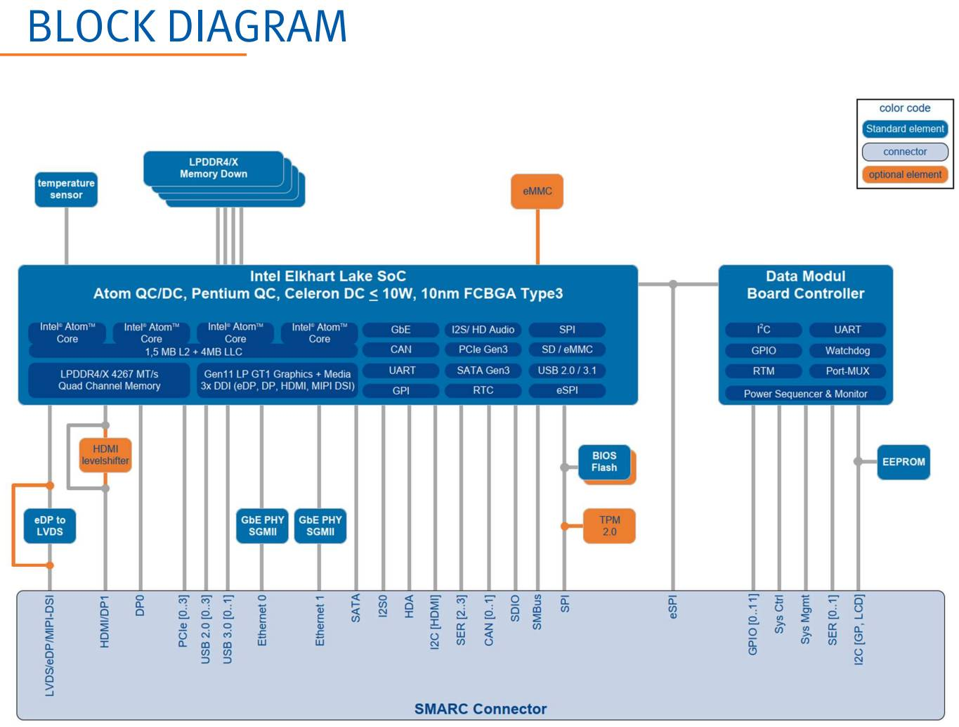
Processor | TDP | Cores | Base  Max. Turbo  frequency | L2 cache | Use  Condition | Graphics  Gen 11
Intel® Atom® x6211E | 6 W | 2 | 1.3 / 3.0 GHz | 1.5 MB | Embedded | 16 EU
Intel® Atom® x6413E | 9 W | 4 | 1.5 / 3.0 GHz | 1.5 MB | Embedded | 16 EU
Intel® Atom® x6425E | 12 W | 4 | 2.0 / 3.0 GHz | 1.5 MB | Embedded | 32 EU
Intel® Atom® x6212RE | 6 W | 2 | 1.2 GHz | 1.5 MB | Industrial | 16 EU
Intel® Atom® x6425RE | 12 W | 4 | 1.9 GHz | 1.5 MB | Industrial | 32 EU

