Congatec conga-SA7
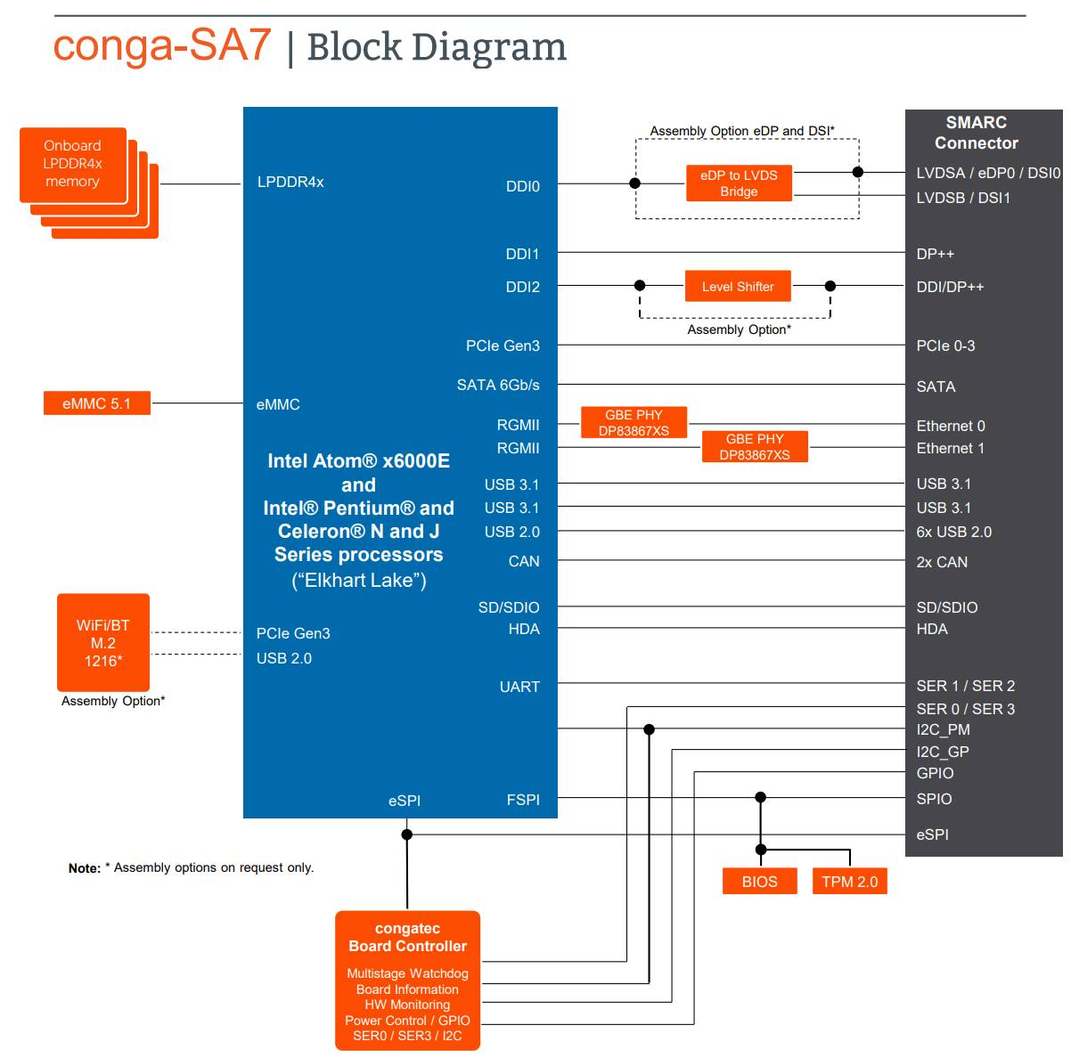
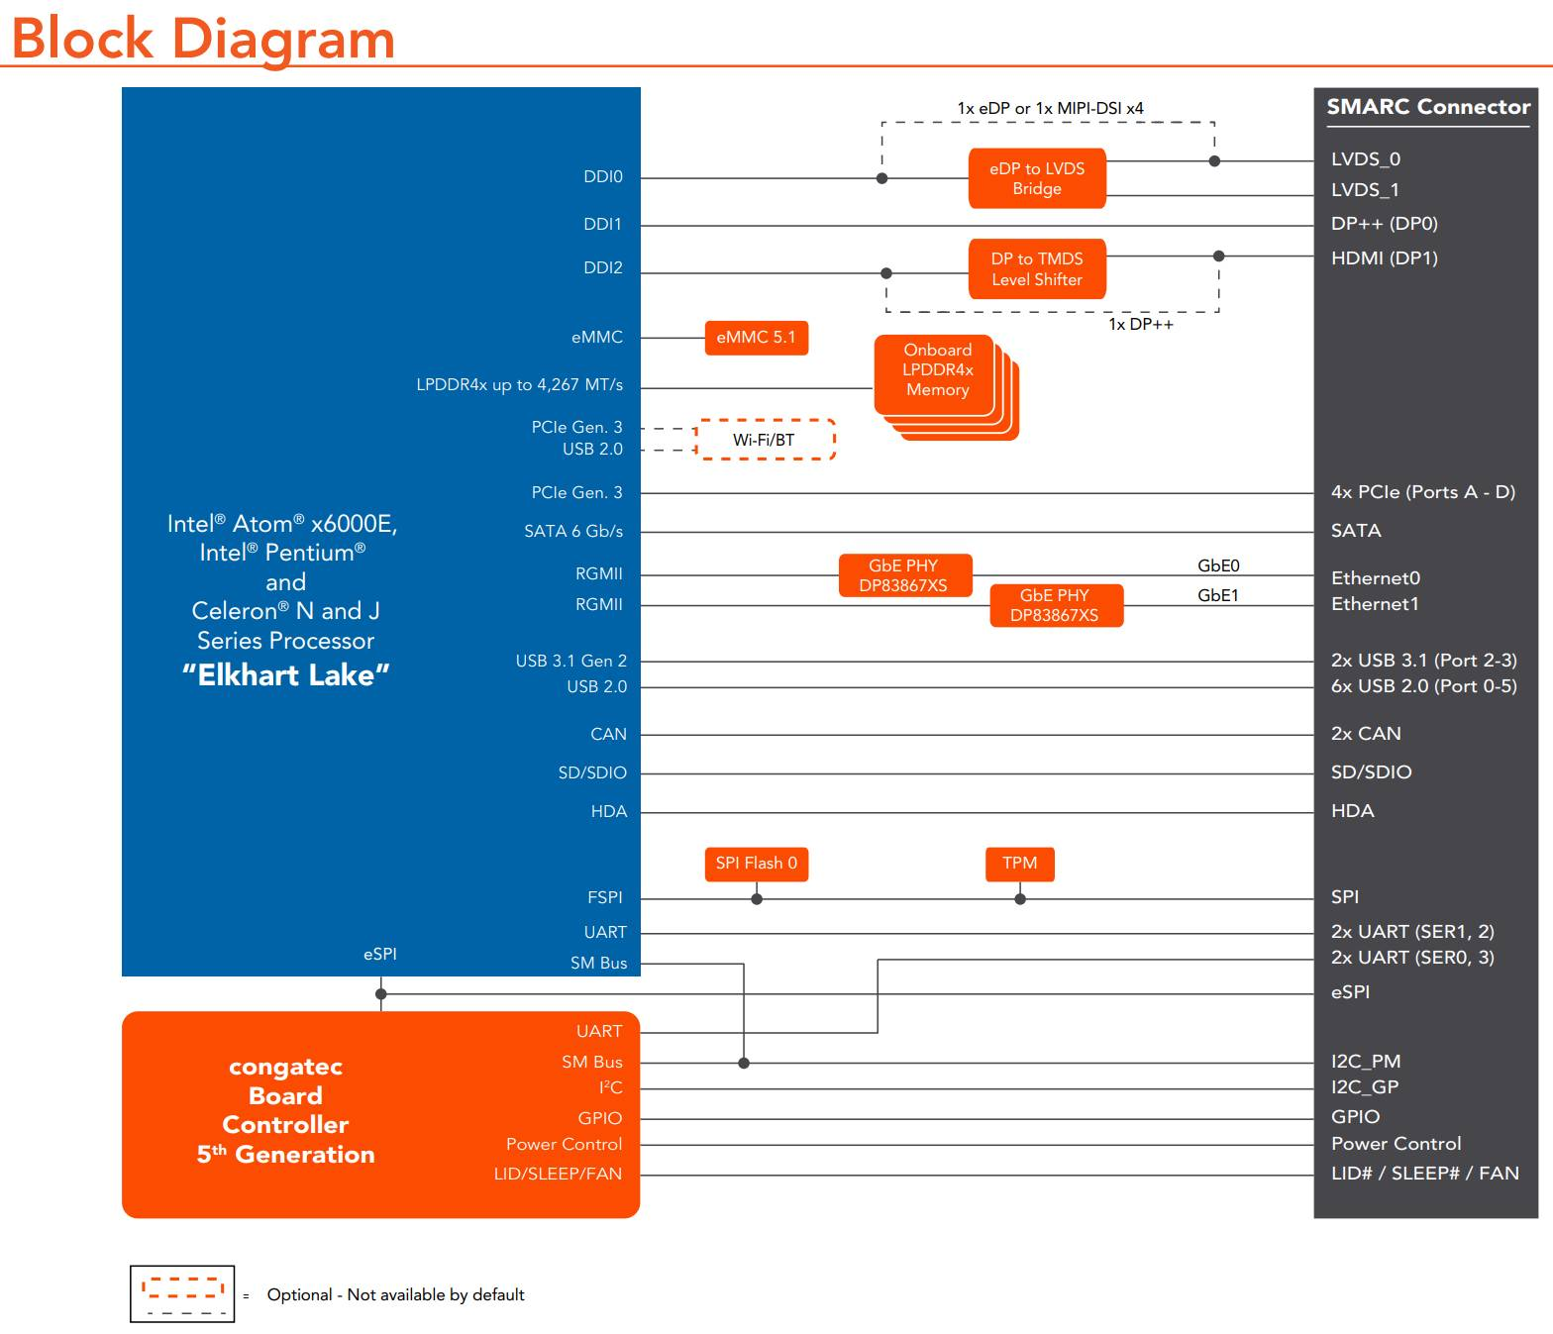
Processor | TDP | Cores / Threads | Base Frequency / max. Turbo | Gfx EUs | Intel Use Condition
J6413 | 10W | 4 / 4 | 1.8 GHz / 3.0 GHz | 16 EU | PC/Client
J6426 | 10W | 4 / 4 | 2.0 GHz / 3.0 GHz | 32 EU | PC/Client
x6211E | 6W | 2 / 2 | 1.3 GHz / 3.0 GHz | 16 EU | Embedded
x6413E | 9W | 4 / 4 | 1.5 GHz / 3.0 GHz | 16 EU | Embedded
x6425E | 12W | 4 / 4 | 2.0 GHz / 3.0 GHz | 32 EU | Embedded
x6212RE | 6W | 2 / 2 | 1.2 GHz / — | 16 EU | Industrial
x6414RE | 9W | 4 / 4 | 1.5 GHz / — | 16 EU | Industrial
x6425RE | 12W | 4 / 4 | 1.9 GHz / — | 32 EU | Industrial

