Congatec conga-SA5
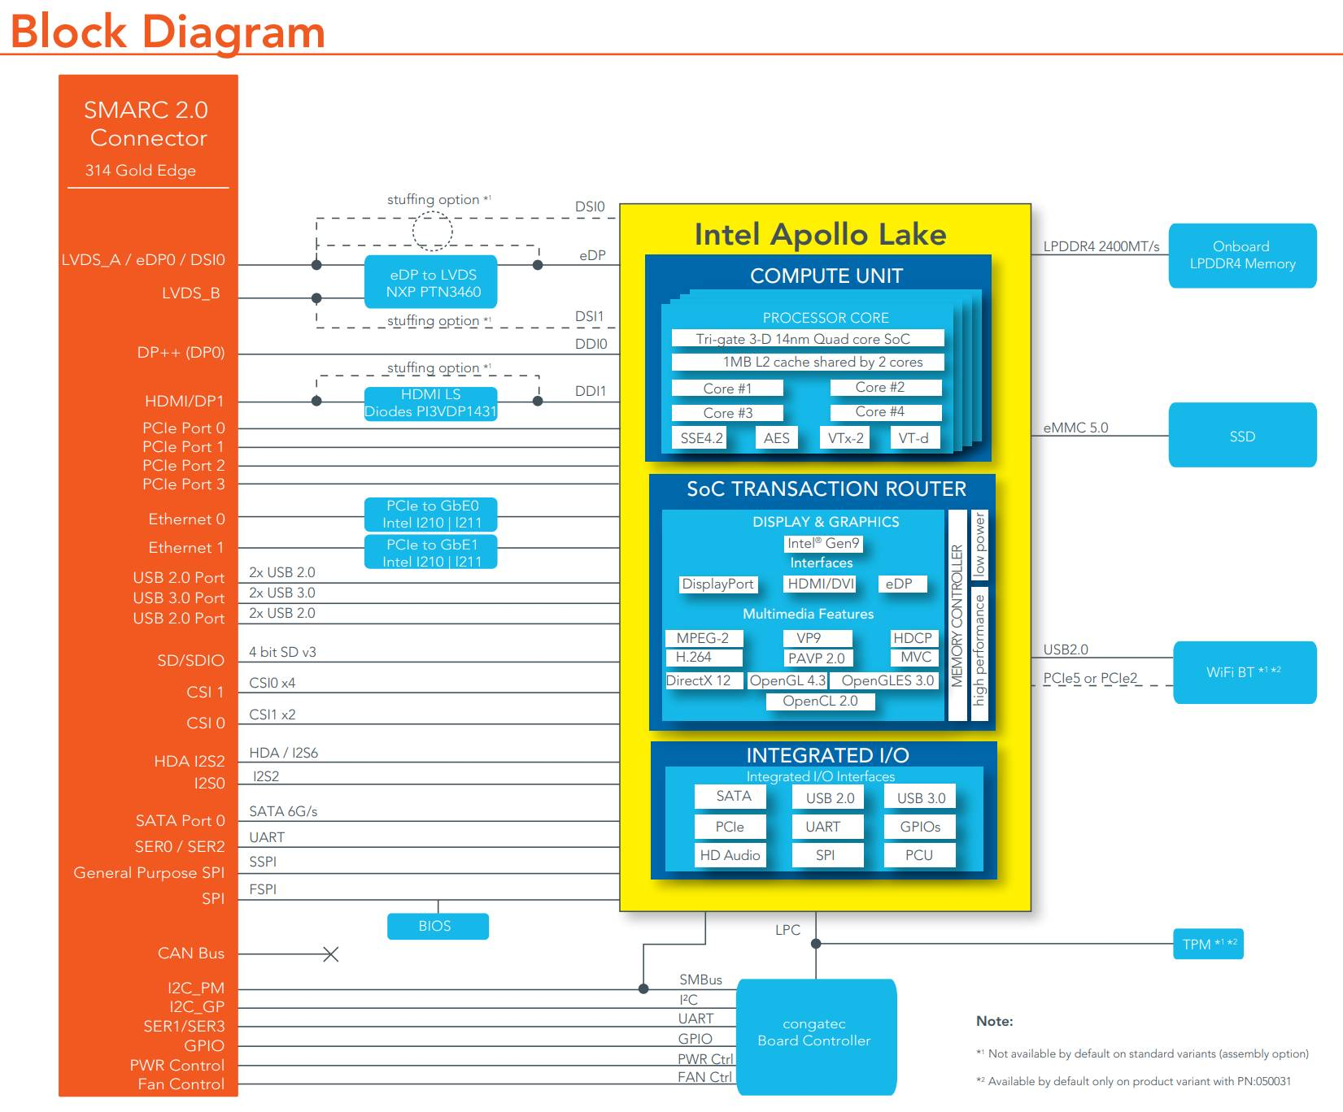
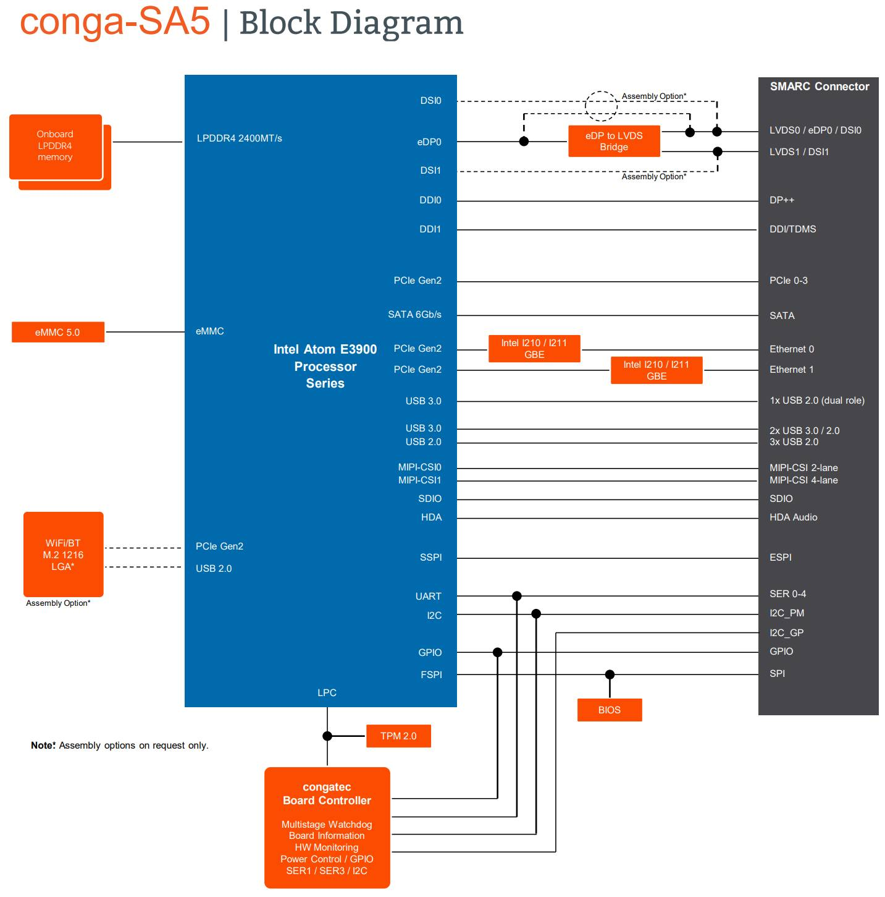
Intel® Atom® x7-E3950 | 2.00 GHz (Burst) | 1.6 GHz Clock | Quad Core | L2 cache 2MB | 12W TDP
Intel® Atom® x5-E3940 | 1.80 GHz (Burst) | 1.6 GHz Clock | Quad Core | L2 cache 2MB | 9W TDP
Intel® Atom® x5-E3930 | 1.80 GHz (Burst) | 1.3 GHz Clock | Dual Core | L2 cache 2MB | 6.5W TDP
Intel® Pentium® N4200 | 2.50 GHz (Burst) | 1.1 GHz Clock | Quad Core | L2 cache 2MB | 6W TDP
Intel® Celeron® N3350 | 2.40 GHz (Burst) | 1.1 GHz Clock | Dual Core | L2 cache 2MB | 6W TDP
Intel® Celeron® J3455 | 2.30 GHz (Burst) | 1.5 GHz Clock | Quad Core | L2 cache 2MB | 10W TDP
Power consumption:


