Congatec Conga-MA7
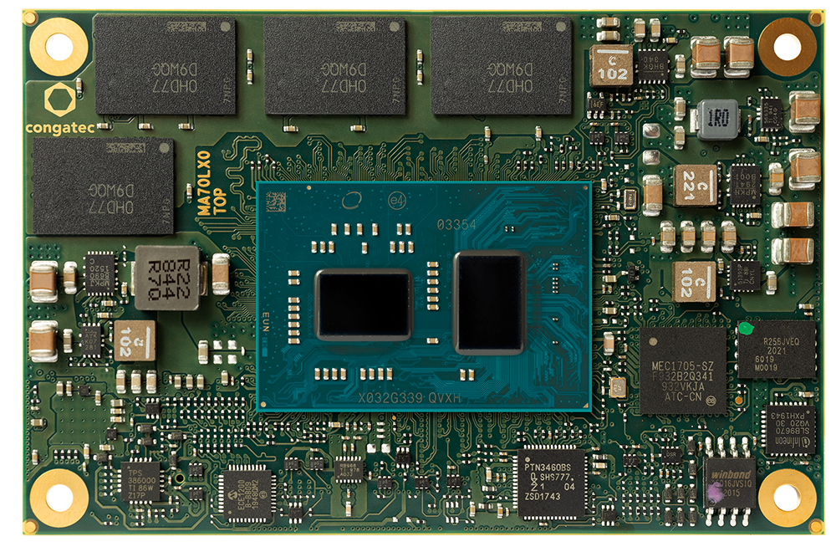 | 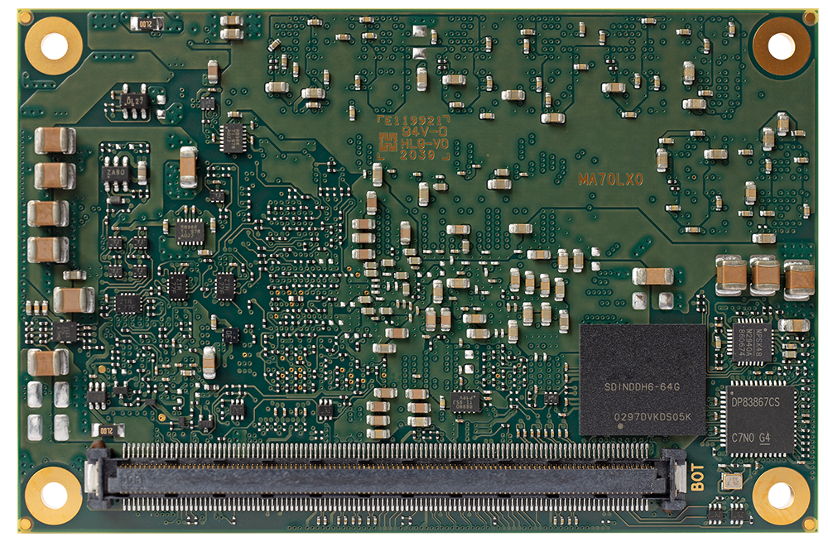
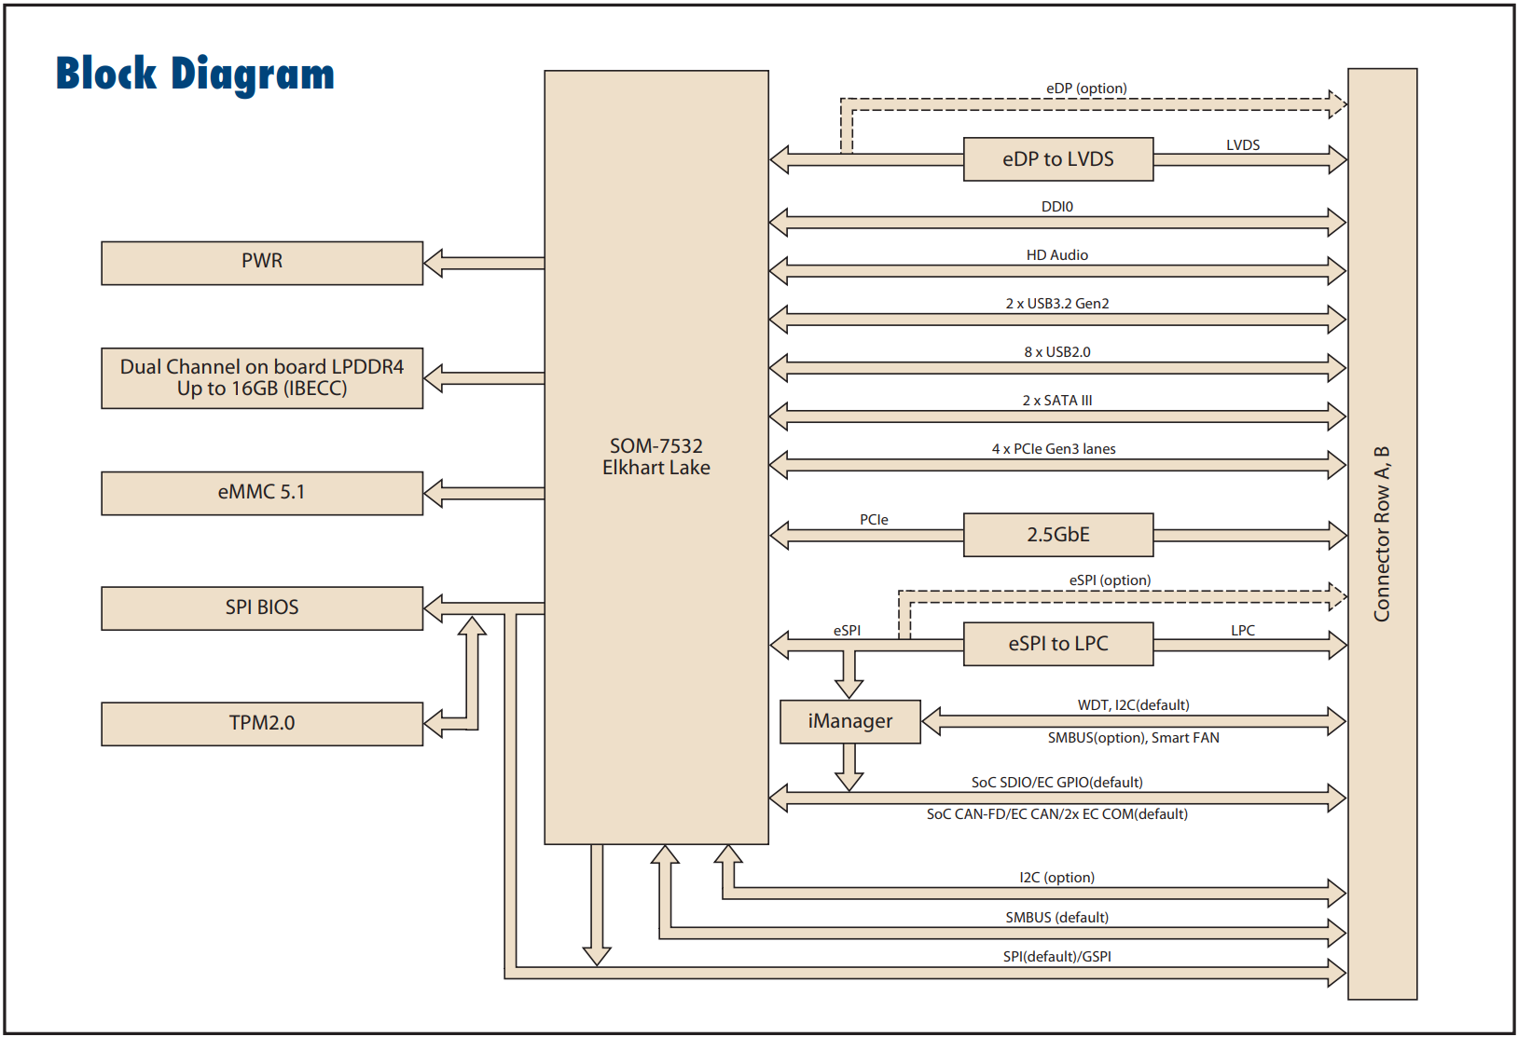

docs
Conga-MA7 | Congatec | SOM flyer | link
Conga-MA7 | Congatec | User Manual | link
ECE1200 | Microchip | eSPI<>LPC | link

LPC
LPC Bus is supported by a eSPI-to-LPC bridge IC

