Advantech SOM-7532
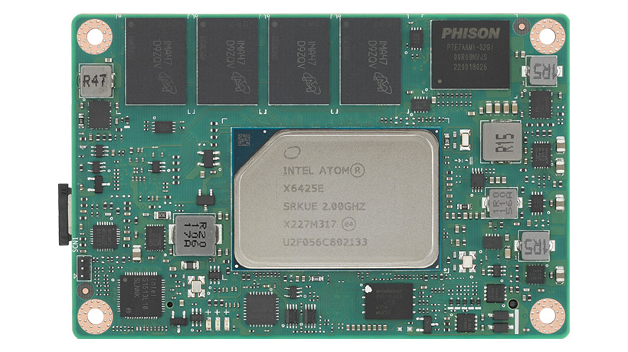 | 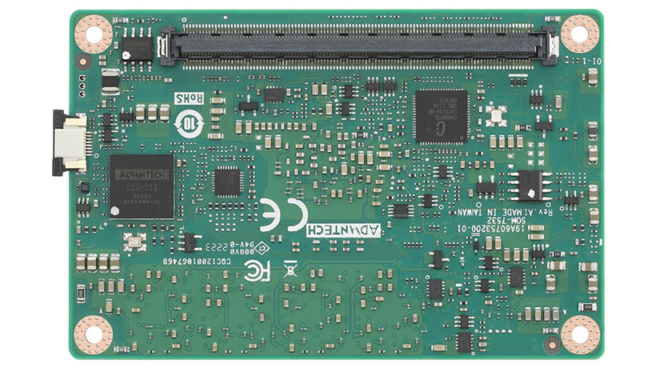
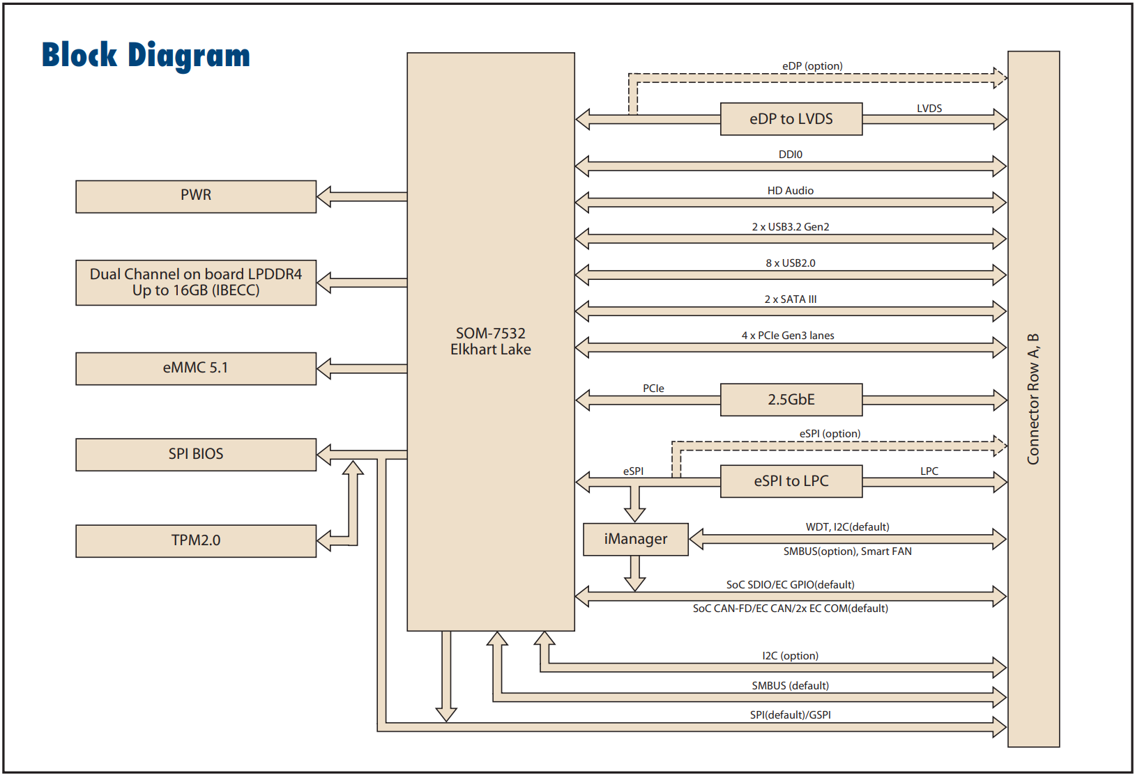

docs
SOM-7532 | Advantech | SOM flyer | link
SOM-7532 | Advantech | User Manual | link
CH7513A | Chrontel | eDP<>LVDS bridge | link
IT5121VG-I-128 | ITE | EC
ECE1200 | Microchip | eSPI<>LPC | link
I225 | Intel | 2.5G Ethernet Controller | link

LPC
LPC Bus is supported by a eSPI-to-LPC bridge IC

