Adlink nanoX-EL
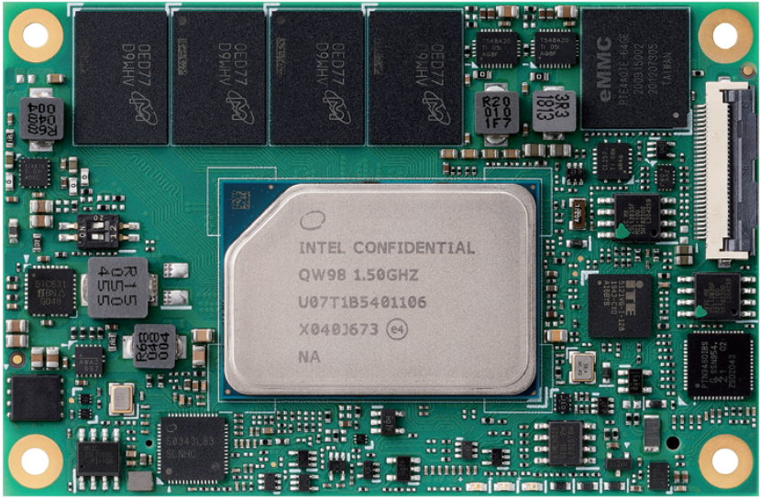 | http://wiki.inmys.ru/start
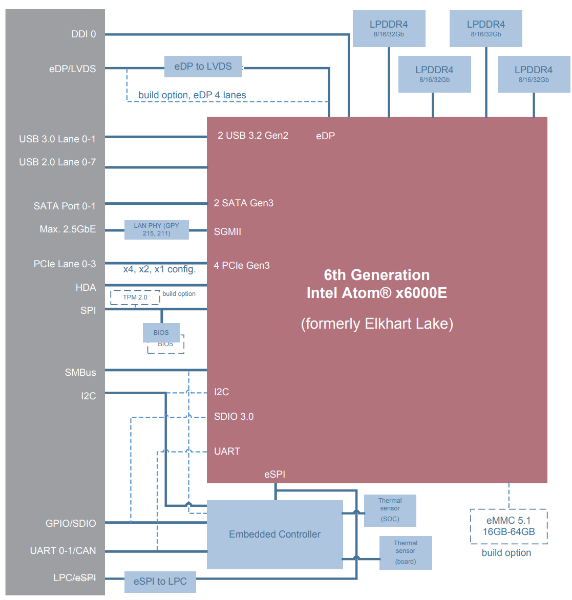

SATA
SATA0 | HSIO 10
SATA1 | HSIO 11

PCIe
PCIE0 | HSIO 2
PCIE1 | HSIO 3
PCIE2 | HSIO 4
PCIE3 | HSIO 5

LPC
LPC_CLK = 24MHz
LPC Bus is supported by a eSPI-to-LPC bridge IC

USB
USB 0 | HSIO 0 | from XHCI controller
USB 1 | HSIO 1 | from XHCI controller

