Security

Manufacturers
Nuvoton
Infineon

TMP Chip
Part name | Interface | TPM ver | Manufacturer | Datasheet | IT link
NPCT650ABAYX | LPC\I2C\SPI | TPM1.2 | Nuvoton | NPCT650ABAYX | IT
NPCT750AADYX | SPI | TPM2.0 | Nuvoton | NPCT750AADYX | IT
SLB9665 (NFND) | LPC | TPM2.0 | Infineon | SLB9665
OPTIGA TPM SLB 9672 FW15 | SPI | TMP2.0 | Infineon | OPTIGA TPM SLB 9672 FW15
OPTIGA TPM SLB 9672 FW16 | SPI | TMP2.0 | Infineon | OPTIGA TPM SLB 9673 FW26
OPTIGA TPM SLB 9673 FW26 | I2C | TMP2.0 | Infineon | OPTIGA TPM SLB 9673 FW26
SLB 9670VQ2.0 | SPI | TMP2.0 | Infineon | SLB 9670VQ2.0
SLI 9670 | SPI | TMP2.0 | Infineon | SLI 9670
SLM 9670 | SPI | TMP2.0 | Infineon | SLM 9670

TMP Module
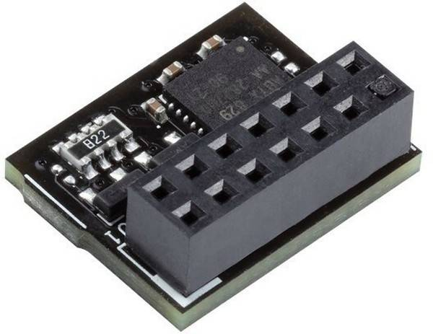 | ASUS | TPM-SPI OEM {20} (210287) / Pin Dimension: 14-1pin | Nuvoton NPCT750
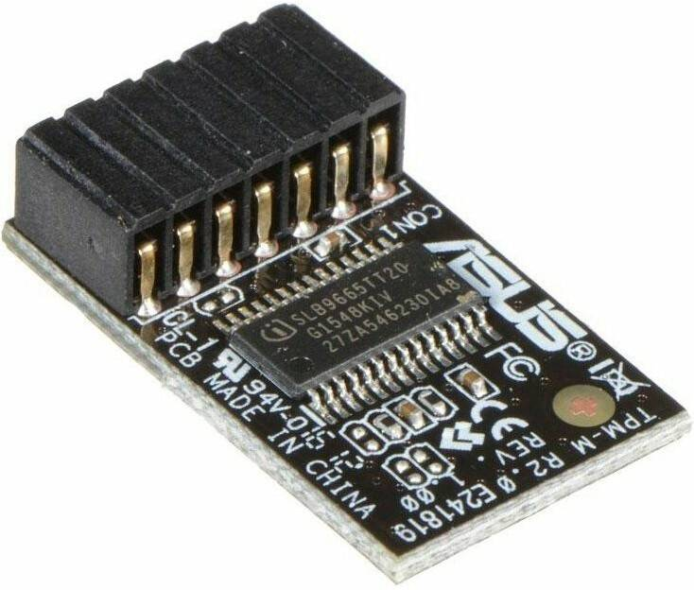 | ASUS | TPM-M R2.0 , OEM {20} (230406) | Infineon SLB9665
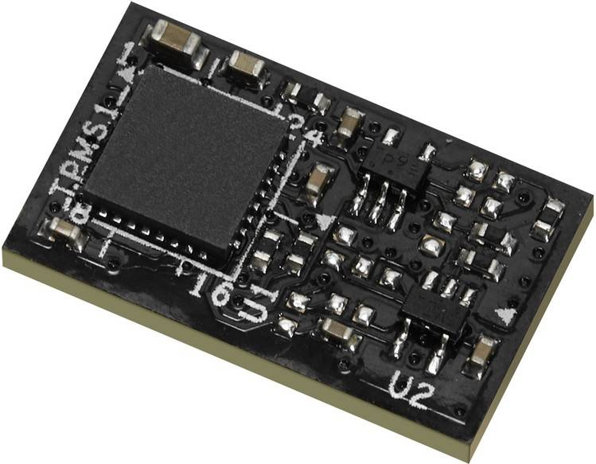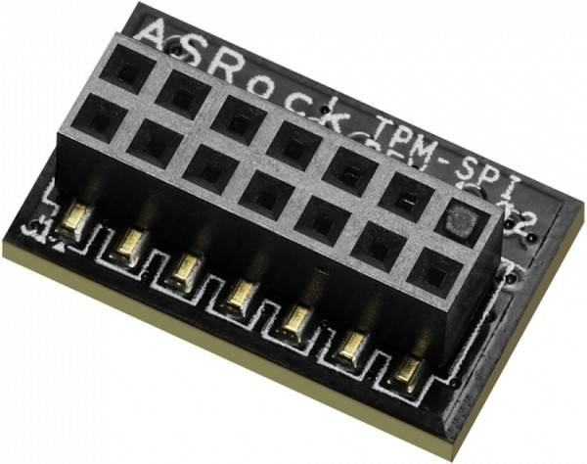 | Asrock | TPM-SPI, SPI interface, TPM 2.0 | Infineon OPTIGA TPM SLB 9670?
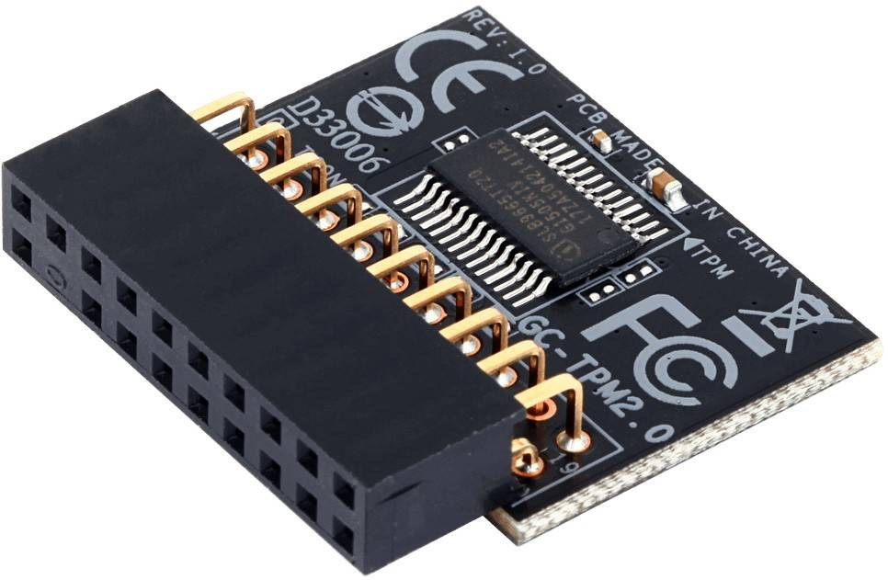 | Gigabyte | GC-TPM2.0, TPM header key, LPC bus, (for Intel 200/100/8/9/99 series, AMD AM4, FM2 series) OEM | Infineon SLB9665


