Processors
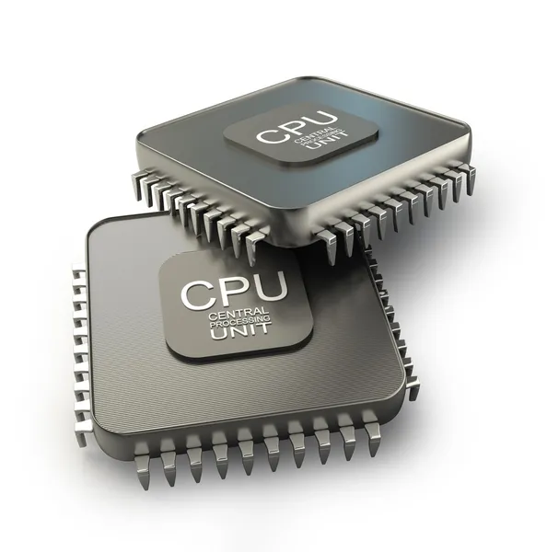

Manufacturers
Байкал | https://www.baikalelectronics.ru/
Миландр | https://www.milandr.ru/
НИИСИ РАН | https://www.niisi.ru/devel.htm | Комдив, К5500ВК018
Элвис | https://elvees.ru/
Rockchip | https://www.rock-chips.com/a/en/index.html
Hangshun | https://www.hsxp-hk.com/ | Аналоги STM32 - HK32
NXP | https://www.nxp.com/ | blocked
TI | https://www.ti.com/
Nuvoton | https://www.nuvoton.com/

