Rockchip RV1103 RV1106

Overview
boot | https://opensource.rock-chips.com/wiki_Boot_option
rkbin | https://github.com/rockchip-linux/rkbin/blob/master/RKBOOT/RV1106MINIALL_EMMC_TB.ini
rkdeveloptool | https://opensource.rock-chips.com/wiki_Rkdeveloptool
rockusb | https://opensource.rock-chips.com/wiki_Rockusb
boot\emmc\u-boot\… | https://blog.csdn.net/qq_28877125/article/details/132999147
sdcard + sdio | https://blog.csdn.net/qq_28877125/article/details/133634104
sdcard boot | https://wiki.luckfox.com/Luckfox-Pico/Luckfox-Pico-Plus-SD
luckfox download | https://wiki.luckfox.com/Luckfox-Pico/Datasheets/
luckfox info | https://www.spotpear.com/index/study/detail/id/1100.html
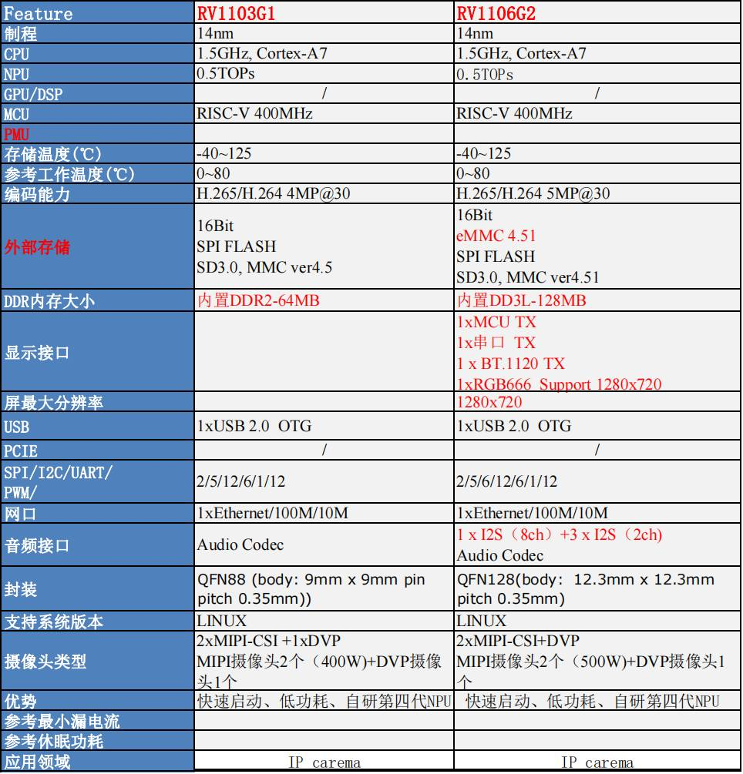

Boot
Boot from SPI flash means firmware for stage 2 and 3(SPL and U-Boot only) in SPI flash and stage 4/5 in other place;
Конспект U-Boot v2017 (next-dev) Development Guide

Struct

Docs
link | ext | description | version | date | lang

Pinout RV1103G1
Pin Name | Pin | Bank | Group
MIPI_CLK0_OUT/GPIO3_C4_d | 1 | GPIO3
GPIO3_C5_d | 2 | GPIO3
PWM7_IR_M2/MIPI_CLK1_OUT/GPIO3_C6_d | 3 | GPIO3
I2C4_SCL_M2/UART5_TX_M2/GPIO3_C7_d | 4 | GPIO3
I2C4_SDA_M2/UART5_RX_M2/GPIO3_D0_d | 5 | GPIO3
DVDD_1 | 6 | CORE | PWR
GPIO4_VCC3V3 | 7 | GPIO4 | PWR
SDMMC0_DET/GPIO3_A1_u | 8 | GPIO3
SDMMC0_D1/UART2_TX_M0/PWM9_M0/GPIO3_A2_u | 9 | GPIO3
SDMMC0_D0/UART2_RX_M0/PWM8_M0/GPIO3_A3_u | 10 | GPIO3
SDMMC0_CLK/UART5_RTSN_M0/I2C0_SCL_M2/PWM10_M0/GPIO3_A4_d | 11 | GPIO3
SDMMC0_CMD/UART5_CTS_M0/I2C0_SDA_M2/PWM11_IR_M0/GPIO3_A5_u | 12 | GPIO3
SDMMC0_D3/UART5_TX_M0/JTAG_CPU_TMS_M0/JTAG_HPMCU_TMS_M1/GPIO3_A6_u | 13 | GPIO3
SDMMC0_D2/UART5_RX_M0/JTAG_CPU_TCK_M0/JTAG_HPMCU_TCK_M1/GPIO3_A7_u | 14 | GPIO3
SARADC_IN1/PWM1_M1/GPI4_C1_z | 15 | GPI4
SARADC_IN0/GPI4_C0_z | 16 | GPI4
SARADC_USB_AVDD1V8 | 17 | USB | PWR
USB_DM | 18 | USB | USB
USB_DP | 19 | USB | USB
USB_AVDD3V3 | 20 | USB | PWR
CODEC_LINEOUT | 21 | CODEC | AUDIO
CODEC_VCM | 22 | CODEC | AUDIO
CODEC_AVDD1V8 | 23 | CODEC | AUDIO
CODEC_MIC0P_MICP | 24 | CODEC | AUDIO
CODEC_MICBIAS | 25 | CODEC | AUDIO
CODEC_MIC1P_MICN | 26 | CODEC | AUDIO
GPIO3_VCC | 27 | GPIO3 | PWR
FSPI_D3/GPIO4_A6_u | 28 | GPIO4
FSPI_D0/GPIO4_A4_u | 29 | GPIO4
FSPI_D1/GPIO4_A3_u | 30 | GPIO4
FSPI_D2/GPIO4_A2_u | 31 | GPIO4
FSPI_CS0/GPIO4_B0_u | 32 | GPIO4
FSPI_CLK/GPIO4_B1_d | 33 | GPIO4
DDR_VDDQ_1 | 34 | DDR | PWR
DDR_VDDQ_2 | 35 | DDR | PWR
DVDD_2 | 36 | CORE | PWR
DRAM_ZQ | 37 | DDR | SYS
DDR_PLL_AVDD1V8 | 38 | DDR | PWR
DVDD_3 | 39 | CORE | PWR
DDR_VDDQ_3 | 40 | DDR | PWR
TVSS | 41 |  | PWR
PWR_CTRL_M0/PWM1_M0/GPIO0_A4_d | 42 | GPIO0
PMU_VCC3V3 | 43 |  | PWR
OSC_PLL_PMU_DVDD | 44 | CLK | PWR
OSC_XIN | 45 | CLK | CLK
OSC_XOUT | 46 | CLK | CLK
OSC_AVDD1V8/PLL_AVDD1V8 | 47 | CLK | PWR
PWM0_M0/CPU_AVS/GPIO1_A2_d | 48 | GPIO1
JTAG_CPU_TCK_M1/UART2_TX_M1/JTAG_HPMCU_TCK_M0/GPIO1_B2_d | 49 | GPIO1
JTAG_CPU_TMS_M1/UART2_RX_M1/JTAG_HPMCU_TMS_M0/GPIO1_B3_u | 50 | GPIO1
GPIO1_VCC3V3 | 51 | GPIO1 | PWR
PWM10_M1/UART4_RTSN_M1/GPIO1_C6_d | 52 | GPIO1
PWM11_IR_M1/UART4_CTSN_M1/GPIO1_C7_d | 53 | GPIO1
I2C3_SCL_M1/UART5_TX_M1/PWM11_IR_M2/AUD_DSM_N/GPIO1_D3_d | 54 | GPIO1
I2C3_SDA_M1/UART5_RX_M1/SPI0_CS1_M0/PWM0_M1/AUD_DSM_P/GPIO1_D2_d | 55 | GPIO1
PWM10_M2/UART5_CTS_M1/UART3_RX_M1/GPIO1_D1_d | 56 | GPIO1
PWM3_IR_M2/UART5_RTS_M1/UART3_TX_M1/GPIO1_D0_d | 57 | GPIO1
DVDD_4 | 58 | CORE | PWR
GPIO6_VCC | 59 | GPIO6 | PWR
PWM9_M1/UART4_TX_M1/SDMMC1_D2_M1/GPIO1_C5_d | 60 | GPIO1
PWM8_M1/UART4_RX_M1/SDMMC1_D3_M1/GPIO1_C4_d | 61 | GPIO1
PWM6_M2/I2C4_SDA_M1/SDMMC1_CMD_M1/SPI0_MISO_M0/GPIO1_C3_d | 62 | GPIO1
PWM5_M2/I2C4_SCL_M1/SDMMC1_CLK_M1/SPI0_MOSI_M0/GPIO1_C2_d | 63 | GPIO1
PWM4_M2/SPI0_CLK_M0/SDMMC1_D0_M1/GPIO1_C1_d | 64 | GPIO1
PWM2_M2/SPI0_CS0_M0/SDMMC1_D1_M1/GPIO1_C0_d | 65 | GPIO1
OTP_AVDD1V8/ETH_AVDD1V8/TSADC_AVDD1V8 | 66 |  | PWR
ETH_PHY_RXN | 67 | ETH | ETH
ETH_PHY_RXP | 68 | ETH | ETH
ETH_PHY_TXN | 69 | ETH | ETH
ETH_PHY_TXP | 70 | ETH | ETH
ETH_AVDD3V3 | 71 | ETH | PWR
ETH_EXTR | 72 | ETH | ETH
DVDD_5 | 73 | CORE | PWR
CPU_DVDD | 74 | CORE | PWR
DVDD_6 | 75 | CORE | PWR
MIPI_CSI_RX_D3N/LVDS_RX_D3N/GPI3_B0_d | 76 | GPI3
MIPI_CSI_RX_D3P/LVDS_RX_D3P/GPI3_B1_d | 77 | GPI3
MIPI_CSI_RX_CK1N/LVDS_RX_CK1N/GPI3_B2_d | 78 | GPI3
MIPI_CSI_RX_CK1P/LVDS_RX_CK1P/GPI3_B3_d | 79 | GPI3
MIPI_CSI_RX_D2N/LVDS_RX_D2N/GPI3_B4_d | 80 | GPI3
MIPI_CSI_RX_D2P/LVDS_RX_D2P/GPI3_B5_d | 81 | GPI3
MIPI_CSI_RX_D1N/LVDS_RX_D1N/GPI3_B6_d | 82 | GPI3
MIPI_CSI_RX_D1P/LVDS_RX_D1P/GPI3_B7_d | 83 | GPI3
MIPI_CSI_RX_CK0N/LVDS_RX_CK0N/GPI3_C0_d | 84 | GPI3
MIPI_CSI_RX_CK0P/LVDS_RX_CK0P/GPI3_C1_d | 85 | GPI3
MIPI_CSI_RX_D0N/LVDS_RX_D0N/GPI3_C2_d | 86 | GPI3
MIPI_CSI_RX_D0P/LVDS_RX_D0P/GPI3_C3_d | 87 | GPI3
MIPI_AVDD1V8/GPIO7_VCC1V8 | 88 | GPIO7 | PWR
VSS | E-PAD |  | PWR

