Rockchip RK3568

Overview
RK3568 page:
- Quad-core Cortex-A55 up to 2.0GHz
- Mali-G52 GPU
- LPDDR4/LPDDR4X/DDR4/DDR3/DDR3L/LPDDR3, ECC
- 4KP60 H.265/H.264/VP9 video decoder
- 1080P60 H.264/H.265 video encoder
- 8M ISP with HDR
- Dual dislplay, LVDS/MIPI-DSI/RGB/eDp/RGB/HDMI2.0/T-CON
- 1x8ch I2S/TDM, 1x8ch PDM, 2x2ch I2S
- USB3.0 x2/SATA3.0 x3/PCIE2.1/QSGMII
- PCIE3.0 1x2Lanes/2x1Lane

Struct
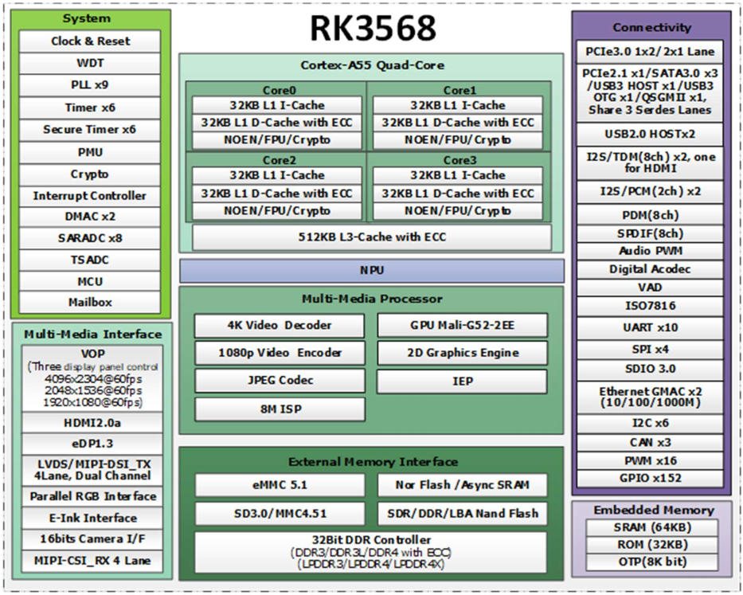

Thermal
- Commercial device RK3568:
  - Absolute Ratings:
    - Storage Temperature - Tstg -40…125 ℃
    - Max Conjunction Temperature - Tj 125 ℃
  - Recommended Operating Condition:
    - Ambient Operating Temperature TA 0…80 ℃
  - Package Thermal Characteristics:
    - The testing PCB is 4 layers, 114.3mmx101.6mm, 1.6mm thickness, Ambient temperature is 25℃.
    - Junction-to-ambient thermal resistance 𝜽𝑱𝑨 15.925 (℃/𝑾)
    - Junction-to-board thermal resistance 𝜽𝑱𝑩 10.813 (℃/𝑾)
    - Junction-to-case thermal resistance 𝜽𝑱𝑪 0.487 (℃/𝑾)
- Industrial device RK3568J:
  - Absolute Ratings:
    - Storage Temperature - Tstg -40…125 ℃
    - Max Conjunction Temperature - Tj 125 ℃
  - Recommended Operating Condition:
    - Ambient Operating Temperature TA -40…85 ℃
  - Package Thermal Characteristics:
    - The testing PCB is 4 layers, 114.3mmx101.6mm, 1.6mm thickness, Ambient temperature is 25℃.
    - Junction-to-ambient thermal resistance 𝜽𝑱𝑨 15.5 (℃/𝑾)
    - Junction-to-board thermal resistance 𝜽𝑱𝑩 11.3 (℃/𝑾)
    - Junction-to-case thermal resistance 𝜽𝑱𝑪 2.43 (℃/𝑾)

Docs
link | ext | description | version | date | lang
RK3568_Methods for Processing Unused Pins_V10_20201218_CN.xlsx | xlsx | Что делать с неиспользуемыми выводами | V1.0 | 2020.12.18 | CN
RK3568_Package_PinLength_V1.0_20200917_EN.xlsx | xlsx | Длины проводников в корпусе table | V1.0 | 2020.09.17 | EN
RK3568_PinOut_V1.0_20201230_EN.xlsx | xlsx | RK3568 PinOut | V1.0 | 2020.12.30 | EN
RK3568_PinOut_V1.1_20210202.xlsx | xlsx | RK3568 Pinout | V1.1 | 2021.02.02
Rockchip RK3568 Datasheet V1.0-20201210.pdf | pdf | RK3568 Datasheet | V1.0 | 2020.12.10
Rockchip RK3568 Datasheet V1.2-20210601.pdf | pdf | RK3568 Datasheet | V1.2 | 2021.06.01
Rockchip RK3568 TRM Part1 V1.1-20210301.pdf | pdf | RK3568 TRM Part 1 | V1.1 | 2021.03.01
Rockchip RK3568 TRM Part2 V1.1-20210301.pdf | pdf | RK3568 TRM Part 2 | V1.1 | 2021.03.01
RK3568_AIoT_REF_SCH_V10_20210204.DSN | DSN | Схема ref design AIoT (ORCAD) | V1.0 | 2021.02.04
RK3568_AIoT_REF_SCH_V10_20210204.pdf | pdf | Схема ref design AIoT (pdf) | V1.0 | 2021.02.04
RK3568_AIOT_REF_SCH_V10_20210204-162.DSN | DSN | Схема ref design AIoT (ORCAD) - Непонятно чем отличающаяся | V1.0 | 2021.02.04

PCB routing
RockChip ref design: 0.035u\0.082 prepreg Dk4.5
impedance | w | s | Impedance | Comment
SE? | 3.5 mil |  | ??? Ohm | BGA breakout
SE? | 4 mil |  | ??? Ohm | LPDDR4, RGMII, EMMC
SE? | 6 mil |  | ??? Ohm | XTAL
DIFF100? | 3.8 mil | 6mil | ??? Ohm | LPDDR4, CSI, DSI, eDP, MDI, HDMI
DIFF85? | 4.7 mil | 4mil | ??? Ohm | PCIe 3.0
DIFF90? | 4 mil | 4mil | ??? Ohm | SATA, USB3 SS, USB2
0201 - 0.25×0.3×0.3

Boot
Support system boot from the following device:
- Serial Nor Flash, 1bit or 4bits data width(device layout in FSPI IO)
- Serial Nand Flash, 1bit data width(device layout in FSPI IO)
- Asynchronous Flash Interface, 8bits data width
- eMMC Interface, 8bits data width
- SDMMC Card, 4bits data width
- Support system code download by USB OTG
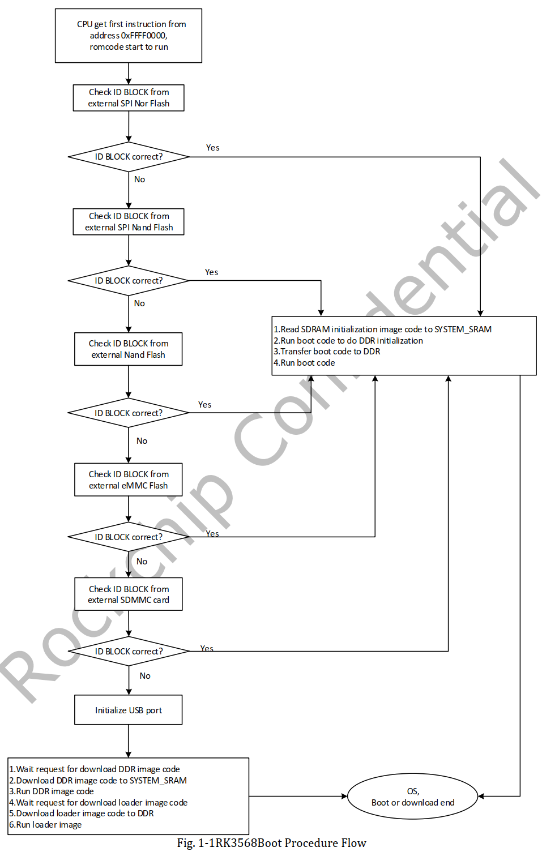
https://roc-rk3328-cc.readthedocs.io/en/latest/flash_emmc.html
https://wiki.t-firefly.com/en/ROC-RK3568-PC/01-bootmode.html
Есть 2 режима для записи eMMC - RockChip USB mode и Maskrom USB mode:
- RockChip USB mode
  - работает, если работает bootloader и SARADC0 == 0 ????
- Maskrom USB mode.
  - работает, если ничего не работает, и D0 (или Clock) bootmedia закорочен на землю
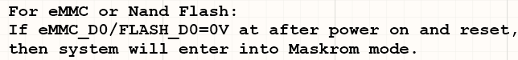
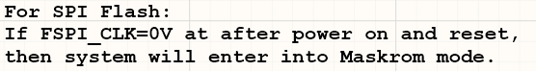
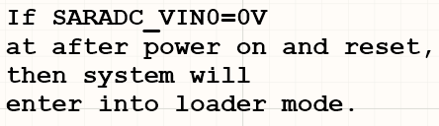
http://opensource.rock-chips.com/wiki_Boot_option#Boot_flow

