eMMC

Manufacturers
P\N | MFG | Dens | CASE | Interface | Memory | Struct | Link
KLM8G1GETF-B041 | SAMSUNG | 8GB | 153FBGA | VDD (1.70V ~ 1.95V or 2.7V ~ 3.6V) | VDDF (2.7V ~ 3.6V) | 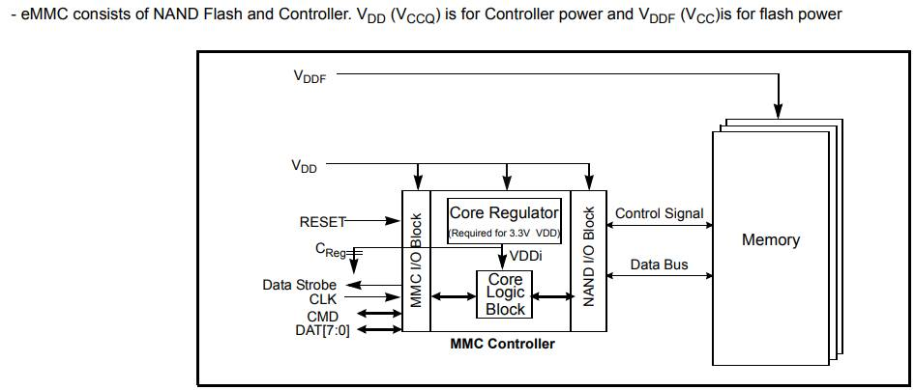 | link
KLMAG1JETD-B041 | SAMSUNG | 16GB | 153FBGA | VDD (1.70V ~ 1.95V or 2.7V ~ 3.6V) | VDDF (2.7V ~ 3.6V) |  | link
KLMBG2JETD-B041 | SAMSUNG | 32GB | 153FBGA | VDD (1.70V ~ 1.95V or 2.7V ~ 3.6V) | VDDF (2.7V ~ 3.6V) |  | link
KLMCG4JETD-B041 | SAMSUNG | 64GB | 153FBGA | VDD (1.70V ~ 1.95V or 2.7V ~ 3.6V) | VDDF (2.7V ~ 3.6V) |  | link
THGAMRG7T13BAIL | KIOXIA | 16GB | 153FBGA | VCCQ = 1.7V to 1.95V | VCC = 2.7V to 3.6V | 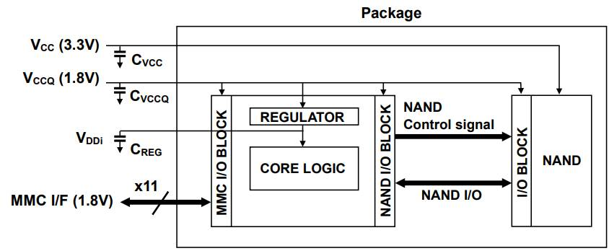 | link
THGBMNG5D1LBAIL | KIOXIA | 4GB | 153FBGA | VCCQ = 1.7V to 1.95V / 2.7V to 3.6V | VCC = 2.7V to 3.6V | 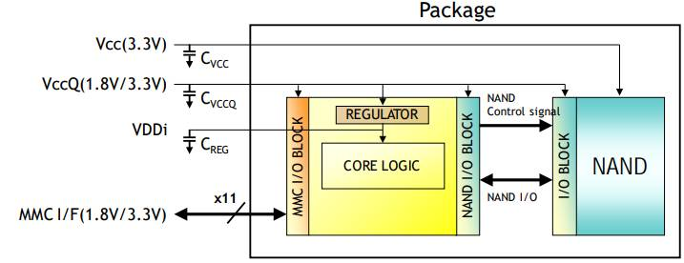 | link

