Inductors

Manufacturers
https://www.coilmaster.com.tw/ | Coilmaster |  |  | Гамма
https://www.codaca.com/ | Codaca |  |  | Гамма
https://www.vishay.com/inductors/ | Vishay
https://www.chinafronter.com/ | chinafronter
https://bec-shop.ru/catalog/transformatory-i-induktivnye-elementy/induktivnosti/ | БЭК
https://www.shareway-tech.com/
https://www.promelec.ru/product/376102/ | Shinhom
https://www.promelec.ru/product/70147/ | CHANGZHOU
https://www.promelec.ru/product/342116/ | Bourns
https://www.promelec.ru/product/384838/ | Chilisin
https://ru.leiditech.com/ | leidtech
Cross-Referense from Coilmaster

Small Signal

RF

Power

Common Choke

Ferrite Bead

Transformers
http://www.magneton.ru/cat.php?id=165
LinkPP | LP2019ANL | 100M | 1 | POE | -40…85 | 0.72A | ~0.35$ | 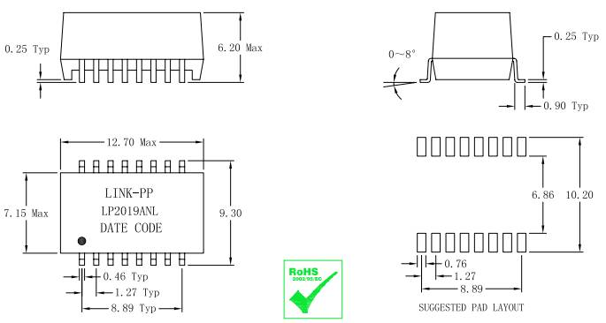 | https://sds.compel.ru/item-pdf/a8f5b7970538f75a4070b846a1a5e0bd/pn/link-pp~lp2019anl.pdf
LinkPP | LP5018ANL | 100M | 4 | POE | -40…85 | 0.6A | ~1$ |  | https://sds.compel.ru/item-pdf/66e102b23e163327b16c1542cca6aaaa/pn/link-pp~lp5018anl.pdf
HanRun | HY601742 | 100M | 1 | POE | ? | ? | ~1$ | 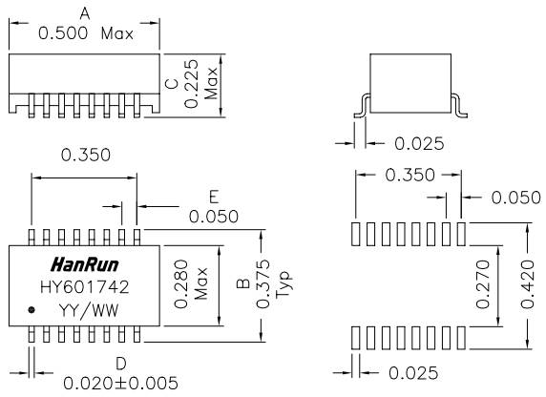 | https://sds.compel.ru/item-pdf/fef330fc0a322a781f9c90db78792956/pn/hanrun~hy601742.pdf
LinkPP | LP1188NL | 100M | 1 | - | -40…85 | - | ~0.25$ |  | https://sds.compel.ru/item-pdf/b6d5f6d7d69bef394f09080948654fae/pn/link-pp~lp1188nl.pdf
LinkPP | LP1102NL | 100M | 1 | - | 0…70 | - | ~0.2$ |  | https://sds.compel.ru/item-pdf/39533f95dc948fe8adc2e17fb68f2e60/pn/link-pp~lp1102nl.pdf

