Heatsink
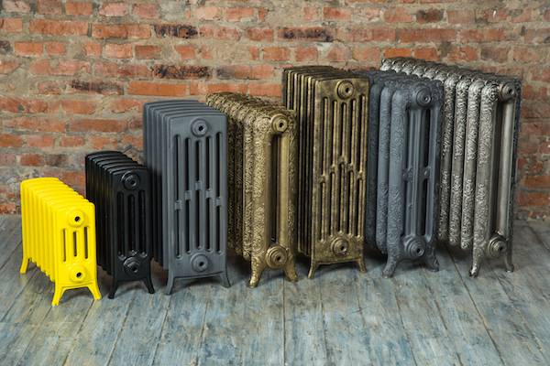

Manufacturers
https://www.supermicro.com/en/support/resources/heatsink | Supermicro | USA
https://www.exegate.ru/catalogue/cooler/ | ExeGate | Taiwan

Models
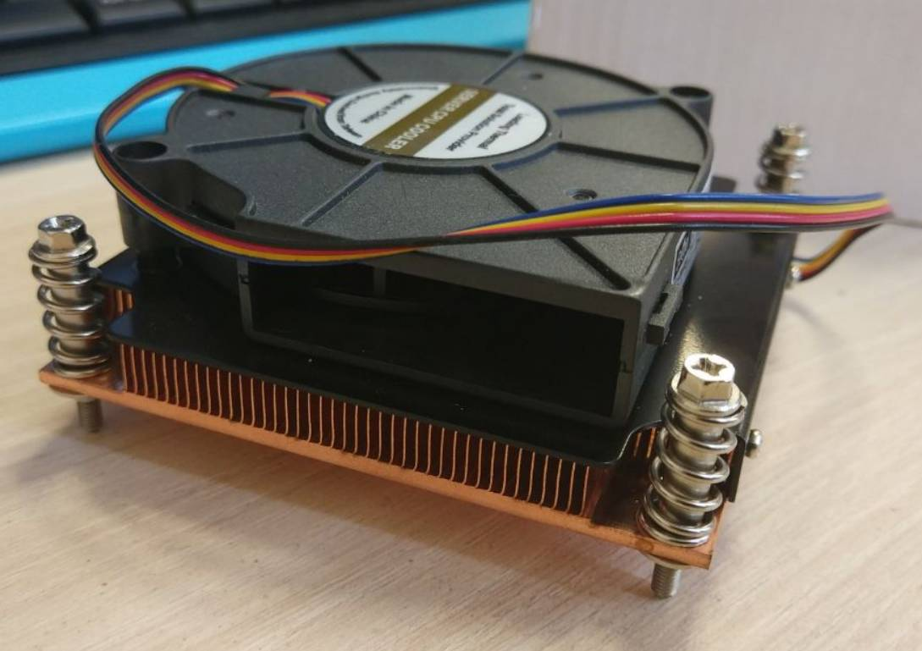 | 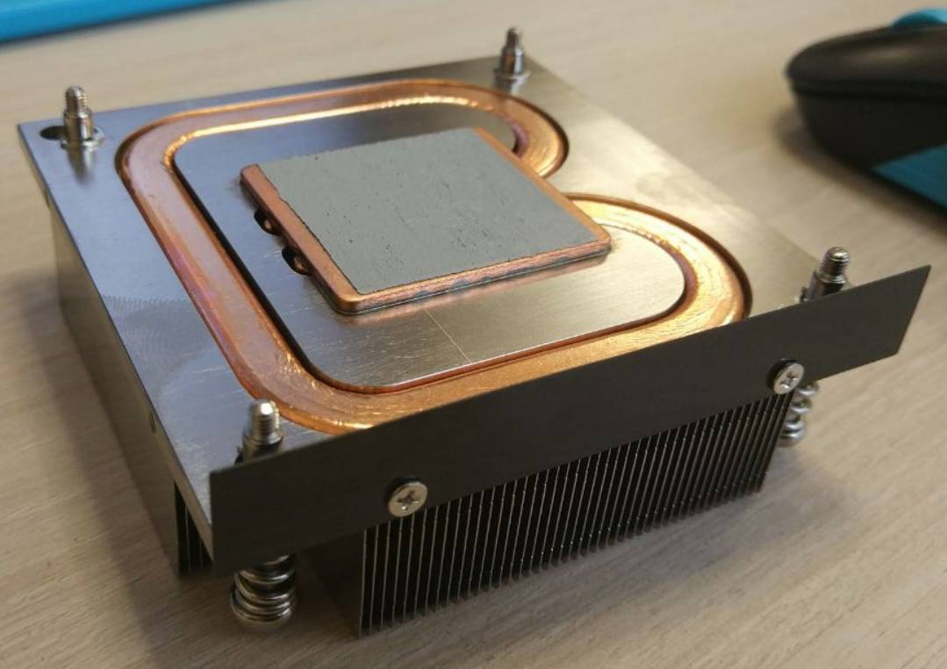 | 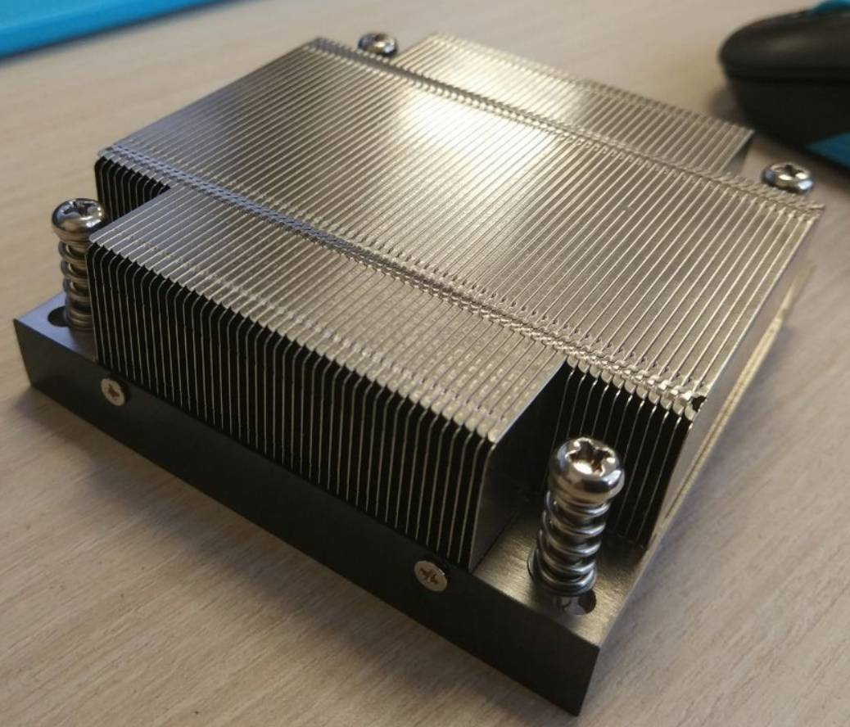
Type | Model | MfgLink | ShopLink | Socket | Perf
1U | SNK-P0046P | Supermicro | Citilink | LGA1151
1U | SNK-P0047PW | Supermicro |  | LGA2011
1U | SNK-P0047P |  | Yandex | LGA2011
1U | ESNK-0046.1U.115x.Cu | ExeGate | Yandex | LGA1151 | 100W
1U | ESNK-0049.PWM.1U.115x.Cu | ExeGate |  | LGA1151 | 115W
На проц 1151 | https://www.dynatron.co/product-page/k129
На проц 1151 | https://www.supermicro.com/en/support/resources/heatsink
На проц 1151 | https://store.supermicro.com/1u-passive-cpu-cooler-snk-p0049p.html
На SPS | https://www.ligra-spb.ru/CAD/AB0290_2.pdf
На PCH | http://www.wakefield-vette.com/Portals/0/wave%20series%20bga%20heat%20sink/Wakefield%20Vette%20Wave%20Series%20Final%20Anchor.pdf

Heatsink LGA115X
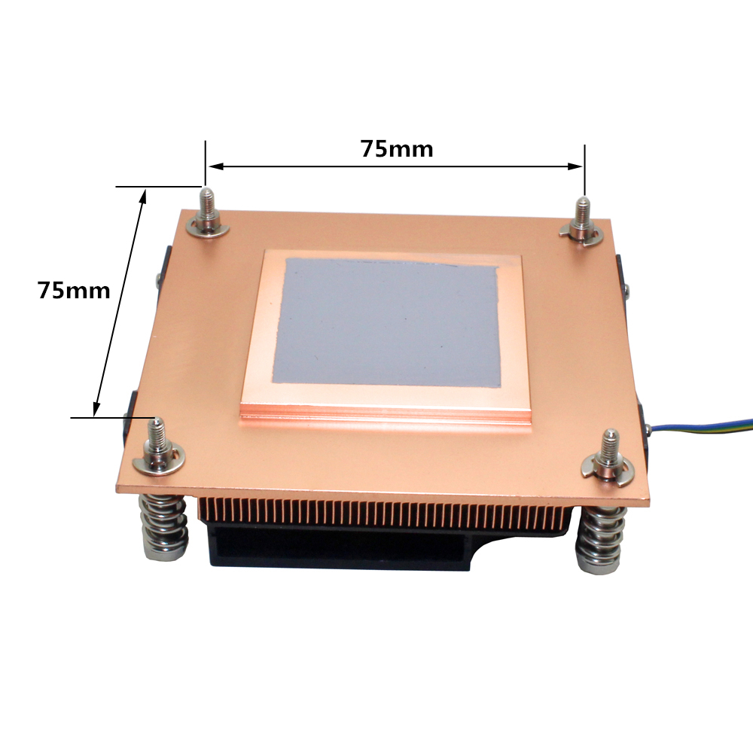 | 

