FPGA Gowin

GW1N
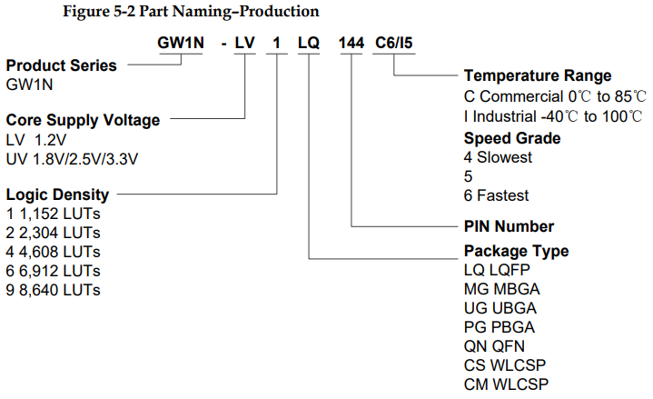
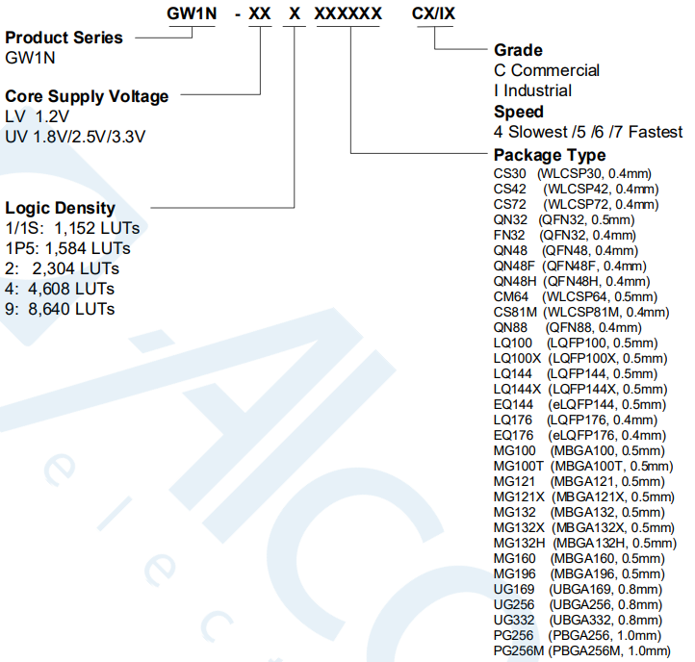
IT link | p\n | LE | case | size | pitch | core | txrx count | txrx sg | txrx speed | temp range | fpga sg | PCIe | Mem cntrl
IT | GW1N-LV4PG256MC5 | 4608 | BGA-256 | 17×17 | 1 | 1.2V | - | - | - | 0…85 | 5 (4 is slowest) | - | -
link | ext | description | manufacturer | version | date | lang
DS100-2.6.2E_GW1N-series-of-FPGA-Products-Data-Sheet.pdf | pdf | DS100 GW1N series of FPGA Products  Data Sheet  DS100-2.6.2E, 07/16/2021  V. 09/21 | Gowin | v2.6.2E | 2021.07.16 | EN
GW1N_series_of_FPGA_Products_Data_Sheet-1830682.pdf | pdf | DS100 GW1N series of FPGA Products  Data Sheet  DS100-1.8E, 07/08/2019 | Gowin | v1.8E | 2019.08.07 | EN
IPUG538-1.0E_Gowin Triple Speed Ethernet MAC User Guide.pdf | pdf | IPUG538 Gowin Triple Speed Ethernet MAC  User Guide  IPUG538-1.0E, 2/20/2019 | Gowin | v1.0E | 2019.02.20 | EN
UG103E.pdf | pdf | UG103 GW1N series of FPGA Products  Package & Pinout User Guide  UG103-2.6E, 01/20/2022 | Gowin | v2.6E | 2022.01.20 | EN
UG107E.pdf | pdf | UG107 GW1N series FPGA Products  GW1N-1 Pinout  UG107-1.1E | Gowin | v1.1E | 2020.02.24 | EN
UG105E.pdf | pdf | UG105 GW1N Series of FPGA Products  GW1N-4 Pinout  UG105-1.8.1E | Gowin | v1.8.1E | 2022.06.10 | EN
UG290E.pdf | pdf | UG290 Gowin FPGA Products  Programming and Configuration Guide  UG290-2.5.1E, 05/10/2022 | Gowin | v2.4.1E | 2022.05.10 | EN
UG289E.pdf | pdf | UG289 Gowin Programmable IO (GPIO)  User Guide  UG289-2.0E, 01/24/2022 | Gowin | v2.0E | 2022.01.24 | EN

