FAN
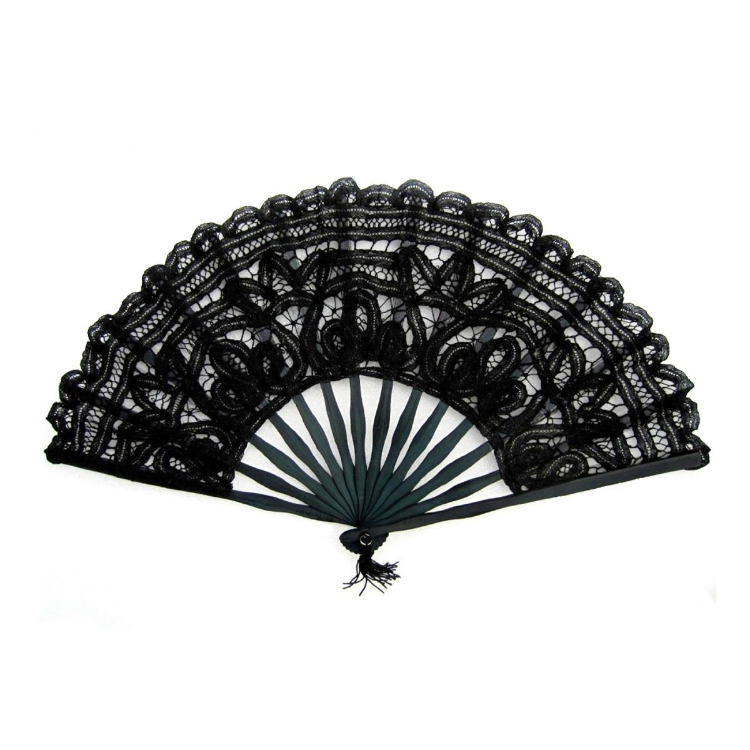

Info
https://landing.coolermaster.com/faq/3-pin-and-4-pin-fan-wire-diagrams/ | Стандартная распиновка 3&4 pin
https://allpinouts.org/pinouts/connectors/motherboards/motherboard-cpu-4-pin-fan/ | Стандартная распиновка 4 pin

Manufacturers
https://products.sanyodenki.com | sanyodenki | Japan

40x40
9GAX0412P3K001 | sanyodenki | 40x40x28mm | 0.92A | 22000 RPM | 28.6 CFM | 3.21 inchH2O
xcom link | supermicro | 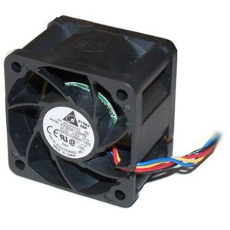 | FAN-0065L4 | 1100р.
supermicro link | supermicro | 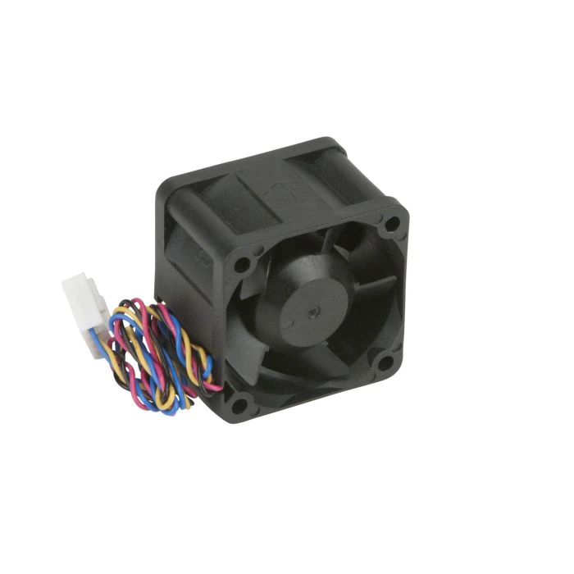 | FAN-0065L4 | 16 USD
Mfg | P\N | img | Img | Comment
AVC | DBTB0428B2S | 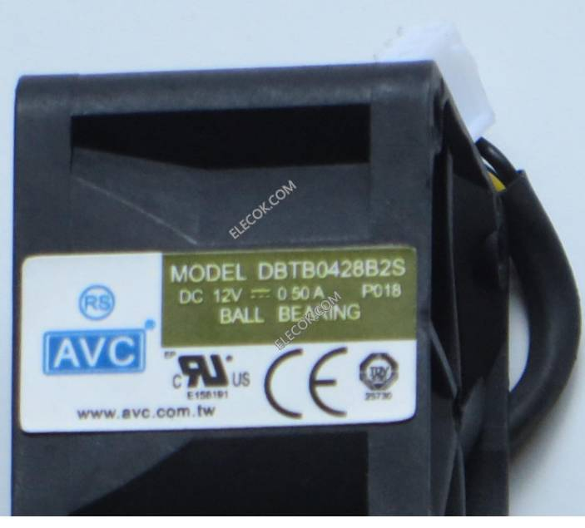 | 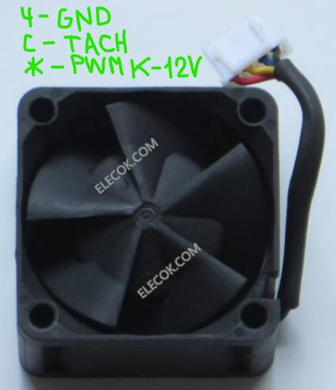 | Синий и жёлтый цвета - функционал не по стандарту!

