LED
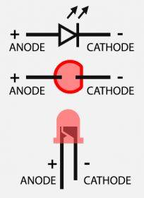

Manufacturers
https://www.proton-orel.ru/ | АО Протон
https://www.luckylight.cn/en/ | LuckyLight | https://www.luckylight.cn/en/products/smd-led/multi-color-smd-led/s195avpgc-2b-g51bm/
 | Wurth
 | Vishay
 | Sharp
 | ParaLight
 | Osram
 | GMKJ
 | ProLight Opto

RGB common anode
SMD 0603 ( 1608 ) RGB Common Anode Led 0603 RGB LED Diode 4-Bin Size:1.6*0.8*0.55mm colorful Red/Green/Blue 1608
https://aliexpress.ru/item/33035649689.html?sku_id=67386016256
Это - неправильно:
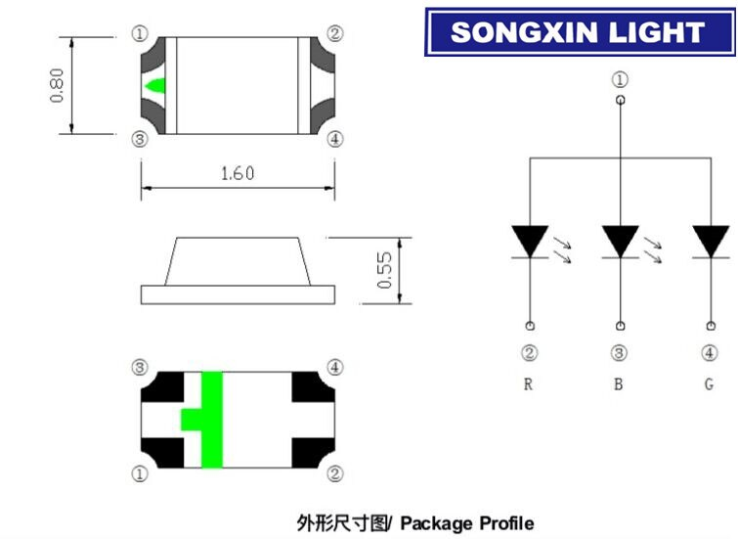
Правильно:
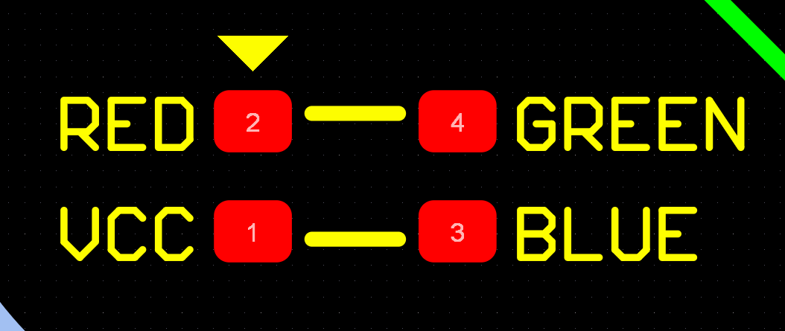

L-937EGW
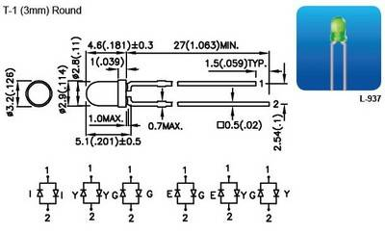

GNL-3012YD
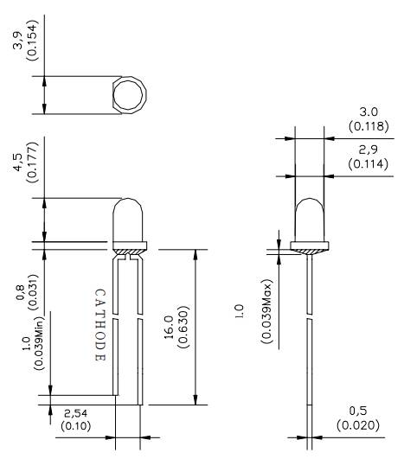

LED IR


