LED
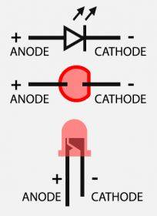

Manufacturers
LuckyLight | link

RGB common anode
SMD 0603 ( 1608 ) RGB Common Anode Led 0603 RGB LED Diode 4-Bin Size:1.6*0.8*0.55mm colorful Red/Green/Blue 1608
https://aliexpress.ru/item/33035649689.html?sku_id=67386016256
Это - неправильно:
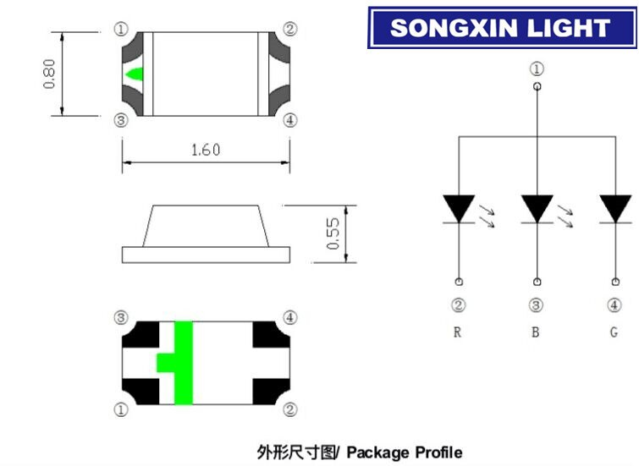
Правильно:
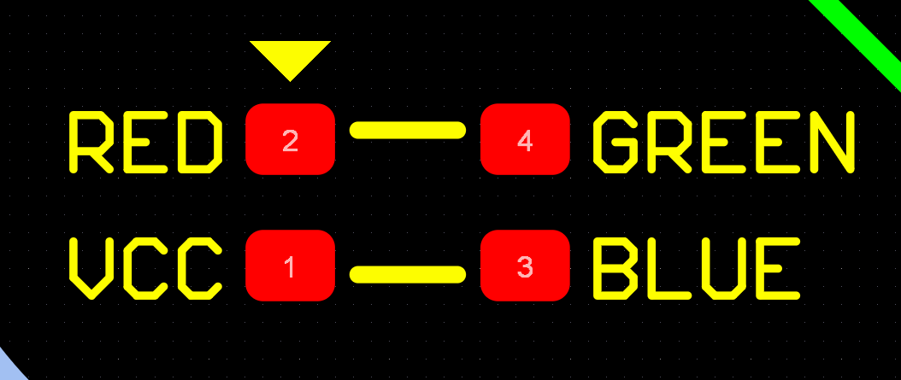

L-937EGW
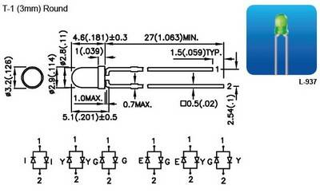

GNL-3012YD
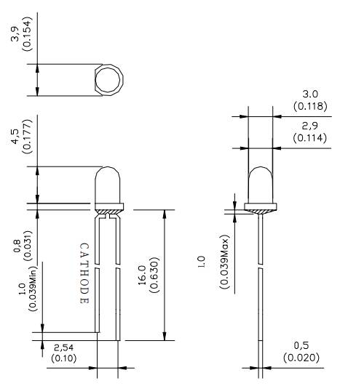

LED IR
HIR67-21C/L289/TR8 | Everlight | link
 | Everlight | table


