Connectors

Manufacturers
https://www.amphenol-cs.com/
https://www.antenk.com/ | China | Antenk
https://edac.net/
https://www.elektrodetal.com/catalog/ | Карачаев |  | Прямоугольные соединители Каталог
http://www.klsele.com/ | China | KLS
https://www.molex.com/molex/home
http://en.ute.com.cn/ | China | UTE | UTE Product List.pdf
http://www.dragoncity.com.hk/dcpoja.html | China | Dragon City
https://gct.co/
https://www.belfuse.com/  https://www.cui.com/ |  | also stewart connector
http://www.starconn.com/ENG/Home.aspx | Taiwan | Starconn
https://www.keyelco.com/index.cfm | USA | Keystone

USB 2.0 Upright (FLAG)
Normal  DS1095-01-W  USB-A1SSW6  292336-1  L-KLS1-191-4P-W | 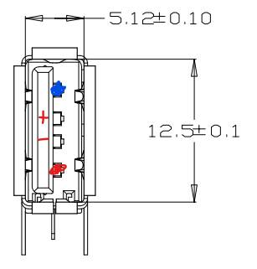 | 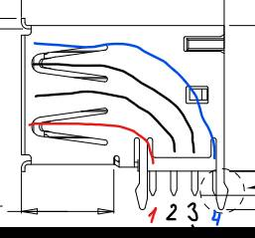 | 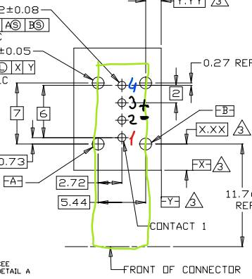
Reversed  48204-0001 | 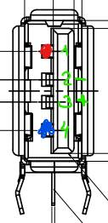 | 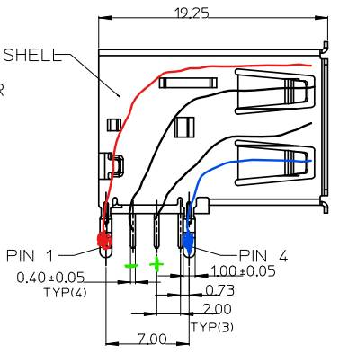 | 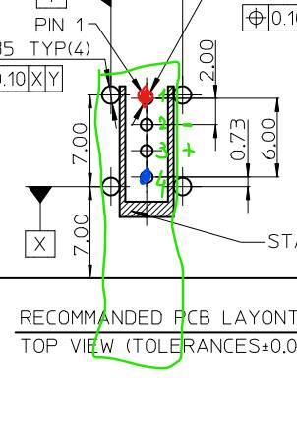 | 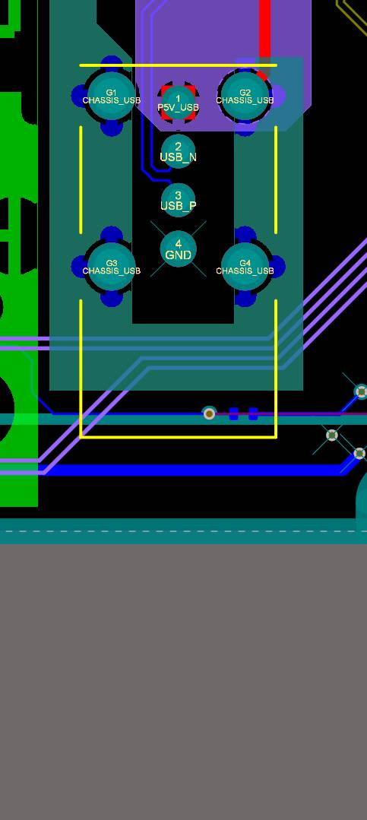

Power Jack
P\N | ID | OD | Current | Voltage | Company
DJK-05D | 1.3 | 3.4\3.8 | 2A | 16V
DTD-00020 | 1.3 | 3.4\3.8 | 2A | 16V
L-KLS1-DC-002A-1.3 | 1.3 | 3.4\3.8 | 2A | 16V | KLS
DS-313 | 1.3 | 3.4\3.8 | 2A | 16V | Dragon City
DJK-02A | 2 | 6.4
K375A | 2 | 6.4
DS-210B | 2 | 6.4 |  |  | Dragon City
DS-261B-HC | 2 | 6.4 | 4A | 20V | Dragon City
L-KLS1-DC-005A-2.0 | 2 | 6.4 | 5A |  | KLS

PCIe

Gen2&3 X4 V TH
1734774-7 | 3.1mm | 0.3$
2-1775801-1 | 2.3mm | 1$
1871058-2 | 2mm | 6.2$
4-1734774-4
4-1734774-3
3-1734774-2
3-1734774-1
3-1734774-0
2-1734774-9
2-1734774-0
1-1734774-9
1734774-8
1734774-6
1734774-5

Gen2 X4 V TH
9-1734774-3 | 2.3mm | 1.5$ | 25дн
8-1734774-1 | 2.3mm | 1$ | 25дн
8-1734774-0 | 2.3mm | 1.2$ | 25дн
6-1734774-9 | 3.1mm | 1.5$ | 2шт. 4дн
5-1734774-6 | 3.1mm | 1.1$
9-1734774-2
7-1734774-9
7-1734774-8
6-1734774-8
5-1734774-7
5-1734774-5
5-1734774-4

Cross Ref
P/N Original | Description | P/N replacement |  |  |  | QTY | Price
P/N Original | Description | UTE | ANTENK | Most Well | LINK-PP |  | UTE | ANTENK | Most Well | LINK-PP | UTE
2289129-2 | zQSFP+/QSFP28, QSFP, QSFP+ & zQSPF+, Cage Assembly with Integrated Connector, 2 x 2, Internal/External EMI Springs, Included Lightpipe, UP 4 LP | N/A | N/A | N/A | N/A | 5 000
 |  |  |  |  |  | 1 250
2289129-3 | zQSFP+/QSFP28, QSFP, QSFP+ & zQSPF+, Cage Assembly with Integrated Connector, 2 x 2, Internal/External EMI Springs, Included Lightpipe, Standard, DOWN, 4 LP | N/A | 160587-00111 | RMW160587-00111 | N/A | 5 000 |  | 30,80 | 32,50
 |  |  |  |  |  | 1 250 |  | 32,50
2289129-4 | zQSFP+/QSFP28, QSFP, QSFP+ & zQSPF+, Cage Assembly with Integrated Connector, 2 x 2, EMI Springs, Included Lightpipe, Standard, UP 4 LP | N/A | N/A | N/A | N/A | 5 000
 |  |  |  |  |  | 1 250
1551920-1 | zQSPF+Connector, Data Rate (Max) 25 Gb/s, Cable-to-Board, 38 Position, .032 in [.8 mm], Connector System: Cable-to-Board | N/A | 49000-04M311 | RMW49091-00M311 | LP11F004 | 5 000 | 1,56 | 2,30 | 1,90
 |  |  |  |  |  | 1 250 |  | 2,39
171722-2002 | zQSFP+® Interconnect System, Data Rate: QSFP+: 10 Gbps zQSFP: 100 Gbps Ethernet; InfiniBand EDR , zQuad Small Form Factor Pluggable Plus (zQSFP+) Stacked Integrated 2-by-2, Connector and Cage with Metal EMI Gasket, 152 Circuit, Gold (Au) Over Nickel Plated, Up/Down Light Pipe Indicators | 1619.B054.05100 | ESF200612-C 10738422F020 | RMW49021-02M311 | I'm waiting still | 5 000 | 21,43 | 18,90 | 30,50 |  | 8 weeks
 |  |  |  |  |  | 1 250 |  | 19,90
171722-2003 | zQSFP+ and QSFP+ Integrated Product Solutions, Data Rate: QSFP+: 10 Gbps, zQSFP: 100 Gbps Ethernet; InfiniBand EDR , zQuad Small Form Factor Pluggable Plus (zQSFP+) Stacked Integrated 2-by-2 Connector and Cage with Metal EMI Gasket, 152 Circuit, Gold (Au) Over Nickel Plated, Up/Down Light Pipe Indicators | 1619.B064.05100 | ESF200612-C 10738422F024 | RMW49021-00M311 | I'm waiting still | 5 000 | 21,43 | 18,50 | 30,50 |  | 8 weeks
 |  |  |  |  |  | 1250 |  | 19,50
2-2170705-1 | Position ZQSFP+ Cage with Heat Sink Connector Press-Fit Through Hole, Right Angle. | N/A | ATK10-5011292-20S | RMWFQ11KS-0C-11 | I'm waiting still | 5 000 |  | 2,72 | 5,5-6,0
 |  |  |  |  |  | 1250 |  | 2,86 - MOQ:2000pcs

QSFP
link | ext | description | manufacturer | version | date | lang
ENG_CD_2289129_E.pdf | pdf | 2289129 QSFP 2×2 | TE
c-2289129-2-a-3d.stp | stp | 2289129-2 zQSFP+/QSFP28, QSFP, QSFP+ & zQSPF+, Cage Assembly with Integrated Connector, 2 x 2, Internal/External EMI Springs, Included Lightpipe, Standard | TE
1619_B054_05100_QSFP56_CAGE_压接式_2X2_带导光柱（左上右下）_镀金30U.pdf | pdf | 1619.B054.05100 QSFP 2×2 | UTE
ATK10-5011292-20S.pdf | pdf | ATK10-5011292-20S QSFP+ 28G 1×1 CAGE 2LP+HEATSINK  ANTENK | Antenk | rev/ A |  | EN
ENG_CD_1551920_M.pdf | pdf | 1551920-X zQSFP+ connector 38 POS TE Connectivity | TE | rev. M |  | EN
ENG_CD_1551920_N.pdf | pdf | X-1551920-Y zQSFP+ connector 38 POS TE Connectivity | TE | rev. N |  | EN
ENG_CD_2170705_D.pdf | pdf | X-2170705-Y QSFP28 CAGE+HEATSINK+LIGHTPIPE | TE |  |  | EN
ENG_CD_2227669_F.pdf | pdf | X-2227669-Y QSFP 2×1 Cage+connector | TE |  |  | EN
ENG_DS_5-1773463-0_zQSFP_Plus_Connector_0519.pdf | pdf | QSFP28/56 and zQSFP+ Interconnects  TE Connectivity Catalog | TE |  |  | EN
LP11F004 (QSFP 38PIN).pdf | pdf | LP11F004 - LINK-PP QSFP 1×1 38PIN SMD | LINK-PP | rev A |  | EN
LQ-004.pdf | pdf | LQ-004 - LINK-PP QSFP-28 1×1 CAGE quad Lightpipe, heatsink | LINK-PP | rev A |  | EN

SFP
link | ext | description | manufacturer | version | date | lang
ENG_CD_2007394_D1.pdf | pdf | 2007394 2×4 SFP+ | TE
c-2007394-5-e-3d.stp | stp | 2007394-5 SFP, SFP+ & zSFP+, Cage Assembly with Integrated Connector, Data Rate (Max) 16 Gb/s, External Springs, SFP+, Included Lightpipe, 2 x 4 | TE
RTS29-DT019-D1S01(SFP+ 2X4 15U__)_Rev A.pdf | pdf | RTS29-DT019-D1S01 2×4 SFP+ | Antenk
RTS29-DT019-D1S01_3D-20220331_Rev1.STEP | STEP | RTS29-DT019-D1S01 2×4 SFP+ | Antenk
LP11F003.pdf | pdf | LP11F003 - Link-PP SFP\SFP+ connector 20PIN SMD | LINK-PP | rev A | 2012.08.27 | EN
LP12F001.pdf | pdf | LP12F001 - LINK-PP SFP+ Cage 1×2 | LINK-PP | rev A | 2012.07.27 | EN

RJ-45
link | ext | description | manufacturer | version | date | lang
31133.A1142.994900(5963-S-2X1-正全开窗带8弹-LED（左绿右绿黄）-8C 扁针15U).pdf | pdf | 31133.A1142.994900 RJ-45 2×1 (RxC) 2x(G+G\Y) UTE  RJSAE5384A2 | UTE | rev. A |  | EN
Amphenol | RJHSE5484 | CONN-RJ45-1000-2LED-TUP
TE | 2-406549-1 | CONN-RJ45-1000-2LED-TUP

RJ-45 + USB
link | ext | description | manufacturer | version | date | lang
ENG_CD_1909119_C.pdf | pdf | 1909119 RJ-45 over USB2.0  1909119-1  1909119-4  1-1909119-4  2-1909119-4  cross = TE 1-1909119-4 → UTE 143.1012.11500 | TE | rev. C |  | EN
c-1-1909119-4-b-3d.stp | stp | 1-1909119-4 RJ-45 over USB2.0 w 2LED G\Y  cross = TE 1-1909119-4 → UTE 143.1012.11500 | TE
LPJE305-0BHNL.pdf | pdf | LPJE305-0BHNL - LINK-PP RJ45 + USB2 w LEDS  substitututes: TE 1-1909119-4, UTE 143.1012.11500 | LINK-PP | rev A | 2013.09.05 | EN

Edge Slot
link | ext | description | manufacturer | version | date | lang
ECM-10-B-H-7-G3-P-A-01.pdf | pdf | 2.54mm EDGE Slot SMT Straddle Mount Connectors | Antenk |  |  | EN
SL-XXR | ali | 2.54mm EDGE Slot TH RA Connectors | China
KLS1-603C | pdf | EDGE CARD SLOT 2.54mm Connector Straight and Right Pin Type | KLS

2.54 header machined (цанговые)
link | web | 2.54mm machined header | china, Connfly

ILM LGA2011
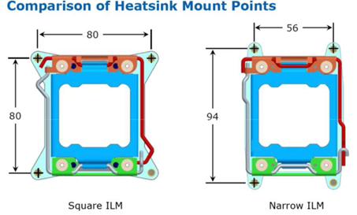

Heatsink LGA115X
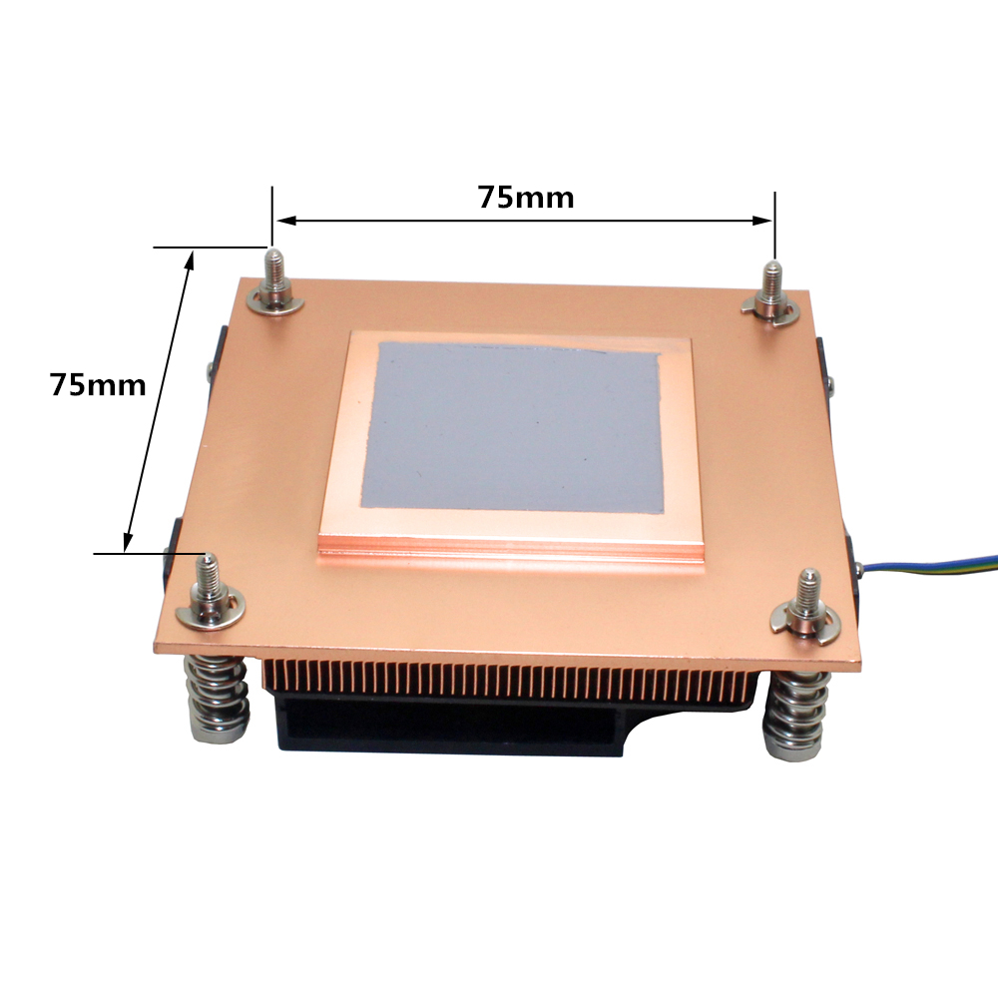 | 

