Connectors

Manufacturers
http://www.klsele.com/ | China | KLS
https://www.antenk.com/ | China | Antenk
http://en.ute.com.cn/ | China | UTE | UTE Product List.pdf
https://www.elektrodetal.com/catalog/ | Карачаев |  | Прямоугольные соединители Каталог

QSFP
link | ext | description | manufacturer | version | date | lang
ENG_CD_2289129_E.pdf | pdf | 2289129 QSFP 2×2 | TE
c-2289129-2-a-3d.stp | stp | 2289129-2 zQSFP+/QSFP28, QSFP, QSFP+ & zQSPF+, Cage Assembly with Integrated Connector, 2 x 2, Internal/External EMI Springs, Included Lightpipe, Standard | TE
1619_B054_05100_QSFP56_CAGE_压接式_2X2_带导光柱（左上右下）_镀金30U.pdf | pdf | 1619.B054.05100 QSFP 2×2 | UTE
ATK10-5011292-20S.pdf | pdf | ATK10-5011292-20S QSFP+ 28G 1×1 CAGE 2LP+HEATSINK  ANTENK | Antenk | rev/ A |  | EN
ENG_CD_1551920_M.pdf | pdf | 1551920-X zQSFP+ connector 38 POS TE Connectivity | TE | rev. M |  | EN
ENG_CD_1551920_N.pdf | pdf | X-1551920-Y zQSFP+ connector 38 POS TE Connectivity | TE | rev. N |  | EN
ENG_CD_2170705_D.pdf | pdf | X-2170705-Y QSFP28 CAGE+HEATSINK+LIGHTPIPE | TE |  |  | EN
ENG_CD_2227669_F.pdf | pdf | X-2227669-Y QSFP 2×1 Cage+connector | TE |  |  | EN
ENG_DS_5-1773463-0_zQSFP_Plus_Connector_0519.pdf | pdf | QSFP28/56 and zQSFP+ Interconnects  TE Connectivity Catalog | TE |  |  | EN
LP11F004 (QSFP 38PIN).pdf | pdf | LP11F004 - LINK-PP QSFP 1×1 38PIN SMD | LINK-PP | rev A |  | EN
LQ-004.pdf | pdf | LQ-004 - LINK-PP QSFP-28 1×1 CAGE quad Lightpipe, heatsink | LINK-PP | rev A |  | EN

SFP
link | ext | description | manufacturer | version | date | lang
ENG_CD_2007394_D1.pdf | pdf | 2007394 2×4 SFP+ | TE
c-2007394-5-e-3d.stp | stp | 2007394-5 SFP, SFP+ & zSFP+, Cage Assembly with Integrated Connector, Data Rate (Max) 16 Gb/s, External Springs, SFP+, Included Lightpipe, 2 x 4 | TE
RTS29-DT019-D1S01(SFP+ 2X4 15U__)_Rev A.pdf | pdf | RTS29-DT019-D1S01 2×4 SFP+ | Antenk
RTS29-DT019-D1S01_3D-20220331_Rev1.STEP | STEP | RTS29-DT019-D1S01 2×4 SFP+ | Antenk
LP11F003.pdf | pdf | LP11F003 - Link-PP SFP\SFP+ connector 20PIN SMD | LINK-PP | rev A | 2012.08.27 | EN
LP12F001.pdf | pdf | LP12F001 - LINK-PP SFP+ Cage 1×2 | LINK-PP | rev A | 2012.07.27 | EN

RJ-45
link | ext | description | manufacturer | version | date | lang
31133.A1142.994900(5963-S-2X1-正全开窗带8弹-LED（左绿右绿黄）-8C 扁针15U).pdf | pdf | 31133.A1142.994900 RJ-45 2×1 (RxC) 2x(G+G\Y) UTE  RJSAE5384A2 | UTE | rev. A |  | EN

RJ-45 + USB
link | ext | description | manufacturer | version | date | lang
ENG_CD_1909119_C.pdf | pdf | 1909119 RJ-45 over USB2.0  1909119-1  1909119-4  1-1909119-4  2-1909119-4  cross = TE 1-1909119-4 → UTE 143.1012.11500 | TE | rev. C |  | EN
c-1-1909119-4-b-3d.stp | stp | 1-1909119-4 RJ-45 over USB2.0 w 2LED G\Y  cross = TE 1-1909119-4 → UTE 143.1012.11500 | TE

Edge Slot
link | ext | description | manufacturer | version | date | lang
ECM-10-B-H-7-G3-P-A-01.pdf | pdf | 2.54mm EDGE Slot SMT Straddle Mount Connectors | Antenk |  |  | EN

ILM LGA2011
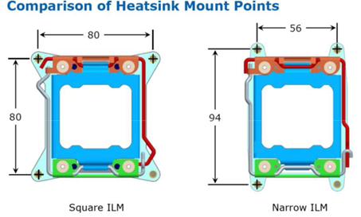

ILM LGA115X
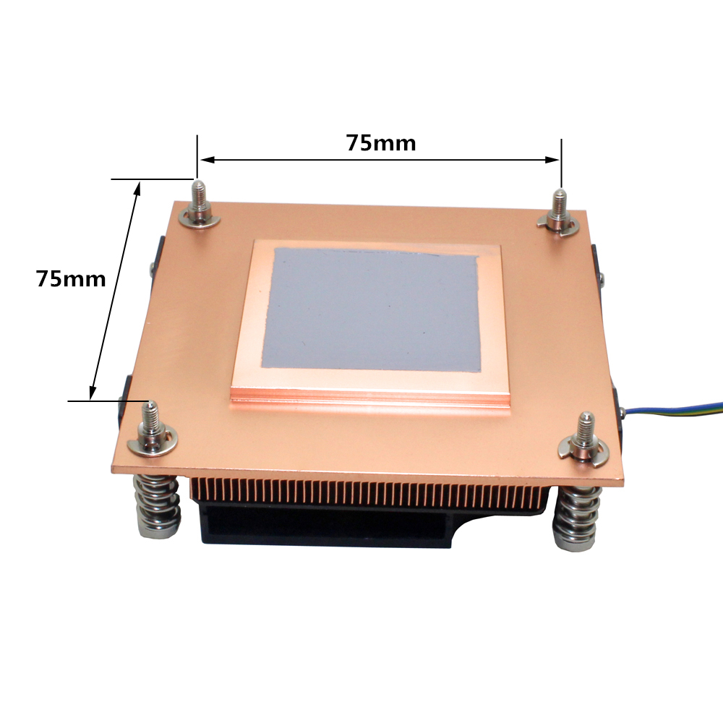 | 

