Surge Arresters (Разрядники)

Manufacturers
RUICHI
CITEL | http://www.tecnorayos.com/pdf/3.CAPSULAS%20GASEOSAS%20CITEL.pdf
DEHN
LEUTRON
OBO Bettermann
RST
ГРОЗОЩИТ
ДКС
Тахион
KLS
ZF
https://skomplekt.com/tovar/6/27/12/
https://www.symmetron.ru/catalog/passivnye-komponenty/razryadniki/

Theory
The main electrical characteristics defining a gas discharge tube are:
- DC sparkover voltage (Volts)
- Impulse sparkover voltage (Volts)
- Discharge current capacity (kA)
- Insulation resistance (Gohms)
- Capacitance (pF)
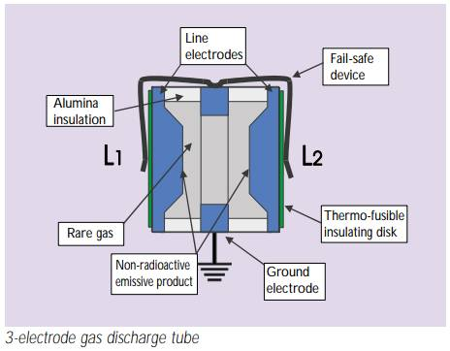

DC sparkover voltage
This is the main characteristic defining the gas discharge tube. It is the voltage at which breakdown will occur between the electrodes when a slowly increasing voltage (dV/dt = 100 V/s) is applied to the component; it depends on the electrode spacing, the pressure, and the properties of the gas mixture and of the emissive substance.
Range of DC sparkover voltages available:
- minimum 75V
- average 230V
- high voltage 500V
- very high voltage 1000 to 3000V
The tolerance on the breakdown voltage is generally ± 20%.

3-electrode configuration
Protecting a two-wire line (for example a telephone pair) with two 2- electrode gas discharge tubes (connected between the wires and ground) may cause the following problem:
The line is subjected to an overvoltage in common mode; because of the dispersion of the sparkover voltages (± 20%), one of the gas discharge tubes sparks over a very short time before the other (a few microseconds); the wire that has sparked over is therefore grounded (neglecting the arc voltages), turning the common-mode overvoltage into a differential-mode overvoltage, very dangerous for the terminal equipment. This risk disappears when the second gas discharge tube arcs over (a few microseconds later).
3-electrode geometry eliminates this drawback: the sparkover of one pole causes a «general» breakdown of the device almost instantaneously (a few nanoseconds) because there is only one gasfilled enclosure.

End of life
Gas discharge tubes are designed to withstand several impulses without destruction or loss of the initial characteristics (typical impulse tests: 10 times 5kA impulses of each polarity).
On the other hand, a sustained strong current (e.g. 10A rms for 15 seconds, simulating the fall of a power line onto a telecommunications line) will put the device out of service definitively.
If a fail-safe end of life is desired (i.e. a short-circuit that will report the fault to the user when the line fault is detected), gas discharge tubes with the fail-safe feature (external short-circuit) should be chosen.

Radial - TH

2-PIN
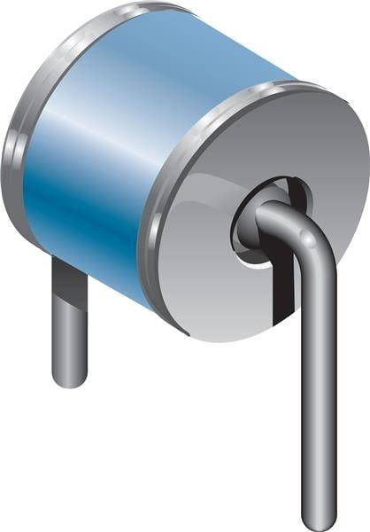
Mounting

3-PIN
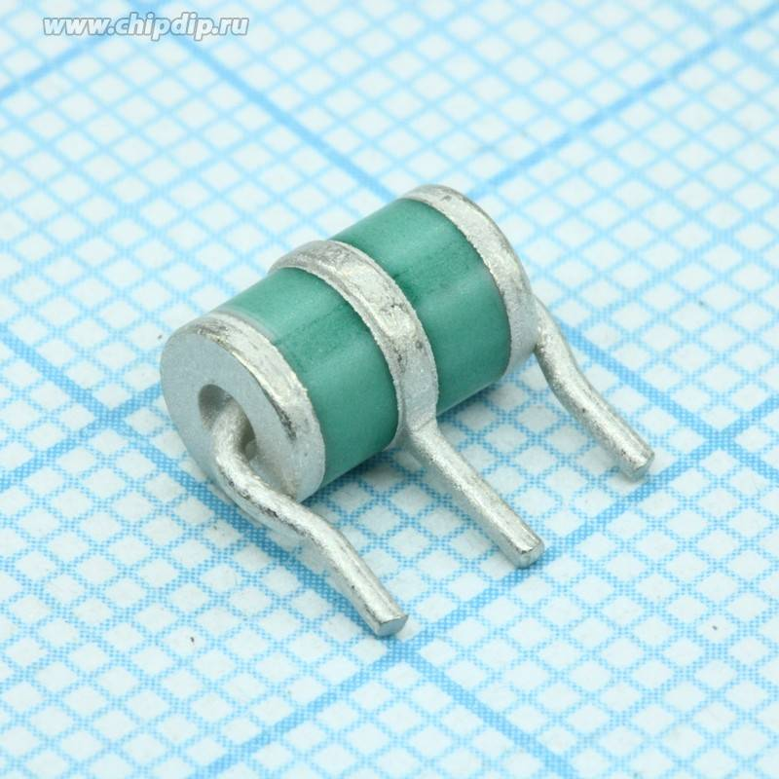

SMD

2-PIN

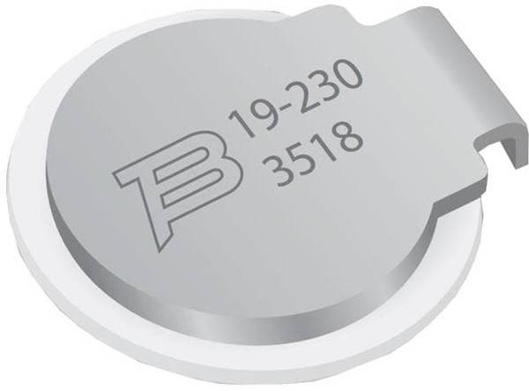
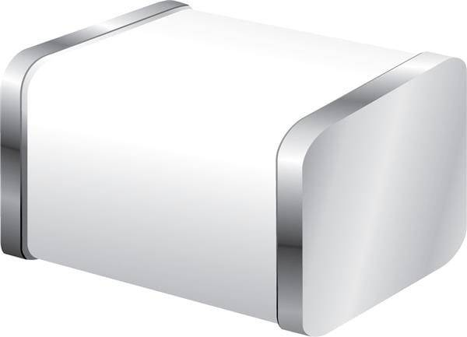
Bourns | 2051-09-SM-RPLF |  | (4.5×3.2×2.7mm 90V +30% 2kA/2A), SMD 2.7×3.2×4.5mm 90V +30% 2kA/2A.
Epcos | M50-C90XSMD | B88069X1640T902 | (5.4x5mm 90V +20% 10kA/5A 2-х элек. SMD M50-C90XSMD), 5.4x5mm 90V +20% 10kA/5A 2-х элек. SMD

3-PIN
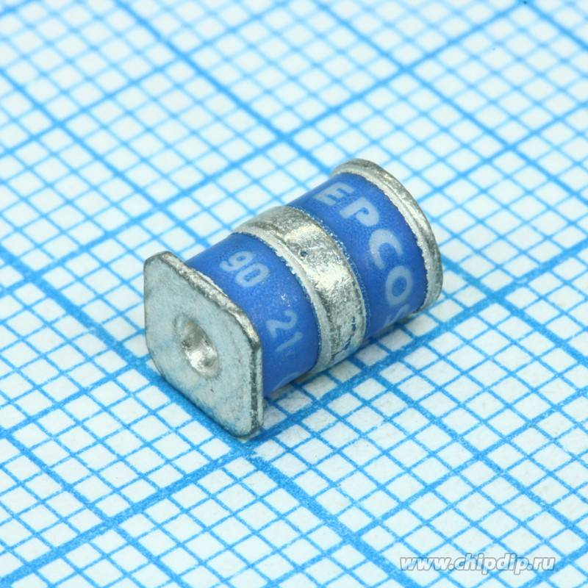

Cable\Connector
https://www.panorama-antennas.com/site/Antenna-Accessories/Surge-Arresters?product_id=380

Disk - TH + varistor


