Circuit Protection

Manufacturers
https://www.belfuse.com/
https://www.bourns.com
https://www.hakel.ru/ | Разные УЗИП
https://www.igur.by/ | Разные УЗИП

Thermistors
Термисторы

Varistors
Варисторы

Fuses
Предохранители

Surge Arresters
Разрядники
- DIAC 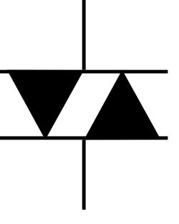
- SIDAC 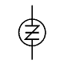
- TSPD (thyristor surge protection device) (crowbar device)
  - ST (Trisil)
  - TOOHONG
  - Bourns (TISP)
  - Littelfuse (SIDACtor)
- transient voltage suppression diodes
  - Transil
Trisil is a trade name for a thyristor surge protection device, an electronic component designed to protect electronic circuits from overvoltage. Unlike a transient voltage suppression diodes, such as Transil, Trisil acts as a crowbar device, switching on when the voltage across it exceeds its breakover voltage.

