Capacitors

Manufacturers
https://industrial.panasonic.com/ww/products/capacitors | Panasonic | Japan

CAP-CER
Керамические многослойные (MLCC - multilayer ceramic capacitor)

CAP-TANT
Танталовые (Tantalum)

CAP-AL
Алюминиевые электролитические

CAP-ALPOL
Алюминиевые полимерные
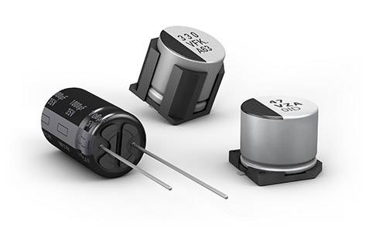

Manufacturers
Panasonic | Japan | https://industrial.panasonic.com/ww/products/capacitors
Murata
Wurth
Kemet
Nichicon
NIPPON | Japan | https://www.chemi-con.co.jp/en/ example
Samwha | Korea | https://www.compel.ru/producer/samwha-capacitor www.samwha.com example
Xuansn? | China | https://xuanxcapacitors.ru/capacitor/12v680uf-solid-capacitor/

CAP-POL
Полимерные (Танталовые-полимерные?)
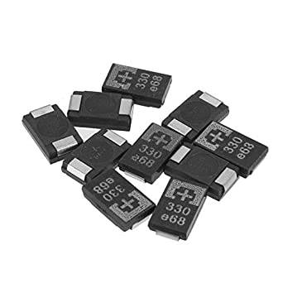

Manufacturers
Panasonic | Japan | https://industrial.panasonic.com/ww/products/capacitors
AVX

CAP-SUPER
Суперконденсаторы

Manufacturers
https://www.vinatech.com/eng/product/supercapacitor.php | Vinatech | Korea | Supercap

