Capacitors

Manufacturers
https://www.topdiode.com/

CAP-CER
Керамические многослойные (MLCC - multilayer ceramic capacitor)

Horizontal and Vertical Oriented Electrodes
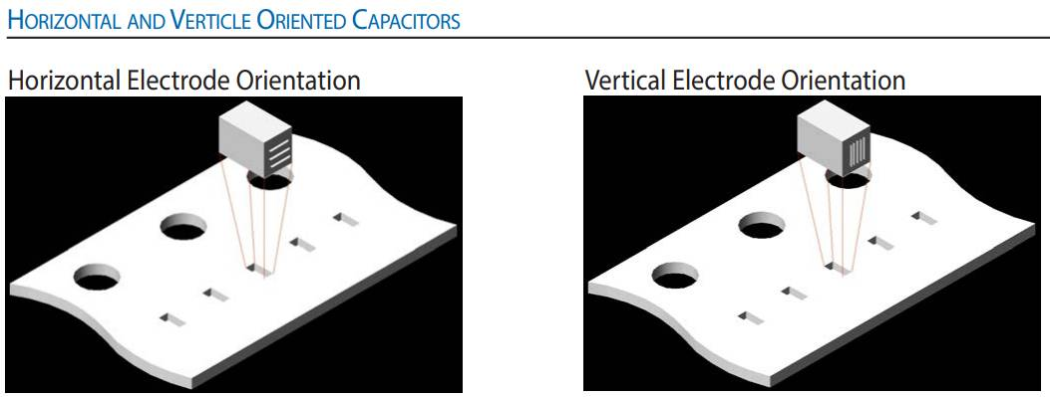

CAP-TANT
Танталовые (Tantalum)

CAP-AL
Алюминиевые электролитические

CAP-ALPOL
Алюминиевые полимерные (+ hybrid)
Aluminium-polymer, aluminium-hybrid
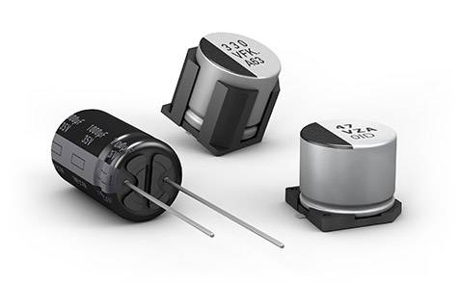
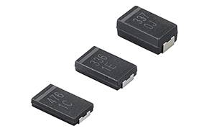

Manufacturers
Panasonic | Japan | https://industrial.panasonic.com/ww/products/capacitors/polymer-capacitors | SP-CAP (chip SMD)  OS-CON (radial)  Hybrid (radial)
Murata | Japan | https://www.murata.com/en-global/products/capacitor/polymer/overview/lineup/ecas | ECAS (chip SMD)
Rubycon | Japan | https://tools.rubycon.co.jp/product-search/?series=PSV | Hybrid? (radial)
Nichicon | Japan | https://www.nichicon.co.jp/english/products/solid/default.htm
NIPPON | Japan | https://www.chemi-con.co.jp/en/ example
Wurth | Germany | https://www.we-online.com/catalog/en/pbs/capacitors/aluminum_polymer_capacitors | (WCAP-PTG5, WCAP-PTHR, WCAP-PTHT, WCAP-PT5H)(radial THT)  (WCAP-PSLC, WCAP-PSLP, WCAP-PSHP)(radial SMD)  (WCAP-PHGP, WCAP-PHLE, WCAP-PHSE)(chip SMD)
Kemet (Yageo) | USA (Taiwan) | chip SMD radial SMD Radial THT
Cornell Dubilier | USA | https://www.cde.com/capacitors/aluminum-polymer/
Samwha | Korea | https://www.compel.ru/producer/samwha-capacitor www.samwha.com example
Hitano | China | https://www.hitano.com.tw/aluminum-electrolytic-capacitor/ | ERS (radial THT)  EVS (radial SMD)
Xuanx? | China | https://www.xuanxcapacitors.com/product-category/capacitor/solid-capacitor
TopMay? | China | https://topmayelectronic.en.made-in-china.com/product/BXanyWYlLwVS/China-Conductive-Polymer-Aluminum-Solid-Capacitor-CS-Cap-Tmce31.html
KNSCHA | China | http://www.knscha.com/en/tio2-solid-bimetallic-capacitors/tio2-solid-cap-pb.html
Apaq | Taiwan | https://www.apaq.com.tw/en/index.html

CAP-POL
Полимерные (Танталовые-полимерные?)
Tantalum-polymer
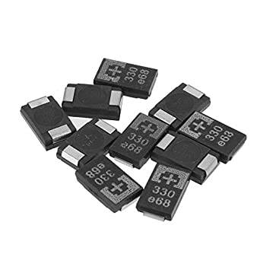

Manufacturers
Panasonic | Japan | https://industrial.panasonic.com/ww/products/capacitors/polymer-capacitors | POSCAP (chip SMD) catalog full catalog
Kyocera AVX |  | https://www.kyocera-avx.com/products/polymer/
Kemet (Yageo) | USA (Taiwan) | https://www.kemet.com/en/us/capacitors/polymer.html?t=692

CAP-SUPER
Суперконденсаторы

Manufacturers
https://www.vinatech.com/eng/product/supercapacitor.php | Vinatech | Korea | Supercap

