Altium
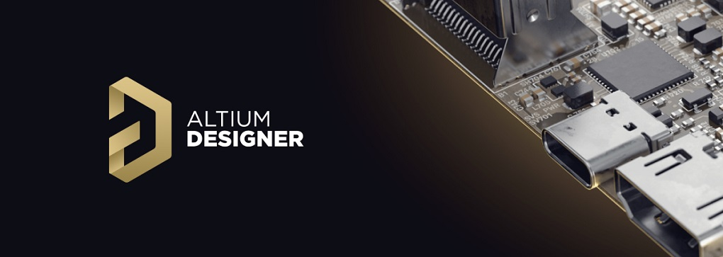
https://altiumlibrary.com/
https://github.com/issus
https://github.com/issus/altium-library
https://github.com/issus/AltiumSharp
https://github.com/issus/DigiKeyApi
https://www.nuget.org/packages/OpenMcdf
https://github.com/vadmium/python-altium
https://github.com/krakdustten/PyAltium365
https://github.com/vadmium/pyparts
https://github.com/krakdustten/PyAltiumRun
https://github.com/coffeenmusic?tab=repositories
https://github.com/Altium-Designer-addons/scripting-reference
https://github.com/openscopeproject/InteractiveHtmlBom
Обязательно надо включать опции:


