NMS-CS-IMX8MINI v2 ds-en
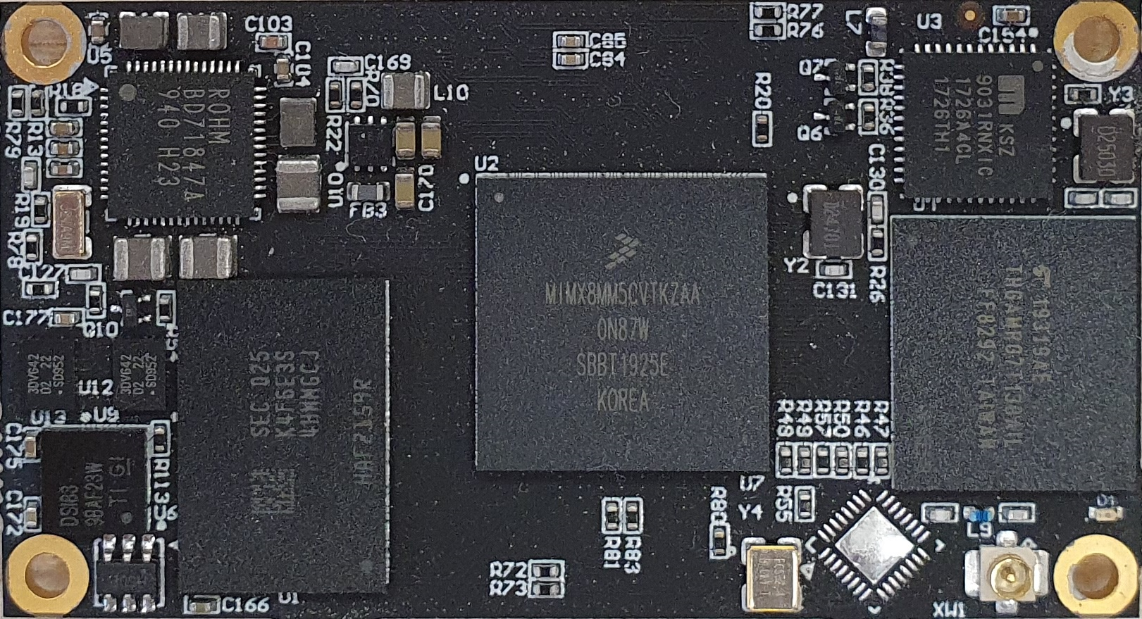
System on Module NMS-CS-IMX8MINI-V2 is based on an ARM archtecture proccessor NXP i.MX8M Mini.

Technical Specifications
Таблица 1: Main technical specifications
Form factor | three 90-pins mezzanine connectors Hirose DF40C
CPU | Series: i.MX8M Mini (MIMX8MM6CVTKZAA)
CPU | Number of Cores/Core Processor: 4 x ARM Cortex A53, 1 x ARM Cortex-M4F
CPU | 32 KB, 32 KB (instruction,data) L1 Cache
CPU | 512 KB unified L2 Cache
CPU | Operating Frequency [Max] 1.6 GHz
RAM | LPDDR4 16 GB, interface 32-bit (K4F6E3S4HM-MGCJ000)
FLASH | eMMC FLASH 16 GB (THGAMRG7T13BAIL)
EEPROM | I2C serial EEPROM 2 KB, Unique ID 48 bit (24AA025)
Power management IC | PMIC (BD71847AMWV)
Other components | WIFI (WF200C)
Other components | Ethernet PHY (KSZ9031)
Other components | MIPI® DSI→LVDS bridge (SN65DSI83ZQER)
Other components | 3-lane high-speed MIPI compatible switch (NX3DV642GU,115)
Interfaces | 1x PCIe
Interfaces | 2x USB OTG 2.0
Interfaces | 1x JTAG
Interfaces | 1x Gigabit Ethernet (from gigabit PHY)
Interfaces | 1x QSPI
Interfaces | 2x ECSPI
Interfaces | 4x SAI
Interfaces | 1x SPDIF
Interfaces | 1x SD
Interfaces | 4x UART
Interfaces | 4x I2C
Interfaces | 1x LVDS (MIPI DSI → LVDS)
Interfaces | 1x MIPI CSI
Interfaces | 14x GPIO
Power supply voltage | 3.5-5V
Power consumption | TBD
Dimensions | 55.2 х 30.1 mm

Block Diagram
Рисунок 1: Module block diagram

Power tree
Рисунок 2: Module power tree

Mechanical Specifications
Board dimensions are: 55.2 х 30.1 mm.
Printed circuit of the board is made of 10 layers, some of them are ground planes, for disturbance rejection.
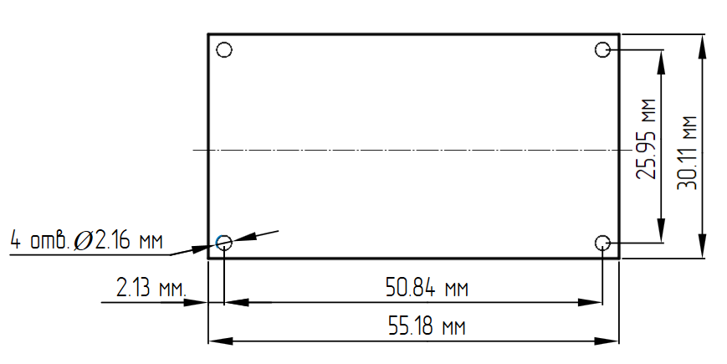
Рисунок 3: Module mechanical dimensions

Main Hardware Components

Component Location

Top View
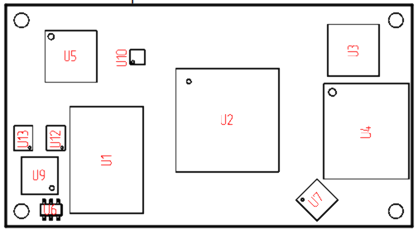
Рисунок 4: Component Location. Top View

Таблица 2: Component description on the board (Top side)
Designator | P/N | Description
U1 | K4F6E3S4HM-MGCJ000 | Memory LPDDR4
U2 | MIMX8MM6CVTKZAA | Processor i.MX8M Mini
U3* | KSZ9031RN | Ethernet PHY
U4 | THGAMRG7T13BAIL | e-MMC flash
U5 | BD71847AMWV_ | PMIC
U6 | 24AA025E48T-I/OT | EEPROM
U7* | WF200C | Network Co-Processor Wi-Fi
U9 | SN65DSI83ZQER | MIPIDSI→LVDS bridge
U10* | PAM2305CGFADJ | DCDC converter 5V→1.2V
U12, U13 | NX3DV642GU,115 | 3-lane high-speed MIPI compatible switch
* - absent in this version

Bottom View
On the bottom side of the board, the components are absent.

Processor
Figure shows the functional modules in the i.MX8M MINI processor system.
Рисунок 5: i.MX8M Mini function modules

Interfaces

I2C
Three I2C interfaces are availbale on NMS-CS-IMX8MINI-V2.
Рисунок 6: I2C interfaces

Таблица 3: I2C Address Mapping
Device | Address
MIPIDSI→2LVDS bridge | 0x0101100
EEPROM | 0x1010000
PMIC | 0x1001000

Таблица 4: I2C signal pinouts on J1-J3 connectors
Signal Name | Pin(s) | Direction | Standard volgate (V) | Description | Connection
I2C2_SCL | J2.32 | in/out | 3.3  PU 4.7 kΩ | General purpose I2C Bus clock line. | U2.D10
I2C2_SDA | J2.30 | in/out | 3.3  PU 4.7 kΩ | General purpose I2C Bus data line. | U2.D9
I2C3_SCL | J3.46 | in/out | 3.3  PU 4.7 kΩ | General purpose I2C Bus clock line. | U2.E10
I2C3_SDA | J3.42 | in/out | 3.3  PU 4.7 kΩ | General purpose I2C Bus data line. | U2.F10
I2C4_SCL | J1.17 | in/out | 3.3  PU 4.7 kΩ | General purpose I2C Bus clock line. | U2.D13
I2C4_SDA | J1.19 | in/out | 3.3  PU 4.7 kΩ | General purpose I2C Bus data line. | U2.E13
where PU - pull-up resistor, PD - pull-down resistor.

Debugging/development interfaces

I2C
There is one I2C interface for communicating between processor and peripherals on NMS-CS-IMX8MINI-V2.
Рисунок 7: I2C1 interface

Таблица 5: IMX8M_MINI I2C singnals
Signal name | Pin(s) | Direction | Voltage standard | Description
I2C1_SCL | E9 | in/out | 3.3  PU 4.7 kΩ | General purpose I2C Bus clock line.
I2C1_SDA | F9 | in/out | 3.3  PU 4.7 kΩ | General purpose I2C Bus data line.
where PU - pull-up resistor, PD - pull-down resistor.

RESET
Рисунок 8: Reset signals

Таблица 6: PMIC reset signals
Signal name | Pin(s) | Voltage standard(V) | Circuit name | Connection | Description
PWRON | U5.40 | 1.8  PU 100 kΩ | PWRON_B | - | Not used
POR | U5.25 | 1.8  PU 10 kΩ | POR_B | U2.B24, J1.24
POR | U5.25 | 1.8  PU 10 kΩ | 1V8_POR_B | U3.42, U4.K5
RTC_RESET | U5.3 | 1.8  PU 100 kΩ | RTC_RESET | U2.F4
where PU - pull-up resistor, PD - pull-down resistor.

CLK
Рисунок 9: Clock signals

Таблица 7: J1 socket clock signals
Signal name | Pin(s) | Voltage Standart(V) | Circuit Name | Connection
GPIO1_IO00 | 1 |  | LP_CLK | U7.23 (through 0Ω )
NAND_DATA07/QSPIB_DATA3 | 35 |  | CLK_I_N | U2.J27
NAND_DATA06/QSPIB_DATA2 | 37 |  | CLK_I_P | U2.H27
NAND_CLE/QSPIB_SCLK | 45 |  | CLK_O_P | U2.H26
NAND_CE2_B/QSPIB_SS0_B | 47 |  | CLK_O_N | U2.J26
PCIE1_REF_CLKN | 51 |  | PCIE_REF_CLK_P | U2.B21
PCIE1_REF_CLKP | 53 |  | PCIE_REF_CLK_N | U2.A21

Таблица 8: J3 socket clock signals
Signal Name | Pin(s) | Voltage Standart(V) | Circuit name | Connection
CSI_P2_DN0 | 84 |  | EXT_LP_CLK | U7.23 (through 0Ω )

External connectors
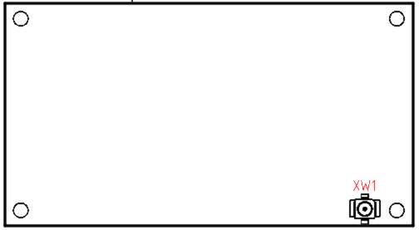
Рисунок 10: Connectors Location. Top View

Designator | P/N | Description
XW1 | 73412-0114 | Microcoaxial connector for antenna
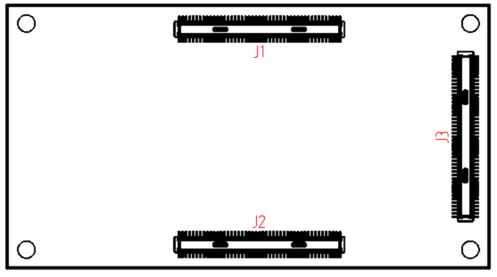
Рисунок 11: Component Location. Bottom View

Designator | P/N | Description
J1-J3 | DF40C-90DP-0.4V | Composite 90-pin mezzanine connector
Connectors, Alternatives

